|  | **MINISTRY OF EDUCATION AND TRAINING** |
| --- | --- |

| **FPT UNIVERSITY** |
| --- |
| Capstone Project Document |
| SMPA – Product Solar MP |

| **GFA23SE89** | |
| --- | --- |
| **Group Members** | Nguyễn Quang Minh – SE140461  Bảo Quốc – SE140751  Nguyễn Thanh Tân – SE140017  Nguyễn Phan Khôi Nguyên – SE140045 |
| **Supervisor** | Nguyễn Trí Thông |
| **Ext Supervisor** | N/A |
| **Capstone Project code** | FA23SE057 |

- Ho Chi Minh City, December/2023 -

**Table of Contents**

Acknowledgment 4

Definition and Acronyms 4

I. Project Introduction 4

1. Overview 4

2. Product Background 4

3. Existing Systems 4

4. Business Opportunity 5

5. Software Product Vision 5

6. Project Scope & Limitations 5

II. Project Management Plan 6

1. Overview 6

2. Management Approach 6

3. Master Schedule 6

4. Project Organization 6

5. Project Communication 6

6. Configuration Management 6

III. Software Requirement Specification 7

1. Overall Description 7

2. User Requirements 7

3. Functional Requirements 7

4. Non-Functional Requirements 7

5. Other Requirements 7

IV. Software Design Description 8

1. Overall Description 8

2. System Architecture Design 8

3. System Detailed Design 8

4. Class Specification 8

5. Data & Database Design 8

V. Software Testing Documentation 9

1. Overall Description 9

2. Test Plan 9

3. Test Cases 9

4. Test Reports 9

VI. Release Package & User Guides 10

1. Deliverable Package 10

2. Installation Guides 10

3. User Manual 10

VII. Appendix 10

1. Glossary [Optional] 10

2. References [Optional] 10

3. Others [Optional] 10

# Acknowledgment

We would like to express my sincere gratitude to my supervisor, Teacher Nguyễn Trí Thông, for his invaluable guidance and support throughout our capstone project. He has been a constant source of inspiration and encouragement and has provided me with constructive feedback and useful suggestions. He has also been very generous with his time and expertise and has always been available to answer my questions and address my concerns. We are truly grateful for his mentorship and professionalism.

We would also like to thank the other members of the capstone committee, Teacher TaiNT, Teacher VanTTN, Teacher LamNN, and Teacher NhanDT for their insightful comments and helpful advice. They have challenged our team to improve the quality and clarity of our work. We appreciate their time and effort in reviewing our project and providing our team with constructive criticism.

Finally, We would like to acknowledge the support of our family and friends, who have been with our team throughout this journey. They have motivated our team to pursue our goals and overcome the difficulties along the way. They have also shared our joys and frustrations, and have celebrated our achievements with our team. We dedicate this project to them.

Best regards,

SMPA Team.

# Definition and Acronyms

| **Acronym** | **Definition** |
| --- | --- |
| SMPA | Solar Minh Phat Application |
| AWS | Amazon Web Services |
| BA | Business Analysis |
| BR | Business Rule |
| ERD | Entity Relationship Diagram |
| GUI | Graphical User Interface |
| PM | Project Manager |
| SDD | Software Design Description |
| SPMP | Software Project Management Plan |
| SRS | Software Requirement Specification |
| UAT | User Acceptance Test |
| UC | Use Case |
| API | Application Program Interface |

# I. Project Introduction

## 1. Overview

### 1.1 Project Information

* Project name: Product Solar Minh Phat
* Project code: FA23SE057
* Group name: GFA23SE89
* Software type: Web App, Mobile App

### 1.2 Project Team

| **Full Name** | **Role** | **Email** | **Mobile** |
| --- | --- | --- | --- |
| Nguyễn Trí Thông | Lecturer | ThongNT@fe.edu.vn | 0907973989 |
| Nguyễn Quang Minh | Leader | minhnqse140461@fpt.edu.vn | 0793429005 |
| Bảo Quốc | Member | quocbse140751@fpt.edu.vn | 0938196994 |
| Nguyễn Thanh Tân | Member | tanntse140017@fpt.edu.vn | 0909643365 |
| Nguyễn Phan Khôi Nguyên | Member | nguyennpkse140045@fpt.edu.vn | 0913909555 |

## 2. Product Background

The increasing use of electrical appliances in households has led to rising monthly electricity bills. This is a major household concern, especially in the current economic climate. The national grid is also unable to meet the electricity demand, so the government is encouraging people to use solar systems.

Minh Phat store was established to meet the needs of customers who are looking for solar solutions. The store offers genuine product packages and construction advice that are

suitable for homes. Minh Phat has a team of professional staff who are committed to providing customers with satisfaction and competitive prices.

## 3. Existing Systems

### 3.1 Vietnam Solar

Vietnam Solar is a company providing solar energy solutions for various customers such as homes, hotels, businesses, and factories.

Link: [Vietnam Solar](https://vietnamsolar.vn/)

Advantages:

* Provides various product packages.
* Friendly User Interface for customers.

Drawbacks:

* The system does not provide contract tracking when construction is in progress.
* The system is current payment using cash only.
* The system does not support iOS and Android.

### 3.2 Green blue

Green blue is a company providing solar energy solutions for homes and businesses. Additionally, they provide wind energy and hydroelectric power solutions.

Link: [Green blue](https://greenblue.vn/)

Advantages:

* Provides various product packages.
* Friendly User Interface for customers.
* Customers can buy individual devices without buying a package.

Drawbacks:

* The system does not provide contract tracking when construction is in progress.
* The system is currently payment using cash only.
* The system does not support iOS and Android.

## 4. Business Opportunity

Existing contract management apps for the solar power industry are often not designed specifically for the industry, which can lead to a lack of customization, high costs, complexity, and lack of integration with other business systems. A solar power construction contract management app can be a valuable tool for improving the efficiency, accuracy, and compliance of solar power construction projects. The app can overcome the limitations of other contract management apps and provide a more effective solution for managing contracts in the solar power industry.

## 5. Software Product Vision

The Solar Management and Power App (SMPA) is a smartphone-enabled app that streamlines the solar panel contracting process for customers and employees of the Minh Phat store. The mobile app allows customers to select a solar product package, track their projects online, and receive notifications. Employees can use the web app to provide customers with information, create contracts, and track projects.

The SMPA is a valuable tool that simplifies the process of acquiring solar power contracts for customers and streamlines the work of employees. The app is user-friendly and secure, and it provides a comprehensive reporting system.

## 6. Project Scope & Limitations

### 6.1 Major Features

### 6.1.1 Admin Role

FE-01: View account list.

FE-02: Create, view, update, and disable accounts.

### 6.1.2 Owner Role

FE-01: Manage products.

FE-02: Manage product packages.

FE-03: Manage brackets.

FE-04: View contract payments.

FE-05: View list of requests.

FE-06: Assign available staff to requests.

FE-07: View customers’ feedback.

FE-08: Manage promotions.

FE-09: View contracts.

FE-10: Manage team.

### 6.1.3 Staff Role

FE-01: View a list of assigned contracts.

FE-02: View construction packages.

FE-03: Create contract.

FE-04: Manage contract status.

FE-05: Manage progress status.

FE-06: Chat with customers.

FE-07: View contract history.

FE-08: Update acceptance.

FE-09: Manage report of warranty.

### 6.1.4 Customer Role

FE-01: View product packages.

FE-02: View contract.

FE-03: Paying online.

FE-04: View contract history.

FE-05: Manage personal details.

FE-06: Feedback construction package.

FE-07: Chat with staff.

FE-08: Send request.

### 6.2 Limitations & Exclusions

**Limitations:**

LI-1: The system currently supports only residential solar panel construction contracts.

LI-2: The system is only available in Ho Chi Minh City

LI-3: The system is currently available only to Android users.

# II. Project Management Plan

## 1. Overview

### 1.1 Scope & Estimation

### 

| **No** | **WBS Item** | **Complexity** | **Est. Effort** |
| --- | --- | --- | --- |
| ***1*** | ***Initiating*** |  | ***3*** |
| 1.1 | Collect requirement | Medium | 3 |
| ***2*** | ***Planning*** |  | ***5*** |
| 2.1 | Create plan documentation with team | Complex | 5 |
| ***3*** | ***Executing*** |  | ***104*** |
| 3.1 | Analysis |  | 5 |
| 3.1.1 | Analysis requirement | Complex | 5 |
| 3.2 | Design |  | 45 |
| 3.2.1 | Design Web Application | Complex | 20 |
| 3.2.3 | Design database | Complex | 25 |
| 3.3 | Prototyping |  | 5 |
| 3.1.1 | Mock-up Web application | Medium | 5 |
| 3.2 | Implementation |  | 31 |
| 3.2.1 | Prepare environment | Medium | 2 |
| 3.2.2 | Implementation of Admin Web Application | Medium | 4 |
| 3.2.3 | Implementation of field owner Web Application | Complex | 15 |
| 3.2.4 | Implement of owner | Medium | 10 |
| 3.3 | Testing |  | 14 |
| 3.3.1 | Integration test | Medium | 4 |
| 3.3.2 | System test | Medium | 7 |
| 3.3.3 | Acceptance test | Medium | 3 |
| 3.4 | Support | Medium | 4 |
| ***4*** | ***Monitoring and controlling*** | | |
| 4.1 | Control the process | Complex | Using Scrum for the process of project |
| ***5*** | ***Closing*** |  | ***12*** |
| 5.1 | Report final | Complex | 12 |
| ***Total Estimated Effort (man-days)*** | | | ***124*** |

### 

### 1.2 Project Objectives

| **#** | **Testing Stage** | **No. of Defects** | **% of Defect** | **Notes** |
| --- | --- | --- | --- | --- |
| 1 | Reviewing | 9 | 29.03% | N/A |
| 2 | Unit Test | 6 | 19.35% | N/A |
| 3 | Integration Test | 4 | 12.9% | N/A |
| 4 | System Test | 7 | 22.58% | N/A |
| 5 | Acceptance Test | 5 | 16.14% | N/A |
|  | **Total** | **31** | **100%** | N/A |

### 1.3 Project Risks

### 

| **#** | **Risk Description** | **Impact** | **Possibility** | **Response Plans** |
| --- | --- | --- | --- | --- |
| 1 | Over deadline reason from  team members | Serious | High | The team must meet and report their tasks daily |
| 2 | Over deadline because of health | Serious | Medium | Allow members to have a break day others will solve their tasks |
| 3 | Unrealistic project schedule | Serious | High | The team must meet, and everyone needs to review the schedule |
| 4 | Communication risks | Medium | High | All members must communicate with the team at the same time and avoid private talk |
| 5 | Conflicts between team members | Medium | High | Create team meeting to share and solve the problem |
| 6 | Poor experience | Medium | Medium | All members should support the leader to handle the project process |
| 7 | The working process is delayed because of power off | Medium | Medium | Overtime every date |
| 8 | Framework technical knowledge | High | High | The team should take the time to research the framework |
| 9 | Not understanding requirements | Serious | High | Develop a prototype and review this with experts and supervisors |

## 

## 2. Management Approach

### 2.1 Project Process

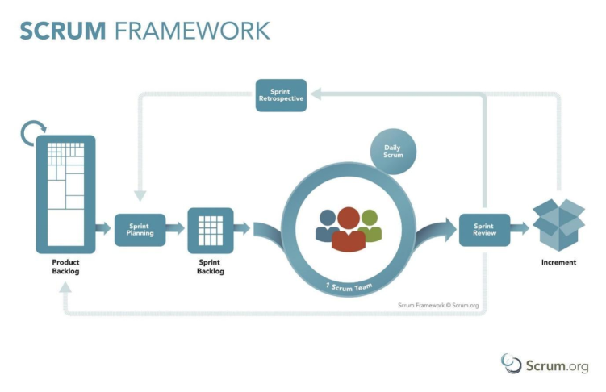

The project is approaching the Scrum model from Agile Software Development methodologies.

The Scrum helps:

* Easily adapt to many changes.
* Break down milestones into smaller phases, help easy to track progress and execution.
* Reduce the risk of mitigation.

### 2.2 Quality Management

### 

| **Approach** | **Description** | **When** | **Waiver criteria** |
| --- | --- | --- | --- |
| Defect prevention | Implement and follow verified coding convention | Before starting each coding phase | Mandatory |
| Self-review using integrated Visual Code and Visual Studio | Before committing | Mandatory |
| Reviewing | Cross-review before pushing code to master branch | After a member finishes his assigned tasks | Mandatory |
| Unit testing | N/A | After a member finishes modules related to a specific feature and all of code is reviewed | Mandatory |
| Integration testing | N/A | After all modules are integrated and unit test cases are passed | Mandatory |
| System testing | Examines every component of an application | After checks individual modules with functional or user story testing and then each component through integration testing | Mandatory |

### 

### 2.3 Training Plan

| **Training Area** | **Participants** | **When, Duration** | **Waiver Criteria** |
| --- | --- | --- | --- |
| Flutter/Firebase | TanNT | 25/10/2023 (1 month) | Mandatory |
| Front-end/React, TypeScript/Firebase | NguyenNPK | 25/10/2023 (1 month) | Mandatory |
| Back-end/C# | QuocB, MinhNQ | 25/10/2023 (1 month) | Mandatory |
| Git, GitHub | Everyone | 25/10/2023 (1 month) | Mandatory |
| Microsoft Azure | Everyone | 25/10/2023 (1 month) | Mandatory |

## 3. Project Deliverables

| **#** | **Deliverable** | **Due Date** | **Notes** |
| --- | --- | --- | --- |
| 1 | Report 1  (Project Introduction Document) | 23/9/2023 | N/A |
| 2 | Report 2  (Project Management Plan) | 23/9/2023 | N/A |
| 3 | Report 3  (Software Requirement Specification) | 21/10/2023 | N/A |
| 4 | Report 4  (Software Design Document) | 21/10/2023 | N/A |
| 5 | Report 5  (Test Documentation) | 18/11/2023 | N/A |
| 6 | Report 6  (Software User Guides) | 18/11/2023 | N/A |
| 7 | Report 7  (Final Project Report) | 18/12/2023 | N/A |

## 4. Responsibility Assignments

*D~Do; R~Review; S~Support; I~Informed; <blank>- Omitted*

| **Responsibility** | **ThongNT** | **MinhNQ** | **QuocB** | **TanNT** | **NguyenNPK** |
| --- | --- | --- | --- | --- | --- |
| Project Planning & Tracking | I | D | R | R | R |
| Prepare Project Introduction Document | I | R | S | D | S |
| Prepare SRS Document | I | R | S | D | S |
| Prepare SDD Document | I | R | S | D | S |
| Prepare Software Test Document | I | R | S | D | S |
| Prepare SUG Document | I | R | S | D | S |
| Prepare Final Project Report | I | R | S | D | S |

## 5. Project Communications

| **Communication Item** | **Who/ Target** | **Purpose** | **When, Frequency** | **Type, Tool, Method(s)** |
| --- | --- | --- | --- | --- |
| Offline | Team member & Supervisor | Task report, Q&A | 2 days/week | FPTU HCM |
| Offline | Team member | Discussion, Task report, Working together | 2 days/week | Outside |
| Online | Team member | Working together | 1 day/week | Google Meet |

## 6. Configuration Management

### 6.1 Document Management

To discuss and archive the project documents, and information, we are using Google Drive.

* Google Drive: All project documents will need to be uploaded on the general project drive, and every addition or change with the version will need to be updated inside of the documents.

### 6.2 Source Code Management

* The source code local must be updated (fetch/pull) when starting to work.
* When working on new features / fixing bugs, the new changes must be in a separate branch based on the main branch.
* The separate branch needs to create a pull request and needs to be reviewed by at least one team member and pass the CI/CD process before merging into the main branch.

### 6.3 Tools & Infrastructures

| **Category** | **Tools / Infrastructure** |
| --- | --- |
| **Technology** | React, TypeScript (FrontEnd), Flutter (Mobile App), C# (BackEnd) |
| **Database** | Microsoft SQL Server, FireBase |
| **IDEs/Editors** | Visual Studio Code, Eclipse |
| **Diagramming** | DrawIO |
| **Documentation** | Microsoft Office, Google Docs |
| **Version Control** | GitHub (Source Codes), Google Drive (Documents) |
| **Deployment server** | Microsoft Azure |
| **Project management** | Microsoft Project (Schedule), GitHub (Tasks, Defects) |

# III. Software Requirement Specification

## 1. Product Overview

SMAP is a project management system for residential solar panel installation and maintenance. It is a web-based application that helps businesses manage the contract process, including consulting on construction packages, storing contract information, tracking the progress of projects, and generating reports. SMAP also provides a user-friendly interface that is easy to use and navigate.

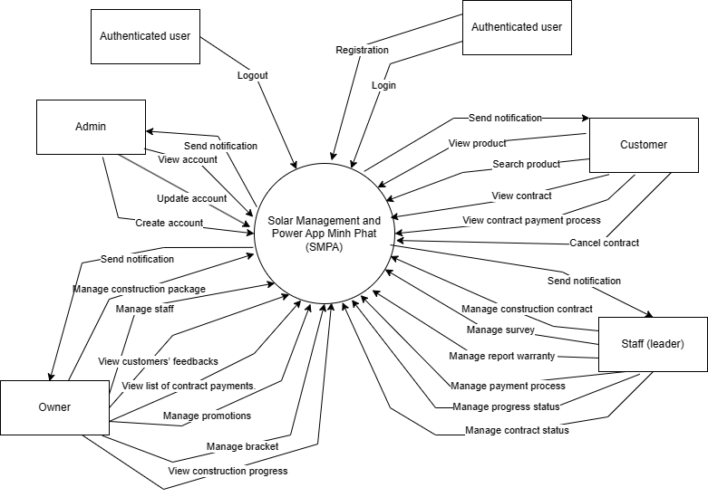

## 2. User Requirements

### 2.1 Actors

| **#** | **Actor** | **Description** |
| --- | --- | --- |
| 1 | Admin | Manage system: set up application’s environment and manage accounts. |
| 2 | Owner | A person who manages product packages, promotions and brackets. He can also confirm and reject contracts. |
| 3 | Staff | A person who manages contracts, surveys, and acceptances. He can also view construction packages and chat with customers. |
| 4 | Customer | A person who uses mobile to search and buy product packages. He can also chat with staff if needed. |
| 5 | Unauthenticated Users | A person who has no account. |
| 6 | Authenticated Users | A person who registered an account into the system. |

### 2.2 Use Cases

#### 2.2.1 Diagram(s)

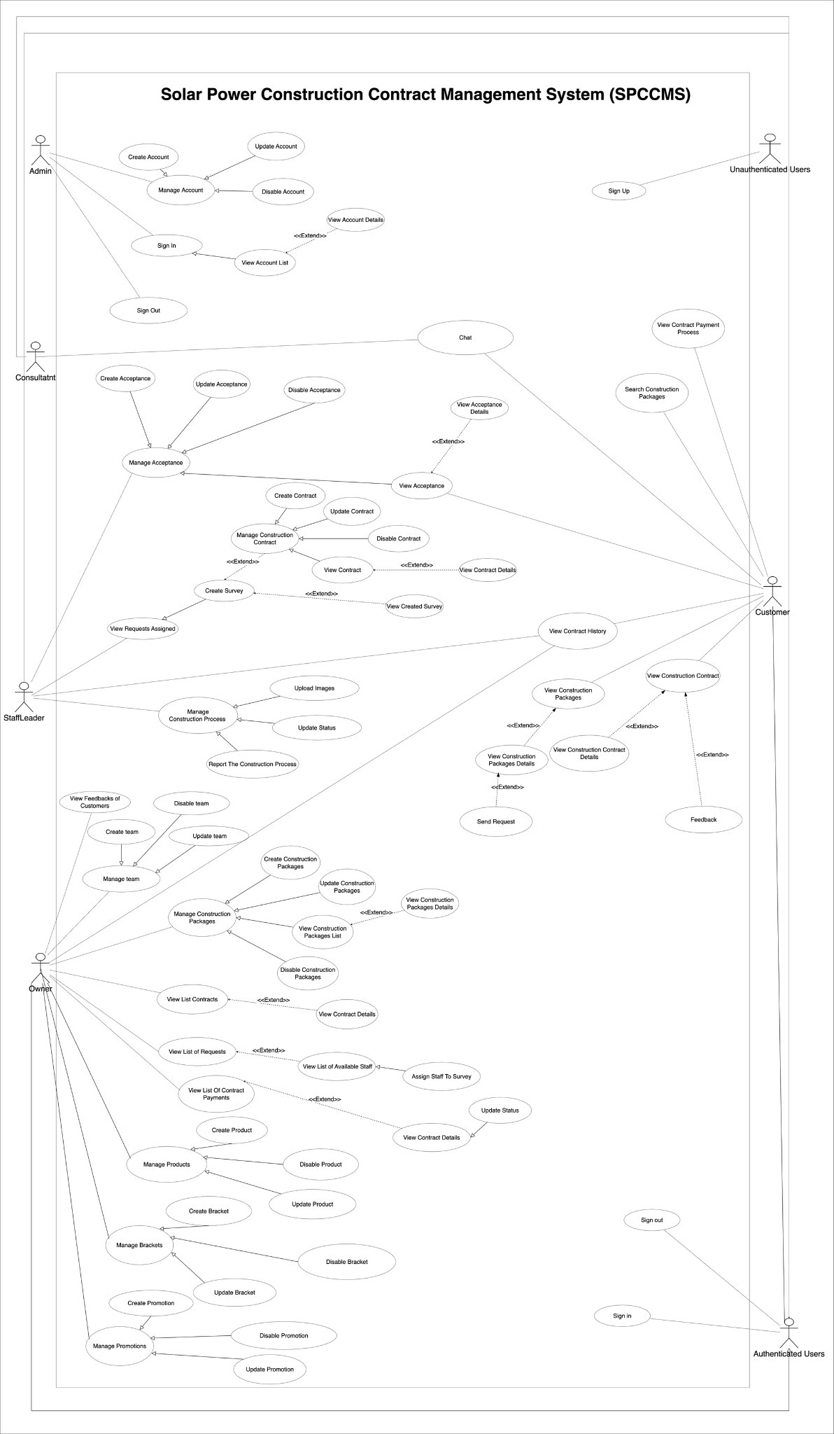

#### 2.2.2 Descriptions

| **ID** | **Use Case** | **Actors** | **Use Case Description** |
| --- | --- | --- | --- |
| 01 | Sign up | Unauthenticated User | Unauthenticated Users sign up to the SPCCMS |
| 02 | Sign in/ Sign out | Authenticated User | Authenticated Users sign in to the SPCCMS |
| 03 | View profile | Authenticated User | This feature allows all users view their profile |
| 04 | Update profile | Authenticated User | This feature allows all users update their profile |
| 05 | Change password | Authenticated User | This feature allows all users change their password |
| 06 | Create Account | Admin | This feature allows the admin to create an account |
| 07 | Update Account | Admin | This feature allows the admin to update an account |
| 08 | View Account List | Admin | This feature allows the admin to view a list of accounts |
| 09 | View Account Detail | Admin | This features allows the admin to view detail of account |
| 10 | Disable Account | Admin | This features allows the admin to disable an account |
| 11 | Create Construction Packages | Owner | This feature allows the owner to create construction package |
| 12 | Update Construction Package | Owner | This feature allows the owner to update construction package |
| 13 | View Construction Package List | Owner | This feature allows the owner to view a list of construction packages |
| 14 | View Construction Package Detail | Owner | This feature allows the owner to view detail of a construction package |
| 15 | Disable Construction Package | Owner | This feature allows owner to disable a construction package |
| 16 | View List Acceptances | Owner | This feature allows the owner to view a list of acceptances. |
| 17 | View List Contracts | Owner | This feature allows the owner to view a list of contracts. |
| 18 | View Contract Detail | Owner | This feature allows the owner to view contract detail |
| 19 | Decline Contract | Owner | This feature allows the owner to decline contract |
| 20 | Accept Contract | Owner | This feature allows the owner to accept contract |
| 21 | View List of Staffs | Owner | This feature allows the owner to view a list of staff |
| 22 | View Staff Detail | Owner | This feature allows the owner to view staff detail |
| 23 | Assign Staff To Survey | Owner | This feature allows the owner to assign staff to survey |
| 24 | View List of Contract Payments | Owner | This feature allows the owner to view a list of contract payments |
| 25 | View Contract Details | Owner | This feature allows the owner to view contract detail |
| 26 | Update Contract Status | Owner | This feature owner to update contract status |
| 27 | View Contract History | Owner, Staff, Customer | This feature allows the owner, staff and customer to view contract history |
| 28 | Create Acceptance | Staff | This feature allows the staff to create an acceptance |
| 29 | Update Acceptance | Staff | This feature allows the staff to update an acceptance |
| 30 | Disable Acceptance | Staff | This feature allows the staff to disable an acceptance |
| 31 | View Acceptance | Staff, Customer | This feature allows the staff and customer to view the acceptance |
| 32 | Create Contract | Staff | This feature allows the staff to create a construction contract |
| 33 | Update Contract | Staff | This feature allows the staff to update a construction contract |
| 34 | Disable Contract | Staff | This feature allows the staff to disable a construction contract |
| 35 | View Contract | Staff | This feature allows the staff to view a construction contract. |
| 36 | View Construction Packages | Staff, Customer | This feature allows the staff and customer to view available construction packages |
| 37 | Report the Construction Process | Staff | This feature allows the staff to report the construction process. |
| 38 | Upload images | Staff | This feature allows the staff to upload images of the construction |
| 39 | Update status | Staff | This feature allows the staff to update the construction’s status |
| 40 | View Contract Payment Process | Customer | This feature allows the customer to track the construction’s payment process |
| 41 | Search Construction Packages | Customer | This feature allows the customer to search construction packages |
| 42 | View Construction Contract | Customer | This feature allows the customer to view the construction contract |

## 3. Functional Requirements

### 3.1 System Functional Overview

#### 3.1.1 Screens Flow

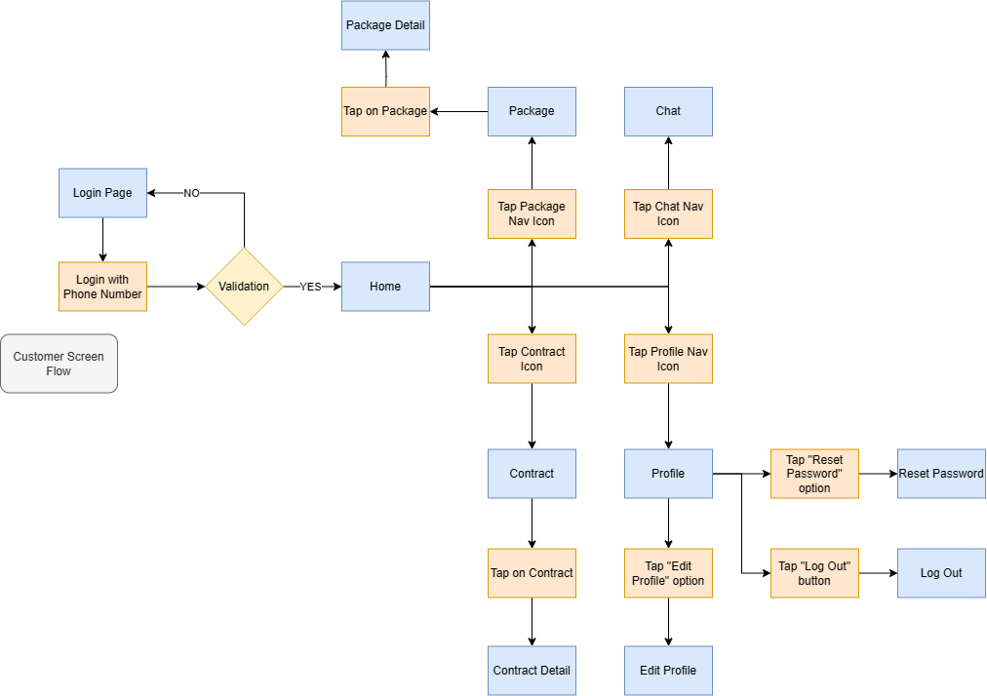

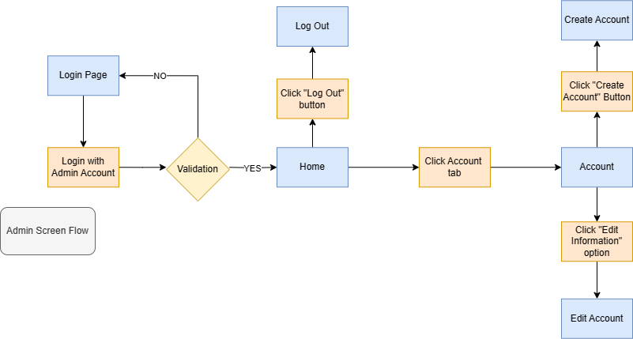

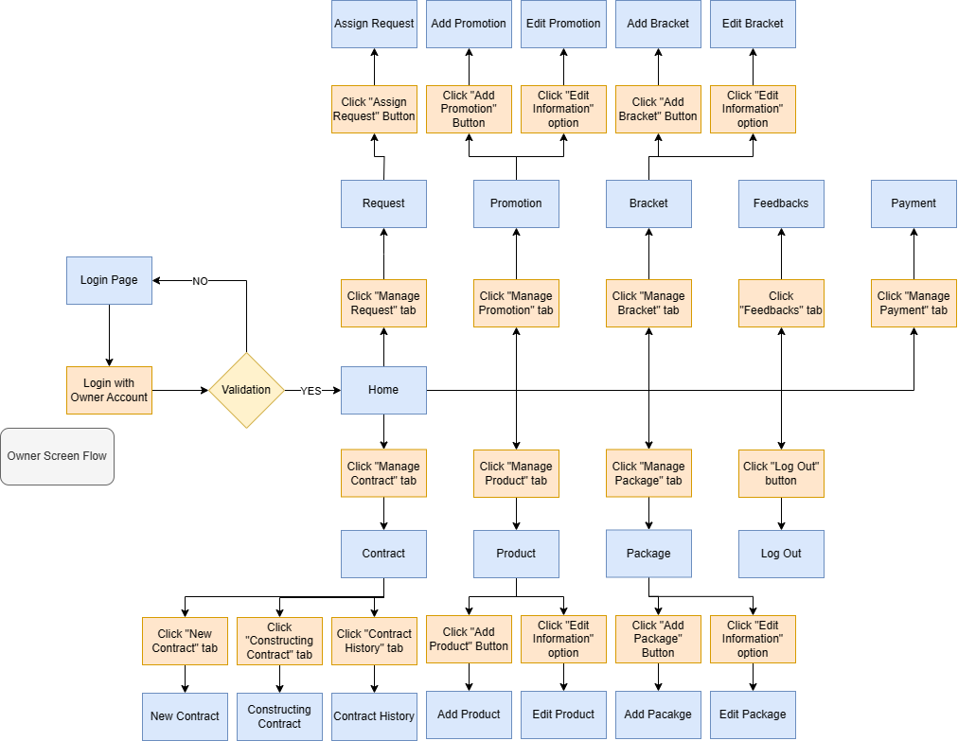

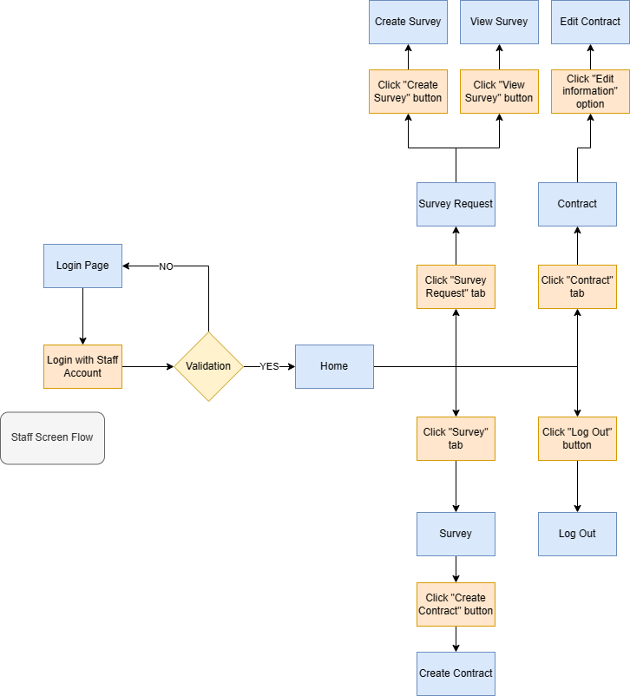

#### 3.1.2 Screen Descriptions

**Login Page**: This is where users log in, by entering the phone number and password for Customer or by entering the username and password for Admin, Owner, and Staff accounts.

**Logout**: This is where customers, admin, owner, and staff log out.

1. **Customer**

* Home: This is where customer can view the homepage and best sale package.
* Package: Customer can view and search for packages.
* Package detail: Customer can view package details.
* Contract: Customer can view the contract list.
* Contract details: Customer can view contract details.
* Chat: Customer can chat with the consultant.
* Profile: Customer can edit profile or reset password.
* Edit Profile: Customer can edit profile details.
* Reset password: Customer can reset password.

1. **Admin**

* Home: This is where the admin can interact with the system.
* Account: Admin can view the account list.
* Create an account: Admin can create accounts.
* Edit account: Admin can edit account details.

1. **Owner**

* Home: This is where the owner can interact with the system.
* Request: The owner can view available staff to assign requests
* Assign Request: The owner can view request lists to assign.
* Promotion: The owner can view the promotion list.
* Add promotion: The owner can add promotions.
* Edit promotion: The owner can edit promotion details.
* Product: The owner can view the product list.
* Add product: The owner can add products.
* Edit product: The owner can edit product details.
* Bracket: The owner can view the bracket list.
* Add bracket: The owner can add brackets.
* Edit bracket: The owner can edit bracket details.
* Package: The owner can view the package list.
* Add package: The owner can add packages.
* Edit package: The owner can edit package details.
* Contract: The owner can view contract list.
* New contract: The owner can view the new contract list.
* Constructing contract: The owner can view the construction contract list.
* Contract history: The owner can view the contract history list.
* Feedback: Owner can view the feedback list.
* Payment: The owner can manage payment.

1. **Staff**

* Home: This is where staff can interact with the system.
* Survey request: Staff can view the assigned request list waiting for the survey.
* Create survey: Staff can create surveys.
* View survey: Staff can view and edit survey details.
* Survey: Staff can view the survey list.
* Create contract: Staff can create contracts from surveys.
* Contract: Staff can view the contract list.
* Edit contract: Staff can edit contract details, update the process, and upload acceptance.

#### 3.1.3 Entity Relationship Diagram

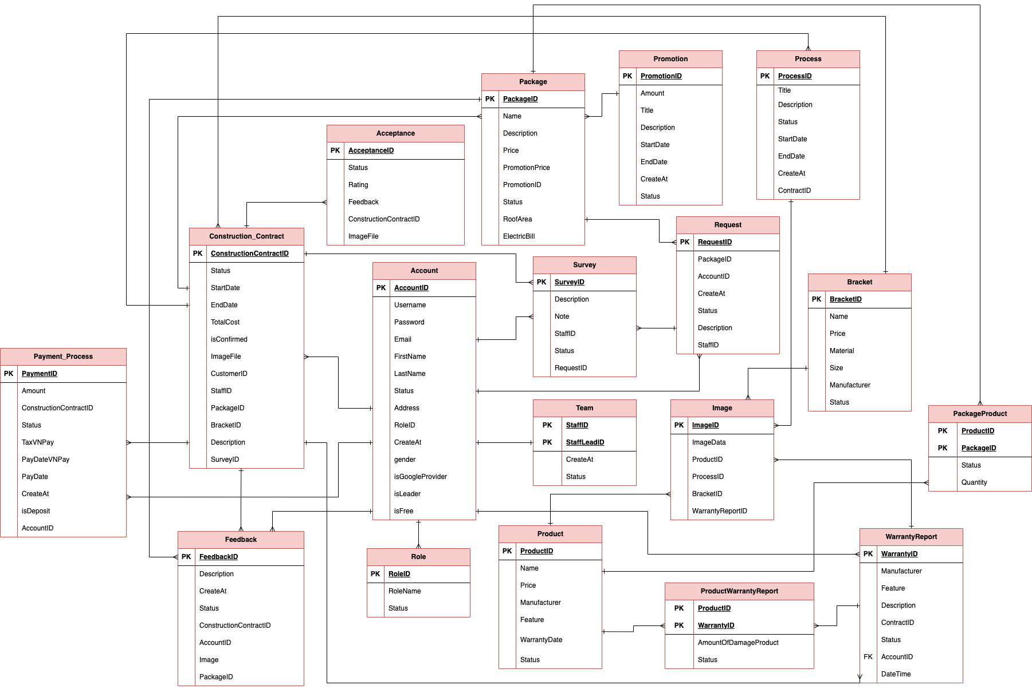

### 3.2 Web application for Admin

#### 3.2.1 <Admin> Login

Function trigger: The user requests to log into the SMPA system

Function description: This function allows the admin to log into the system

Screen layout:

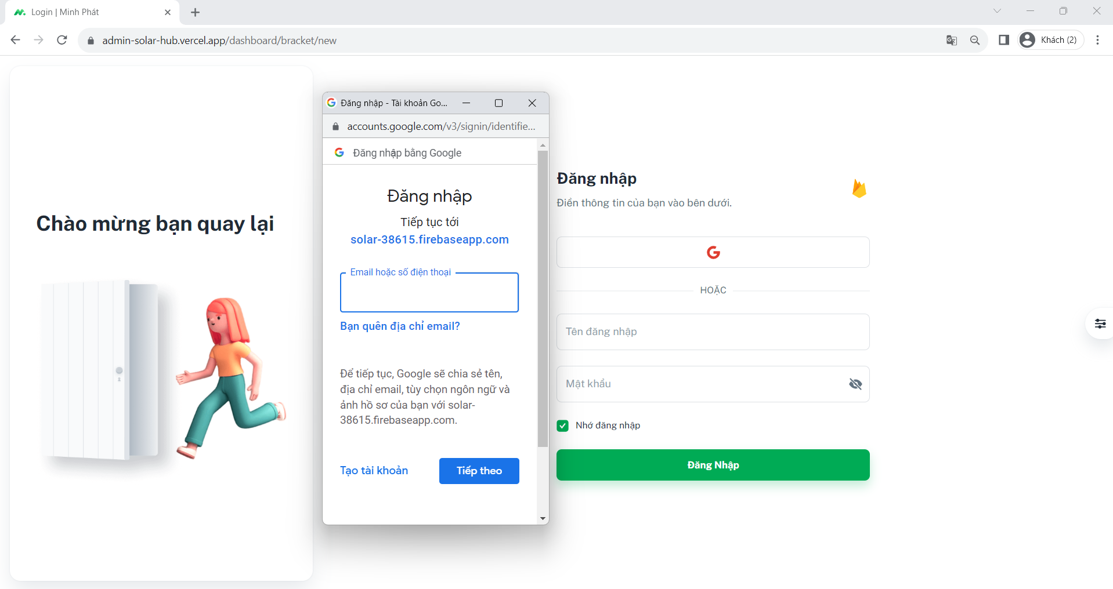

Function details:

* The user enters their “Tên đăng nhập” and “Mật khẩu” or using the Google account to log in.
* Then the user clicks on “Đăng nhập” button.
* The system verifies these input values and then returns the user a token and account.
* The actor receives a token and saves the token to check if the token has a role as an admin.
* The system will redirect to the corresponding screen with the role admin:
  + **Success**: Redirects to the dashboard screen.
  + **Fail**: Returns an error message “Có lỗi xảy ra, vui lòng thử lại!”.

#### 3.2.2 <Admin>Get List Account

Function trigger: The admin requests to view the list of accounts

Function description: This function allows the admin to view the list of the accounts in the system

Screen layout:

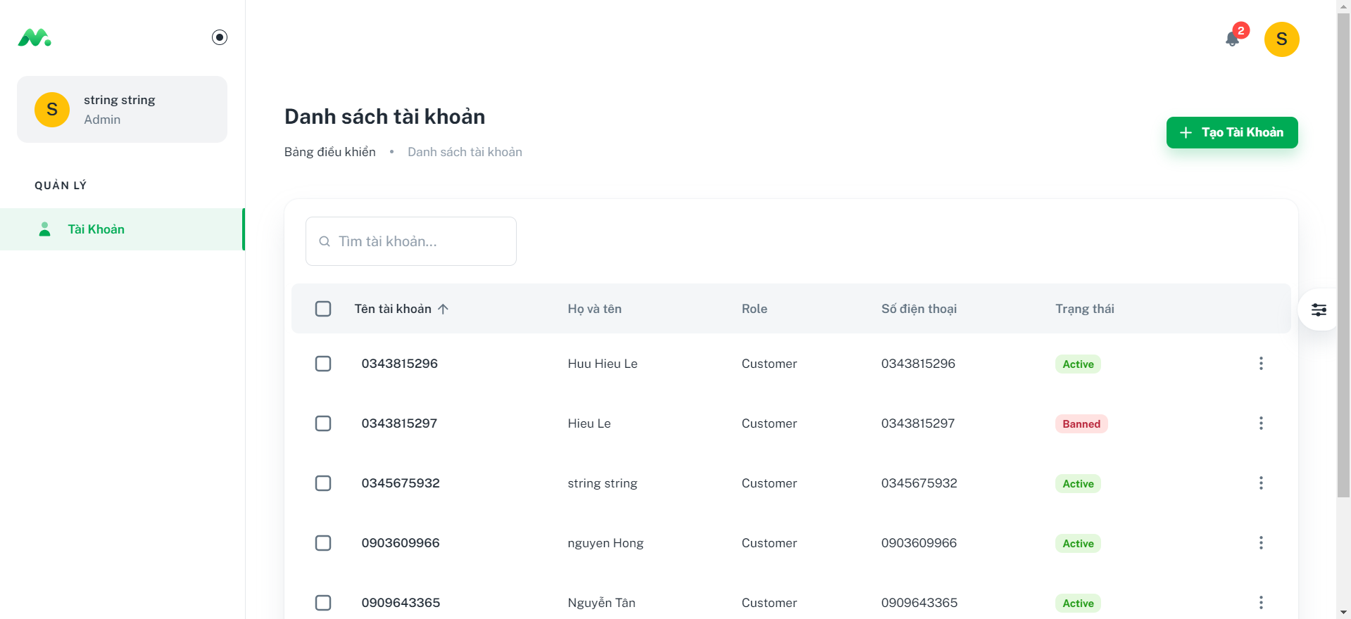

Function details:

* The admin clicks on the “Tài khoản” tab in the dashboard.
* The system shows a list of accounts in the system.

#### 3.2.3 <Admin> Create new account

Function trigger: The admin request to create a new account

Function description: This function allows the admin to create a new account

Screen layout:

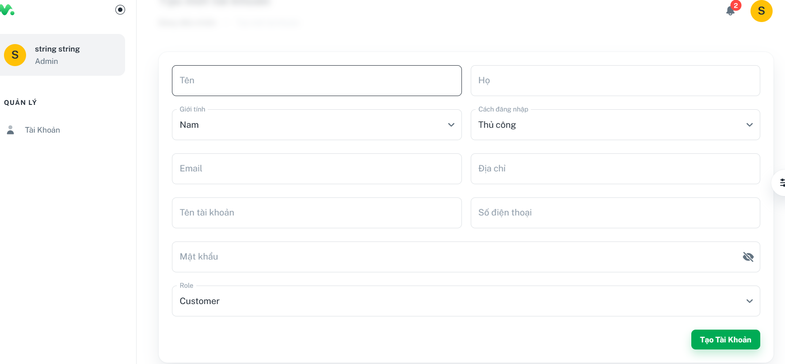

Function details:

* The admin clicks on the “Tạo Tài Khoản” button in the tab “Tài khoản”.
* The admin fills in all the required information fields such as First name and name, gender, email, address, username, and phone and sets the “Role” for the account.
* The admin clicks the “Tạo Tài Khoản” button.
* The system will appear notification on the screen:
  + **Success**: Returns an error message “Tạo tài khoản thành công”.
  + **Fail**: Returns an error message “Có lỗi xảy ra, vui lòng thử lại!”.

#### 3.2.4 <Admin> Update account

Function trigger: The admin requests to update an account

Function description: This function allows the admin to update information of an existing account

Screen layout:

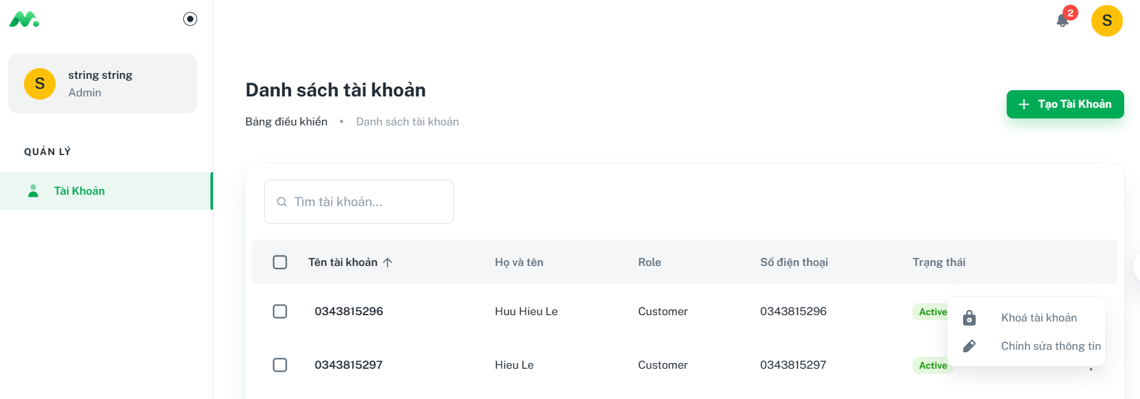

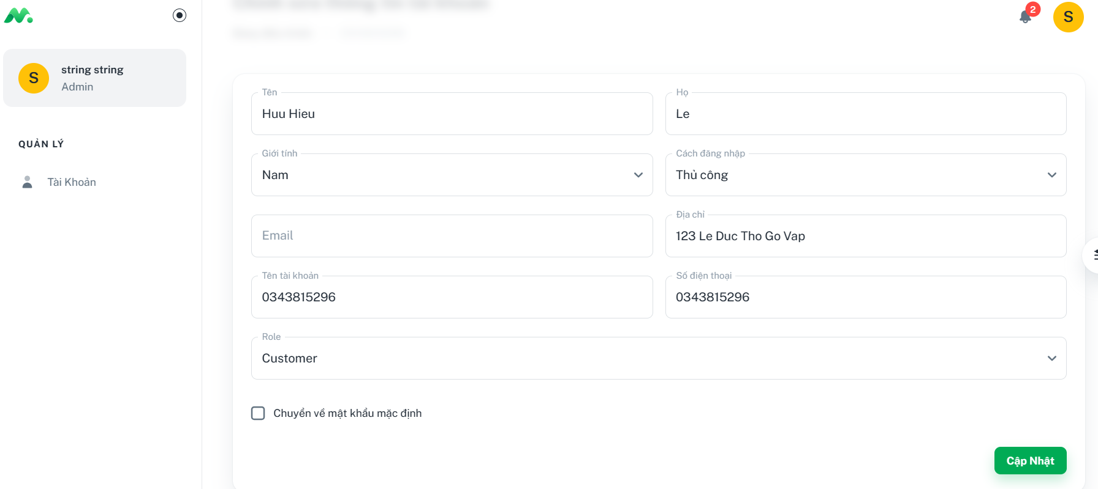

Function details:

* The admin clicks on the “ ⋮ “ button on the right of an account
* The admin clicks on the “Chỉnh sửa thông tin” on the pop-up menu
* The admin edit the information fields such as First name and name, gender, email, address, email, login method, username, phone and set the “Role” for the account.
* The admin clicks the “Cập nhật” button.
* The system will appear notification on the screen:
  + Success: Returns an error message “Cập nhật thành công”.
  + Fail: Returns an error message “Có lỗi xảy ra, vui lòng thử lại!”.

#### 3.2.5 <Admin> Disable account

Function trigger: The admin requests to disable an existing account

Function description: This function allows the admin to disable an existing account in the system

Screen layout:



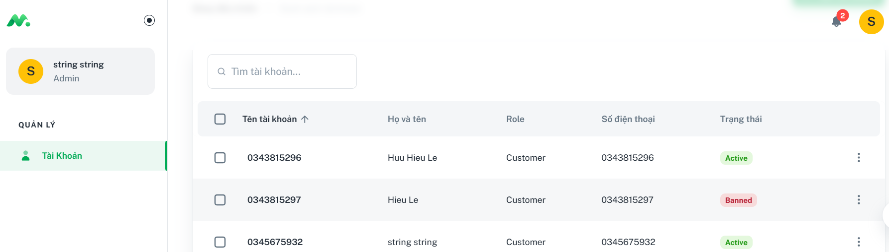

Function details:

* The admin clicks the “Tài khoản” tab on the left menu on the screen
* The admin clicks on the "⋮" icon on the right side of the account that the admin wants to disable.
* The admin clicks “Khóa tài khoản” on the pop-up menu.
* The status “Trạng thái” of that account changes to “Banned”

### 3.3 Web application for Owner

#### 3.3.1 <Owner> Login

Function trigger: The user requests to log into the SMPA system

Function description: This function allows the owner to log into the system

Screen layout:



Function details:

* The user enters “Tên đăng nhập” and “Mật khẩu” or uses the Google account to log in.
* Then the user clicks on “Đăng nhập” button.
* The system verifies these input values and then returns the user a token and account.
* The actor receives a token and saves the token to check if the token has a role as an owner.
* The system will redirect to the corresponding screen with the role owner:
  + **Success**: Redirects to the dashboard screen.
  + **Fail**: Returns an error message “Tài khoản hoặc mật khẩu không chính xác”.

#### 3.3.2 <Owner> Get combo list

Function trigger: The owner requests to view the list of combos

Function description: This function allows the owner to view the list of the combos in the system

Screen layout:

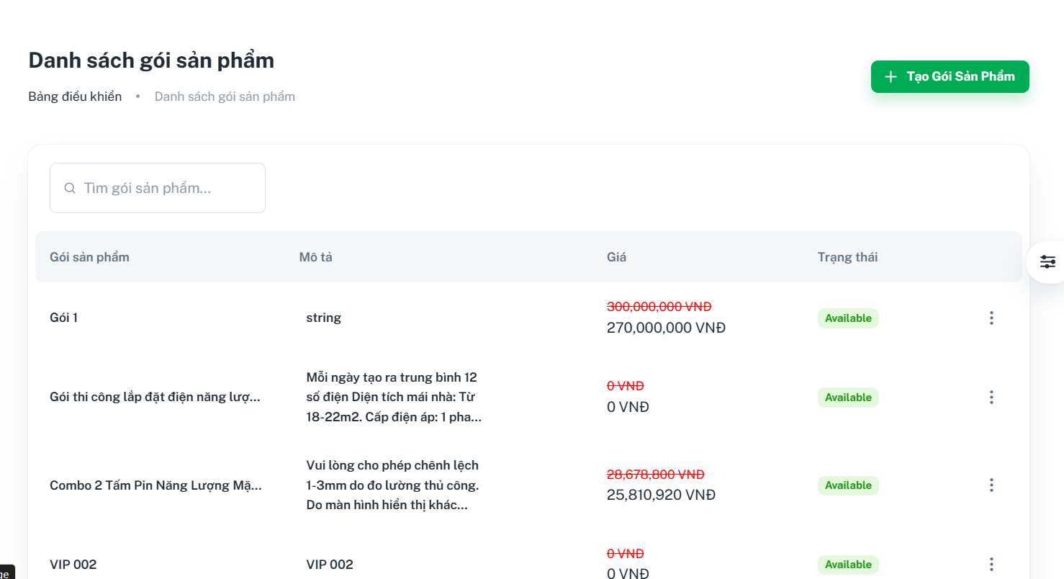

Function details:

* The owner clicks “Quản lý Gói” tab on the left menu.
* The system shows a list of combos in the system.

#### 3.3.3 <Owner> Create new combo

Function trigger: The owner requests to create a new combo

Function description: This function allows the owner to create a new combo in the system

Screen layout:

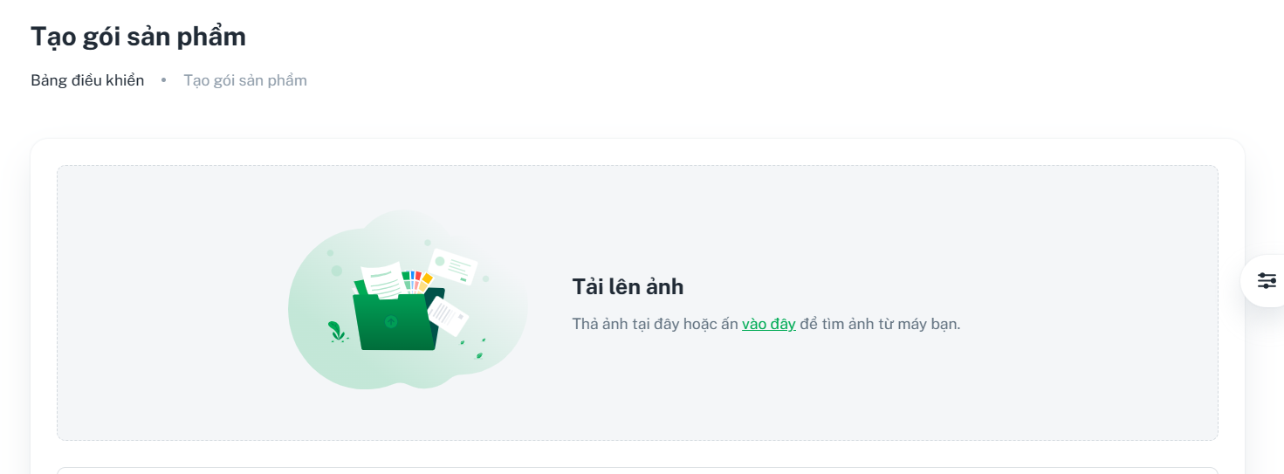

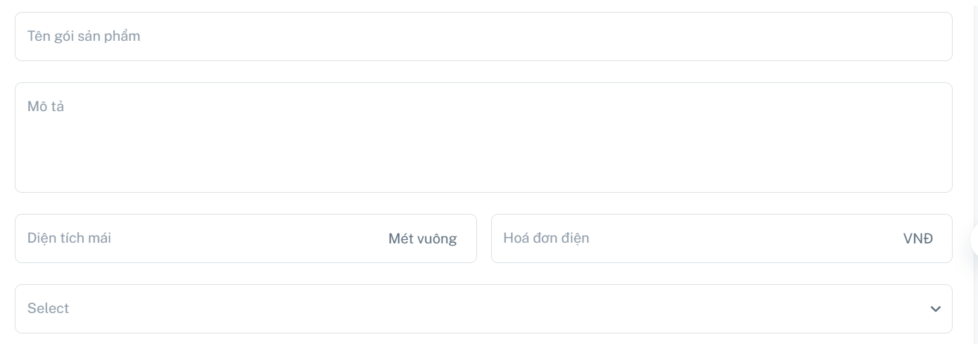

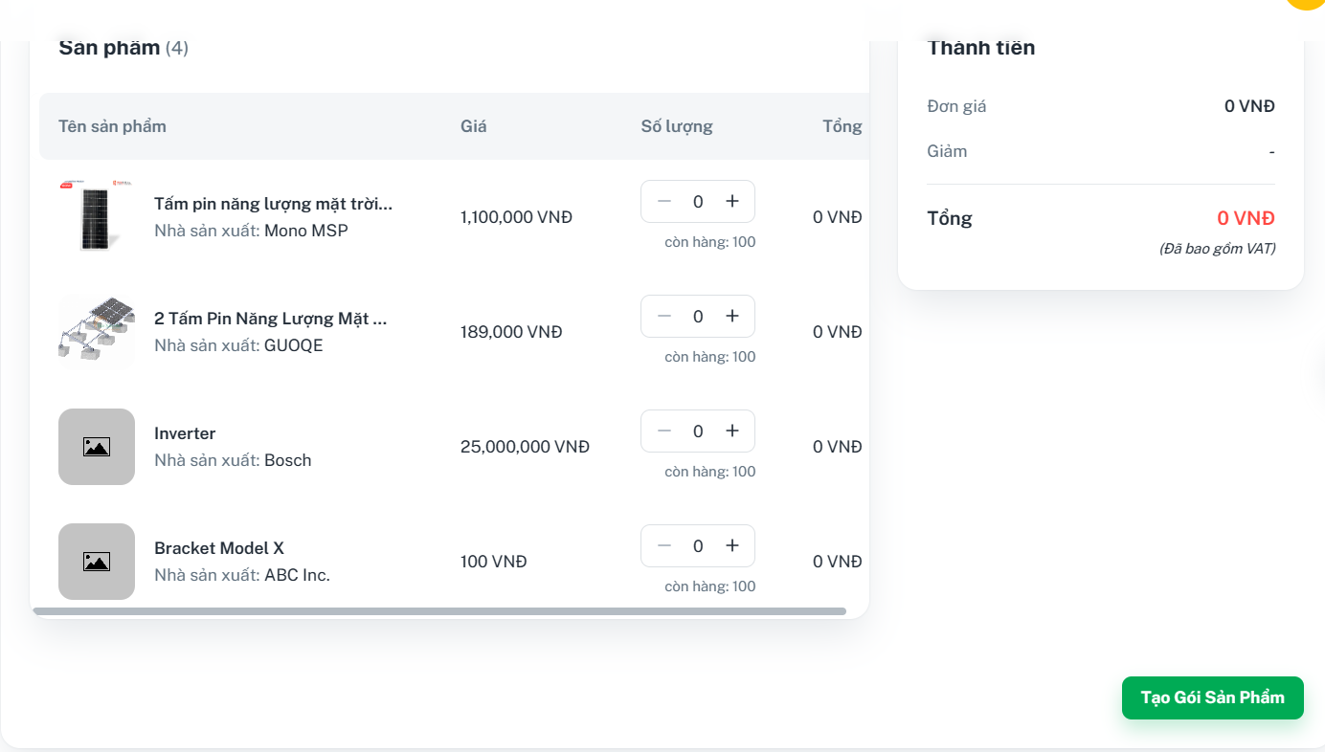

Function details:

* The owner clicks the “Quản lý Gói” tab on the left menu.
* The owner clicks the “Tạo gói sản phẩm” button in the “Quản lý combo” page.
* The owner fills in the required information fields such as Combo Name, Description, Roof Area, Electric Bill, and Promotion, and choose the Product quantity
* Then, when the owner clicks on the “Tạo gói sản phẩm” button, the system will notify on the screen:
  + **Success:** Returns a message “Tạo gói sản phẩm thành công”.
  + **Fail:** Returns an error message”Có lỗi xảy ra, vui lòng thử lại!”.

#### 3.3.4 <Owner> Enable/Disable combo

Function trigger: The owner requests to enable/disable a combo

Function description: This function allows the owner to enable/disable a combo in the system

Screen layout:

Enable a disabled combo

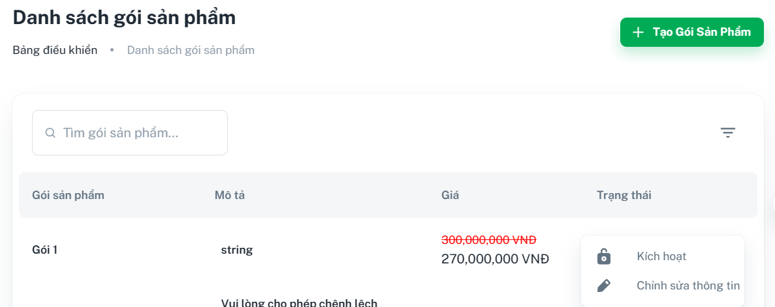

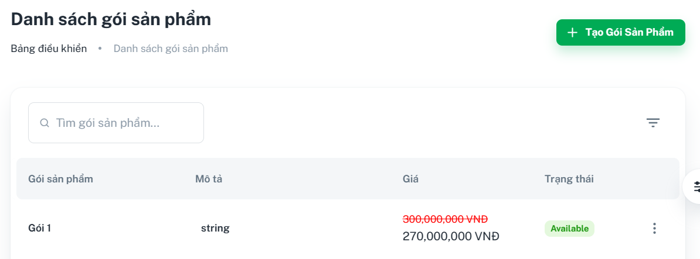

Disable an enabled combo

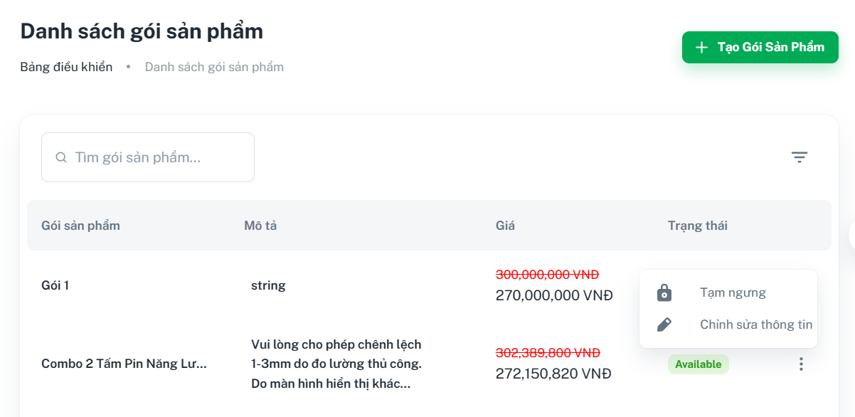

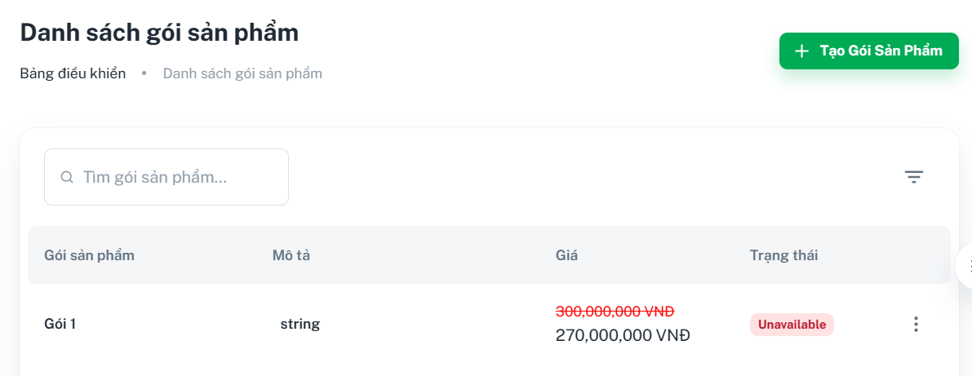

Function details:

The owner clicks tab “Quản lý combo” on the left menu

To enable a disabled combo:

* The owner clicks the button “⋮” on the right of the combo and clicks “Kích hoạt”
* The system will change that combo status from ”Unavailable” into “Available”

To disable an enabled combo:

* The owner clicks the button “⋮” on the right of the combo and clicks “Tạm ngưng”
* The system will change that combo status from ”Available” into “Unavailable”

#### 3.3.5 <Owner> Update combo

Function trigger: The admin request to update a combo

Function description: This function allows the owner to update information of an existing combo

Screen layout:

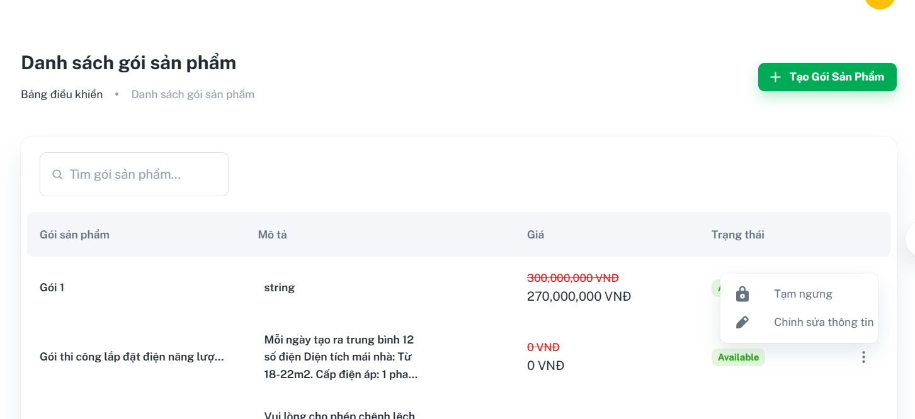

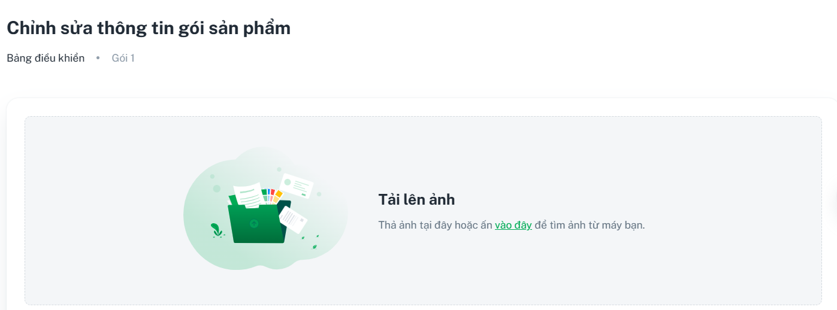

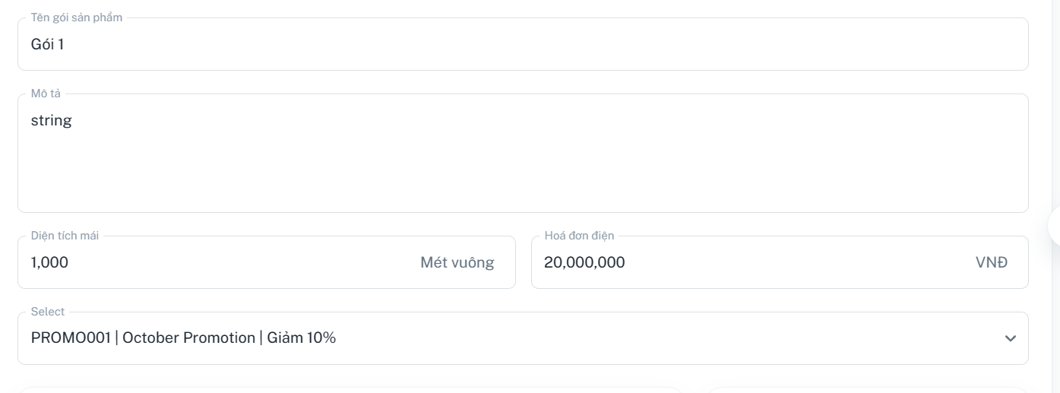

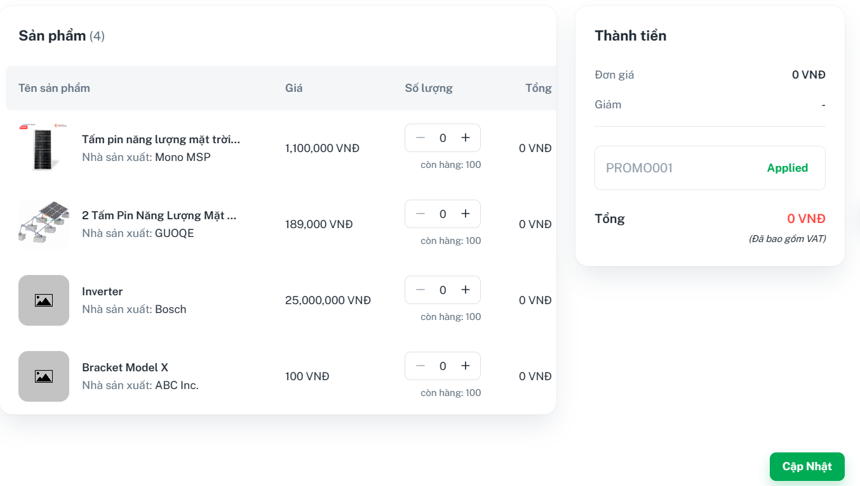

Function details:

* The owner clicks the “Quản lý Gói” tab on the left menu.
* The owner clicks the button “⋮” on the right of the combo and clicks “Chỉnh sửa thông tin”
* The owner updates the information fields such as Combo Name, Description, Roof Area, Electric Bill, Promotion, chooses the Product quantity
* Then, when the owner clicks on the “Cập nhật” button, the system will notify on the screen:
  + **Success:** Returns a message “Cập nhật gói sản phẩm thành công”.
  + **Fail:** Returns an error message”Có lỗi xảy ra, vui lòng thử lại!”.

#### 3.3.6 <Owner> Get request list

Function trigger: The owner requests to view the list of requests

Function description: This function allows the owner to view the list of the requests in the system

Screen layout: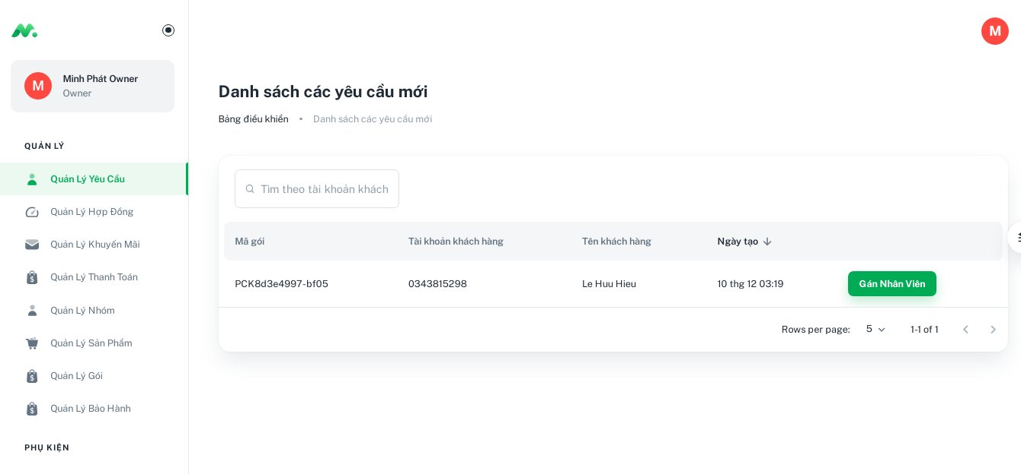

Function details:

The owner clicks on the “ Quản lý yêu cầu” tab on the left menu

The system shows a list of requests in the system.

#### 3.3.7 <Owner> Assign request to staff

Function trigger: The admin request to assign a request to the staff leader

Function description: This function allows the owner to assign a request to the staff leader

Screen layout:



Function details:

* The owner clicks the “Quản lý Yêu Cầu” tab on the left menu.
* The owner chooses the available staff to be assigned and clicks the “Gán nhân viên” button
* The owner chooses the request for staff in the request list
* Then, the staff leader’s status will be updated.

#### 3.3.8 <Owner> Get promotion list

Function trigger: The owner requests to view the list of promotions

Function description: This function allows the owner to view the list of promotions in the system

Screen layout:

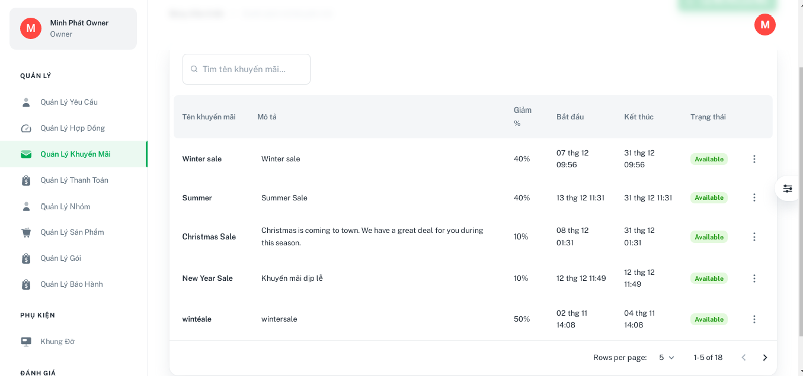

Function details:

* The owner clicks “Quản lý Khuyến Mãi” tab on the left menu.
* The system shows a list of promotions in the system.

#### 3.3.9 <Owner> Create new promo

Function trigger: The owner request to create a new promo

Function description: This function allows the owner to create a new promo in the system

Screen layout:

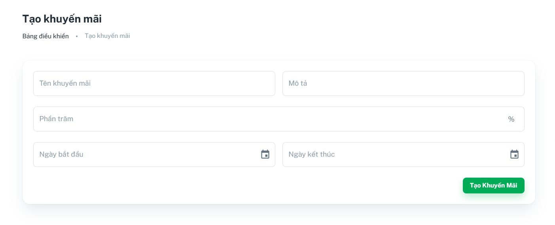

Function details:

* The owner clicks the “Quản lý Khuyến Mãi” tab on the left menu.
* The owner clicks the “Tạo Mã Khuyến Mãi” button in the “Quản lý khuyến mãi” page.
* The owner fills in the required information fields such as Promo Name, Description, Promo %, Start Date, and End Date
* Then when the owner clicks on the “Tạo khuyến mãi” button, the system will notify on the screen:
  + **Success:** Returns a message “Tạo khuyến mãi thành công”.
  + **Fail:** Returns an error message”Có lỗi xảy ra, vui lòng thử lại!”.

#### 3.3.10 <Owner> Enable/Disable promo

Function trigger: The owner requests to enable/disable a promotion

Function description: This function allows the owner to enable/disable a promotion in the system

Screen layout:

Enable a disabled promo

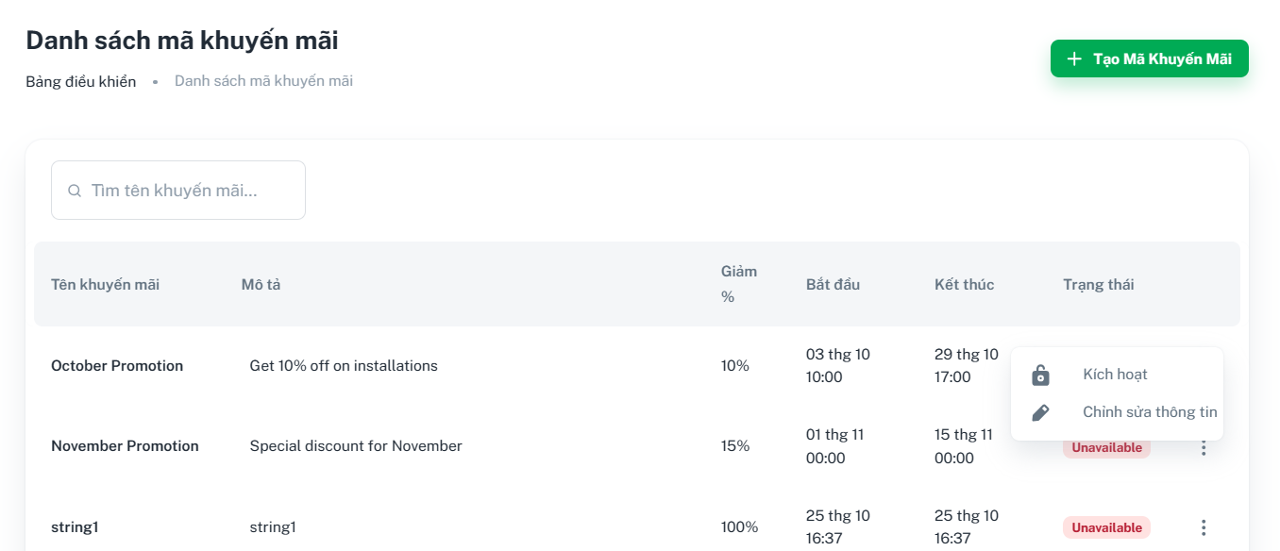

Disable an enabled promo

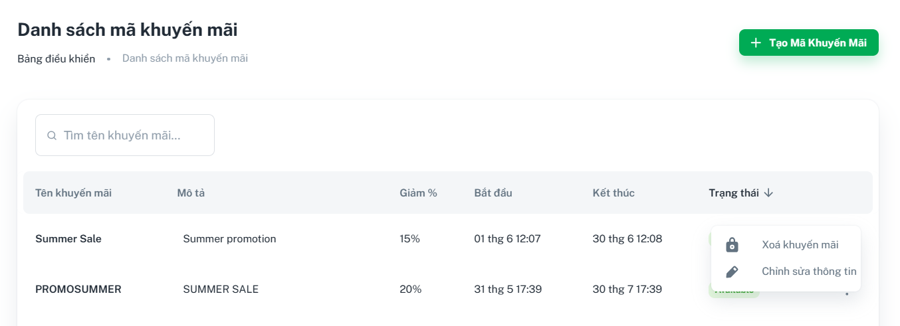

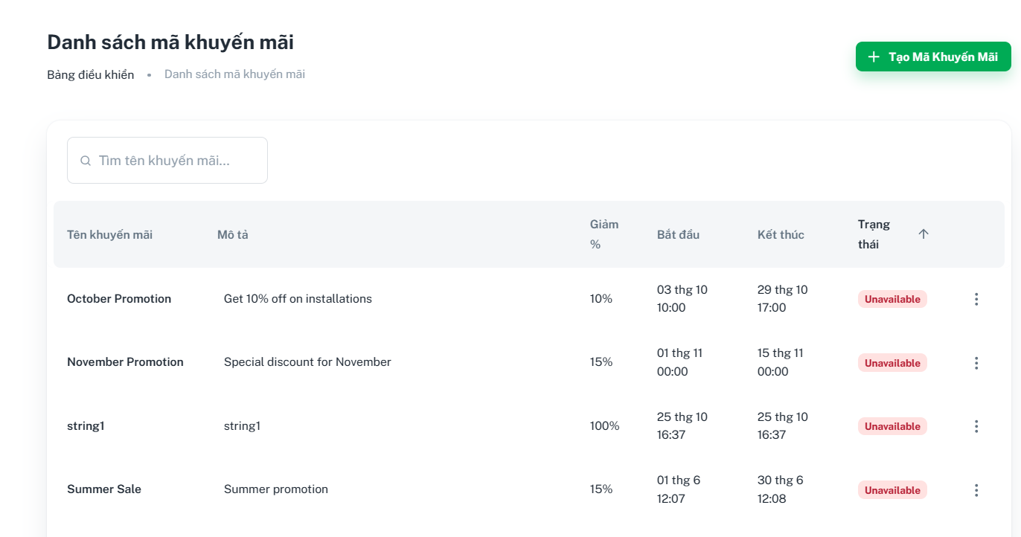

Function details:

The owner clicks tab “Quản lý Khuyến Mãi” on the left menu

To enable a disabled combo:

* The owner clicks the button “⋮” on the right of the combo and clicks “Kích hoạt”
* The system will change that combo status from ”Unavailable” into “Available”

To disable an enabled combo:

* The owner clicks the button “⋮” on the right of the combo and clicks “Xóa Khuyến Mãi”
* The system will change that combo status from ”Available” into “Unavailable”

#### 3.3.11 <Owner> Update promotion

Function trigger: The owner request to update a promo

Function description: This function allows the owner to update information of an existing promo

Screen layout:

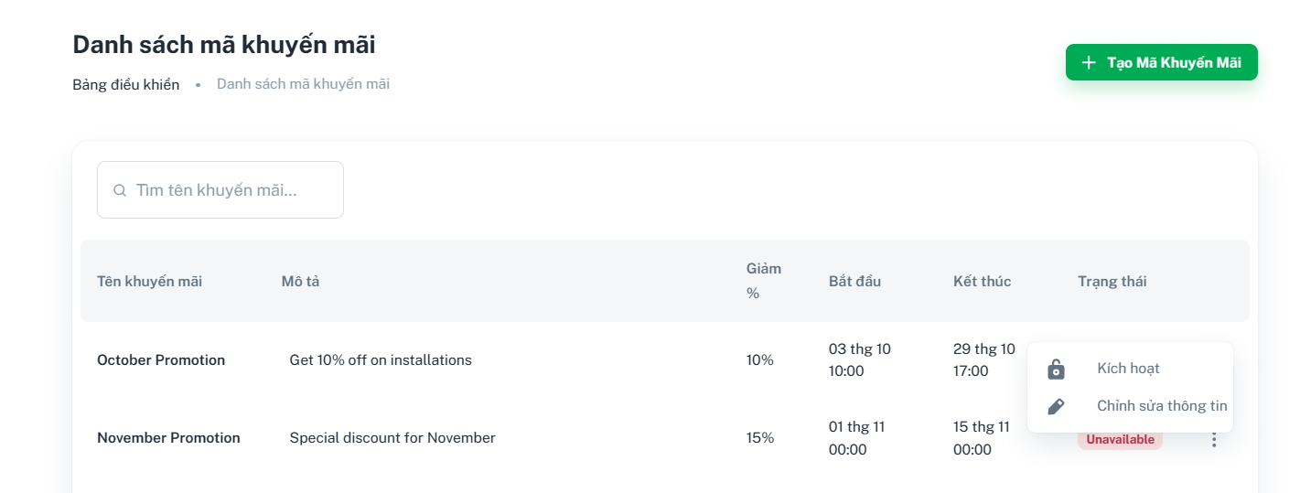

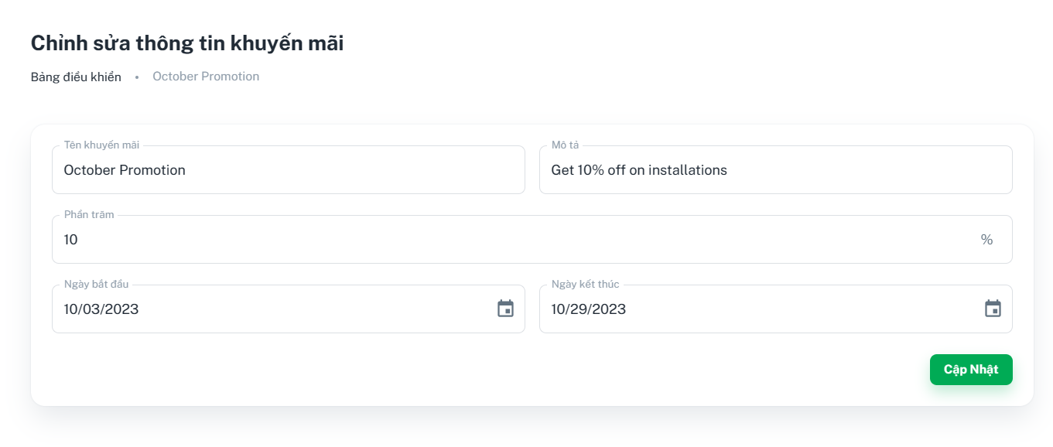

Function details:

* The owner clicks the “Quản lý Khuyến Mãi” tab on the left menu.
* The owner clicks the button “⋮” on the right of the combo and clicks “Chỉnh sửa thông tin”
* The owner update the information fields such as: Promo Name, Description, Promo %, Start Date, and End Date
* Then, when the owner clicks on the “Cập nhật” button, the system will notify on the screen:
  + **Success:** Returns an message “Cập nhật thành công”.
  + **Fail:** Returns an error message”Có lỗi xảy ra, vui lòng thử lại!”.

#### 

#### 3.3.12 <Owner> Get product list

Function trigger: The owner request to view the list of products

Function description: This function allows the owner to view the list of the products in the system

Screen layout:

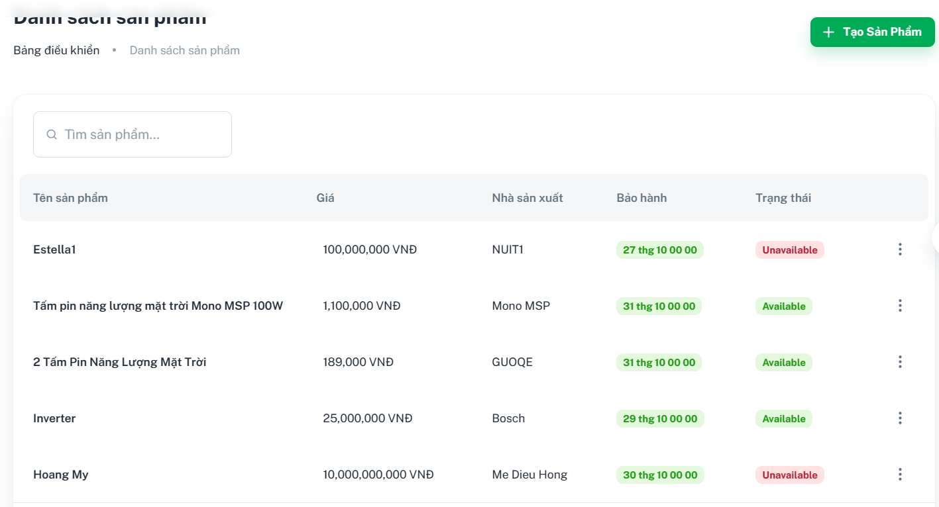

Function details:

* The owner clicks the “Quản lý sản phẩm” tab on the left menu.
* The system shows a list of combos in the system.

#### 

#### 3.3.13 <Owner> Create new product

Function trigger: The owner requests to create a new product

Function description: This function allows the owner to create a new product in the system

Screen layout:

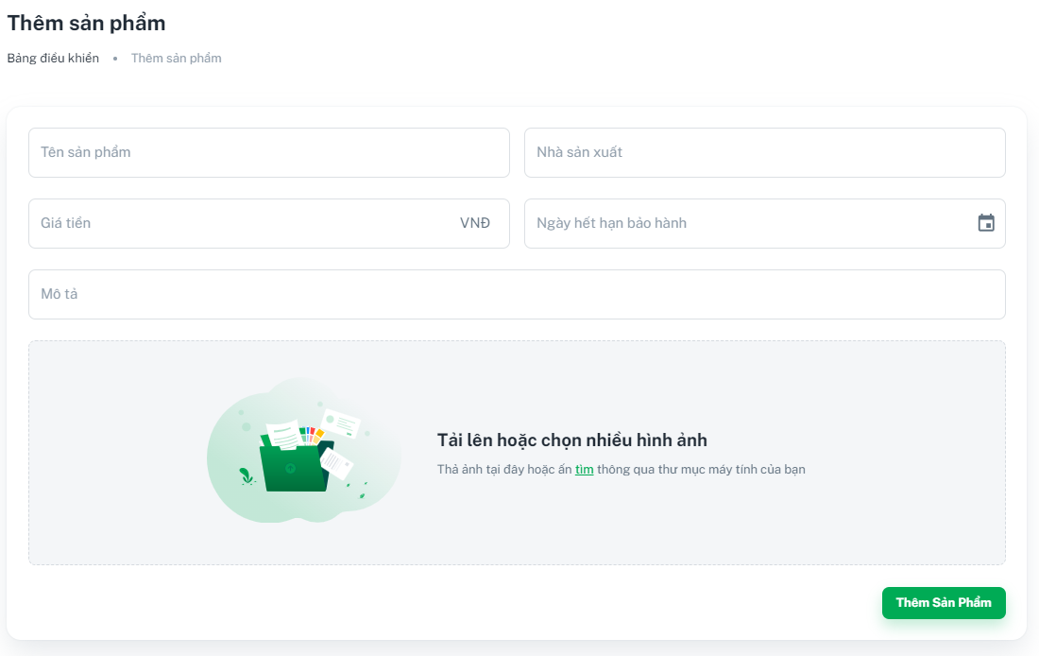

Function details:

* The owner clicks the “Quản lý Sản Phẩm” tab on the left menu.
* The owner clicks the “Tạo Sản Phẩm” button on the “Quản lý Sản Phẩm” page.
* The owner fills in the required information fields such as Product Name, Manufacturer, Price, Warranty Expiration Date, Description, and Upload Images.
* Then, when the owner clicks on the “Thêm Sản Phẩm” button, the system will notify on the screen:
  + **Success:** Returns a message “Tạo sản phẩm thành công”.
  + **Fail:** Returns an error message ”Có lỗi xảy ra, vui lòng thử lại!”.

#### 3.3.14 <Owner> Enable/Disable product

Function trigger: The owner requests to enable/disable a product

Function description: This function allows the owner to enable/disable a product in the system

Screen layout:

Enable a disabled product

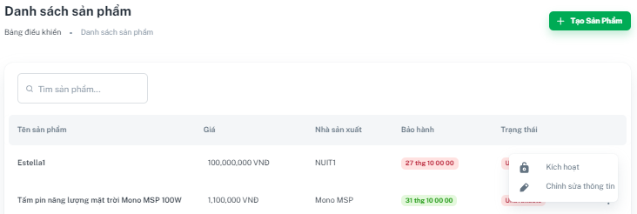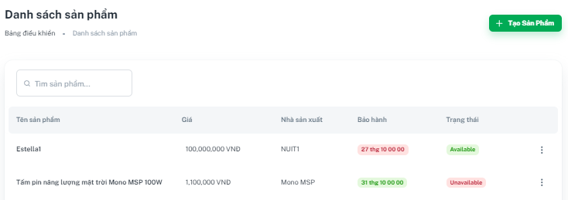

Disable an enabled product

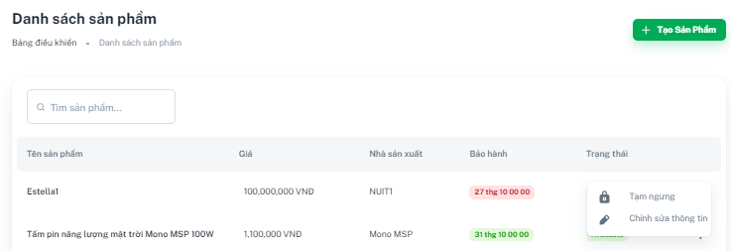

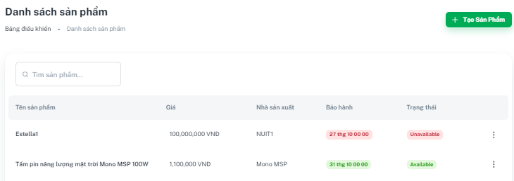

Function details:

The owner clicks tab “Quản Lý Sản Phẩm” on the left menu

To enable a disabled product:

* The owner clicks the button “⋮” on the right of the product and clicks “Kích hoạt”
* The system will change that product status from ”Unavailable” into “Available”

To disable an enabled product:

* The owner clicks the button “⋮” on the right of the product and clicks “Tạm ngưng”
* The system will change that product status from ”Available” into “Unavailable”

#### 3.3.15 <Owner> Update product

Function trigger: The owner request to update a product

Function description: This function allows the owner to update information of an existing product

Screen layout:



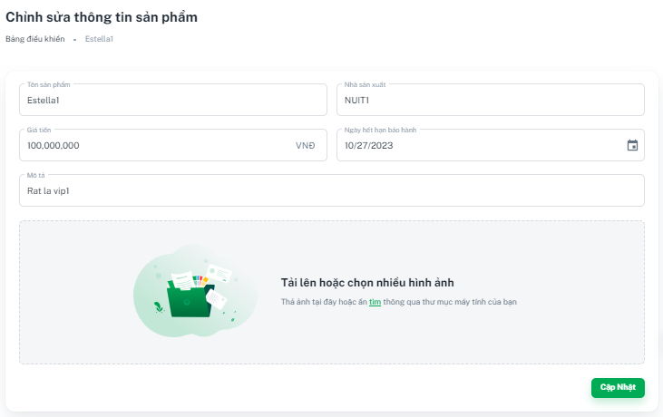

Function details:

* The owner clicks the “Quản lý Sản Phẩm” tab on the left menu.
* The owner clicks the button “⋮” on the right of the product and clicks “Chỉnh sửa thông tin”
* The owner updates the information fields such as Product Name, Manufacturer, Price, Warranty Expiration Date, Description and Uploads images.
* Then, when the owner clicks on the “Cập nhật” button, the system will notify on the screen:
  + **Success:** Returns a message “Cập nhật sản phẩm thành công”.
  + **Fail:** Returns an error message ”Có lỗi xảy ra, vui lòng thử lại!”.

#### 

#### 3.3.16 <Owner> Get bracket list

Function trigger: The owner requests to view the list of brackets

Function description: This function allows the owner to view the list of the brackets in the system

Screen layout:

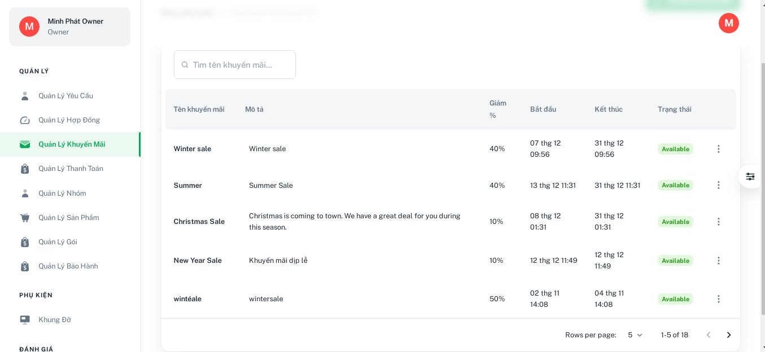

Function details:

* The owner clicks the “Khung Đỡ” tab on the left menu.
* The system shows a list of brackets in the system.

#### 

#### 3.3.17 <Owner> Create new bracket

Function trigger: The owner request to create a new bracket

Function description: This function allows the owner to create a new bracket in the system

Screen layout:

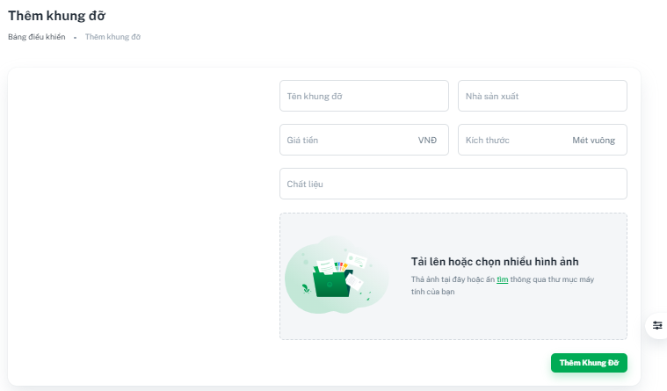

Function details:

* The owner clicks the “Khung Đỡ” tab on the left menu.
* The owner clicks the “Tạo Khung Đỡ” button on the “Khung Đỡ” page.
* The owner fills in the required information fields such as Bracket name, Manufacturer, Price, Size, Material and Upload Images.
* Then, when the owner clicks on the “Thêm Khung Đỡ” button, the system will notify on the screen:
  + **Success:** Returns a message “Tạo khung đỡ thành công”.
  + **Fail:** Returns an error message”Có lỗi xảy ra, vui lòng thử lại!”.

#### 3.3.18 <Owner> Enable/Disable bracket

Function trigger: The owner requests to enable/disable a bracket

Function description: This function allows the owner to enable/disable a bracket in the system

Screen layout:

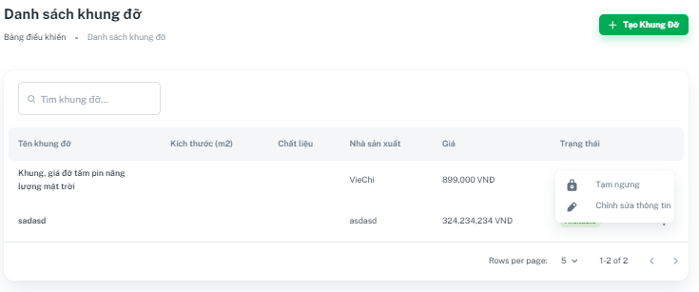

Function details:

The owner clicks tab “Khung Đỡ” on the left menu

To enable a disabled bracket:

* The owner clicks the button “⋮” on the right of the bracket and clicks “Kích hoạt”
* The system will change that bracket status from ”Unavailable” into “Available”

To disable an enabled bracket:

* The owner clicks the button “⋮” on the right of the bracket and clicks “Tạm ngưng”
* The system will change that bracket status from ”Available” into “Unavailable”

#### 3.3.19 Update bracket

Function trigger: The owner request to update a bracket

Function description: This function allows the owner to update information of an existing bracket

Screen layout:



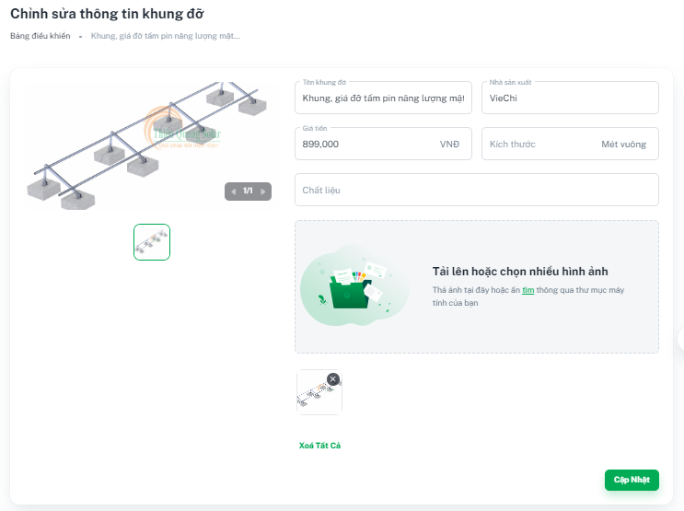

Function details:

* The owner clicks the “Khung Đỡ” tab on the left menu.
* The owner clicks the button “⋮” on the right of the bracket and clicks “Chỉnh sửa thông tin”
* The owner updates the information fields such as Bracket name, Manufacturer, Price, Size, Material and Upload Images.
* Then, when the owner clicks on the “Cập nhật” button, the system will notify on the screen:
  + **Success:** Returns a message “Cập nhật khung đỡ thành công”.
  + **Fail:** Returns an error message ”Có lỗi xảy ra, vui lòng thử lại!”.

#### 

#### 3.3.20 Get feedbacks list

Function trigger: The owner request to view the list of feedbacks

Function description: This function allows the owner to view the list of feedbacks in the system

Screen layout:

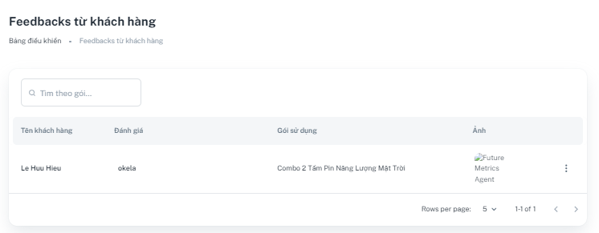

Function details:

* The owner clicks the “Feedbacks” tab on the left menu.
* The system shows a list of feedbacks in the system.

#### 

#### 3.3.17 <Owner> Disable feedback

Function trigger: The owner requests to disable a feedback

Function description: This function allows the owner to disable a feedback in the system

Screen layout:

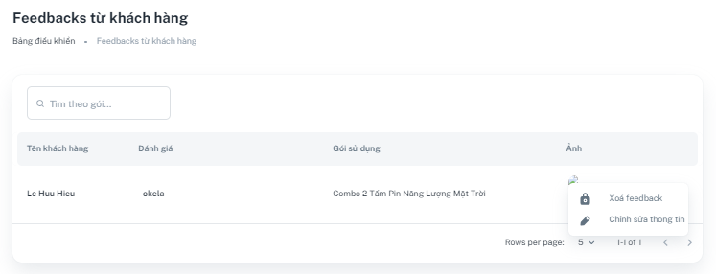

Function details:

* The owner clicks the “Feedbacks” tab on the left menu.
* The owner clicks the button “⋮” on the right of the feedback and clicks “Xóa feedback”

**3.4 Web application for Staff**

#### 3.4.1 <Staff> Login

Function trigger: The user requests to log into the SMPA system

Function description: This function allows the staff to log into the system

Screen layout:



Function details:

* The user enters “Tên đăng nhập” and “Mật khẩu” or uses the Google account to login.
* Then the user clicks on the “Đăng nhập” button.
* The system verifies these input values and then returns the user a token and account.
* The actor receives a token and saves the token to check if the token has a role as an staff.
* The system will redirect to the corresponding screen with the role staff:
  + **Success**: Redirects to the dashboard screen.
  + **Fail**: Returns an error message “Tài khoản hoặc mật khẩu không chính xác”.

#### 

#### 3.4.2 <Staff> Get surveyed lists

Function trigger: The owner request to view the list of surveyed lists

Function description: This function allows the staff to view the list of the surveyed lists in the system

Screen layout:

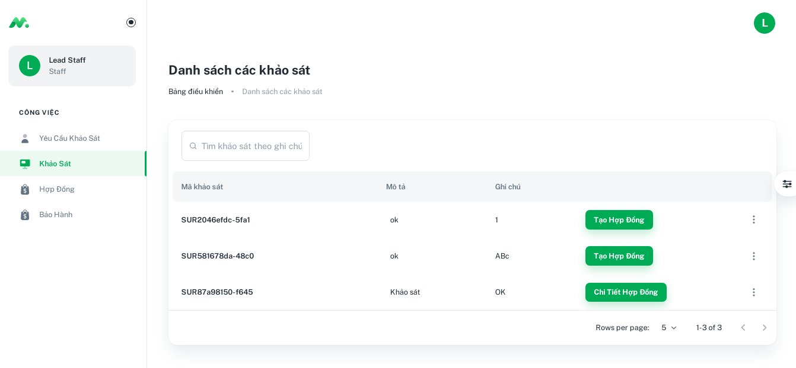

Function details:

* The staff clicks “Khảo sát” tab on the left menu.
* The system shows a list of surveyed lists in the system.

#### 3.4.3 <Staff> Get contract lists

Function trigger: The owner requests to view the list of contract lists

Function description: This function allows the staff to view the list of the contract lists in the system

Screen layout:

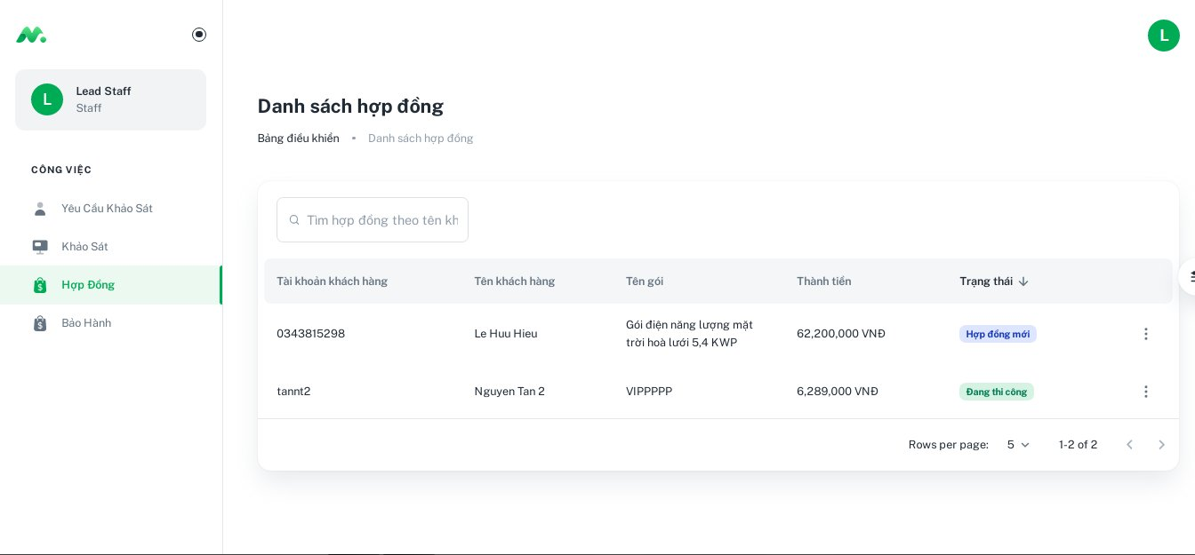

Function details:

* The staff clicks “Hợp đồng” tab on the left menu.
* The system shows a list of contract lists in the system.

#### 

#### 3.4.4 <Staff> Create contract

Function trigger: The staff request to create a new contract

Function description: This function allows the staff to create a new contract in the system

Screen layout:

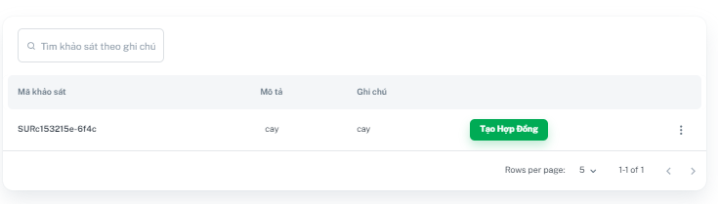

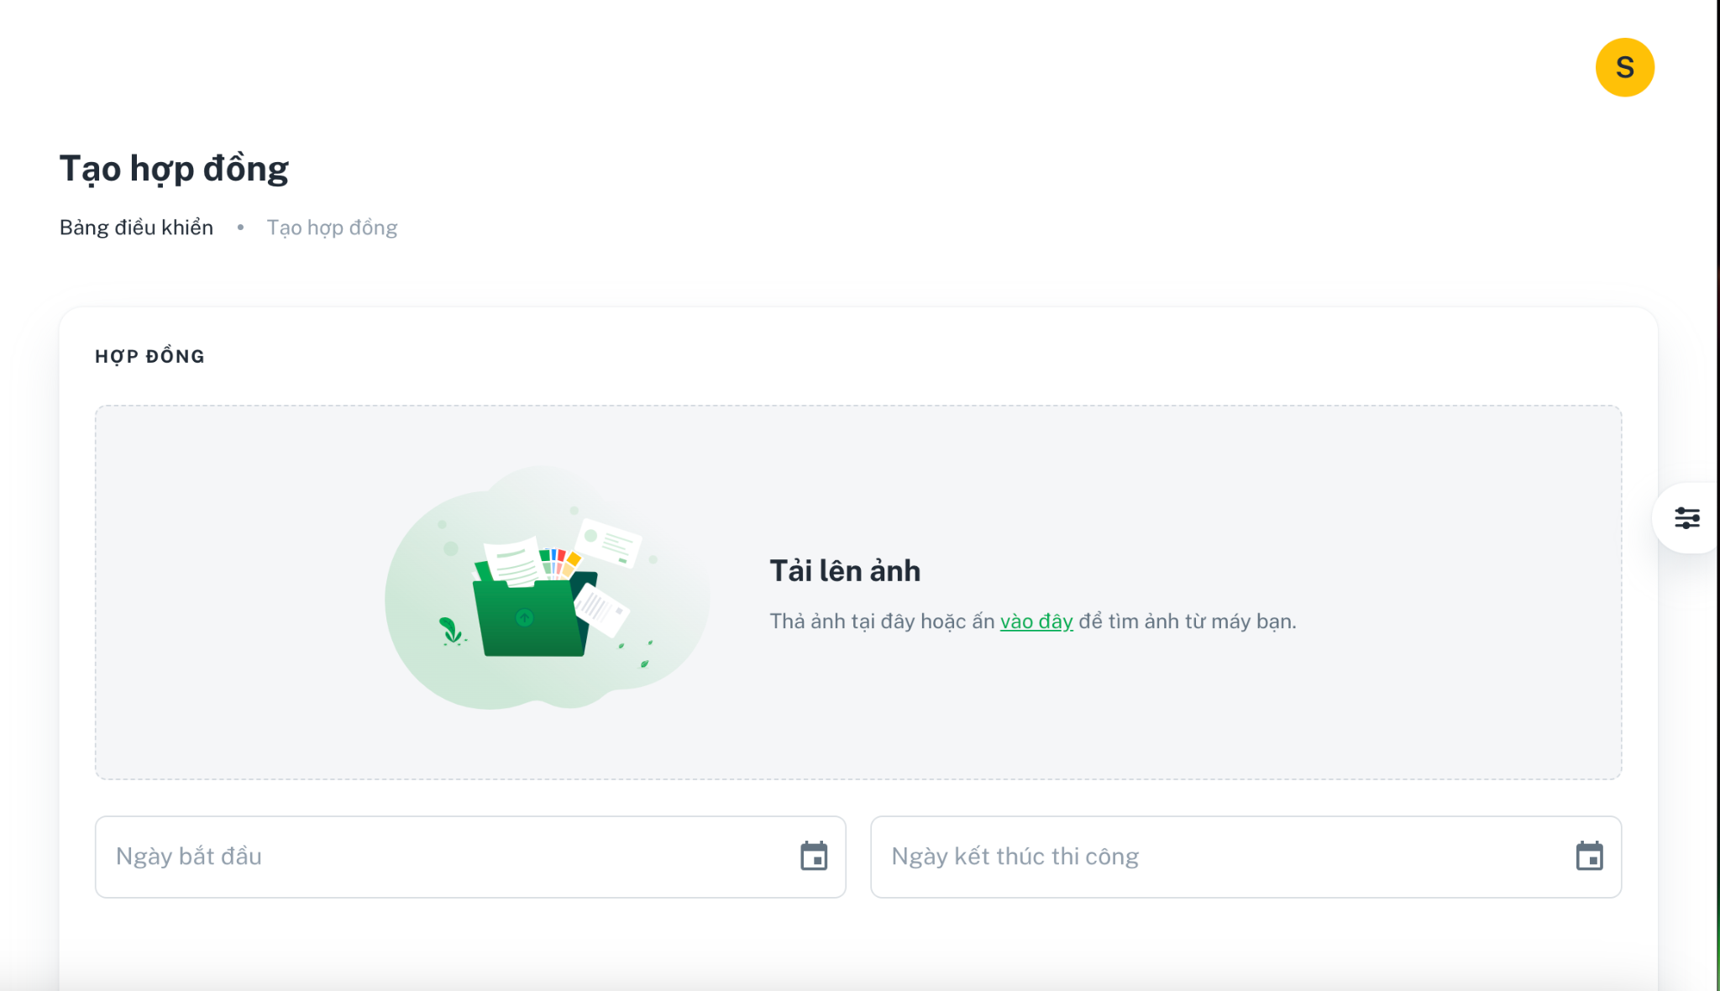

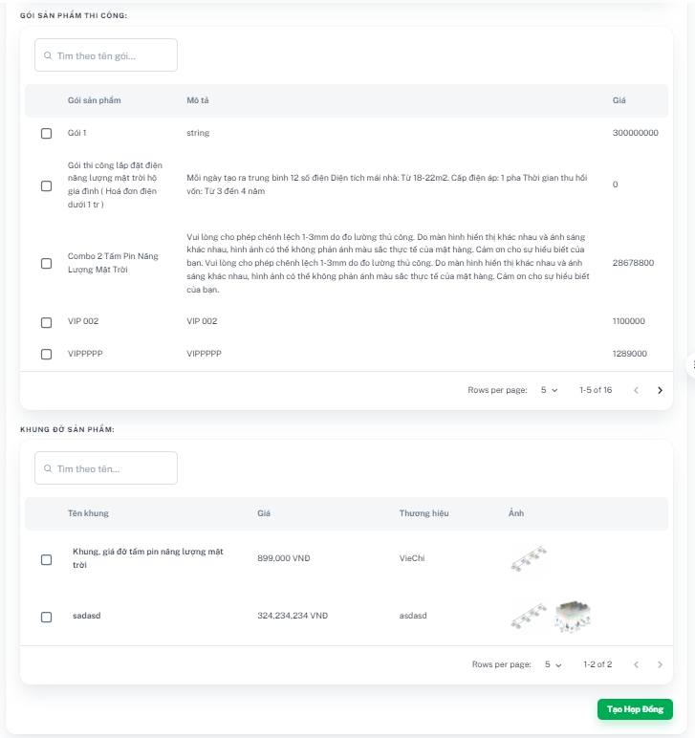

Function details:

* The staff clicks the “Khảo Sát” tab on the left menu.
* The staff clicks the “Tạo Hợp Đồng” button on the “Khảo Sát” page.
* The staff fills in the required information fields such as Image, Start Date, Finish Date, Customer, Combo, and Bracket.
* Then, when the staff clicks on the “Tạo Hợp Đồng” button, the system will notify on the screen:
  + **Success:** Returns a message “Tạo hợp đồng thành công”.
  + **Fail:** Returns an error message ”Có lỗi xảy ra, vui lòng thử lại!”.

#### 3.4.5 <Staff>Create survey

Function trigger: The staff requests to create a new survey

Function description: This function allows the staff to create a new survey in the system

Screen layout:



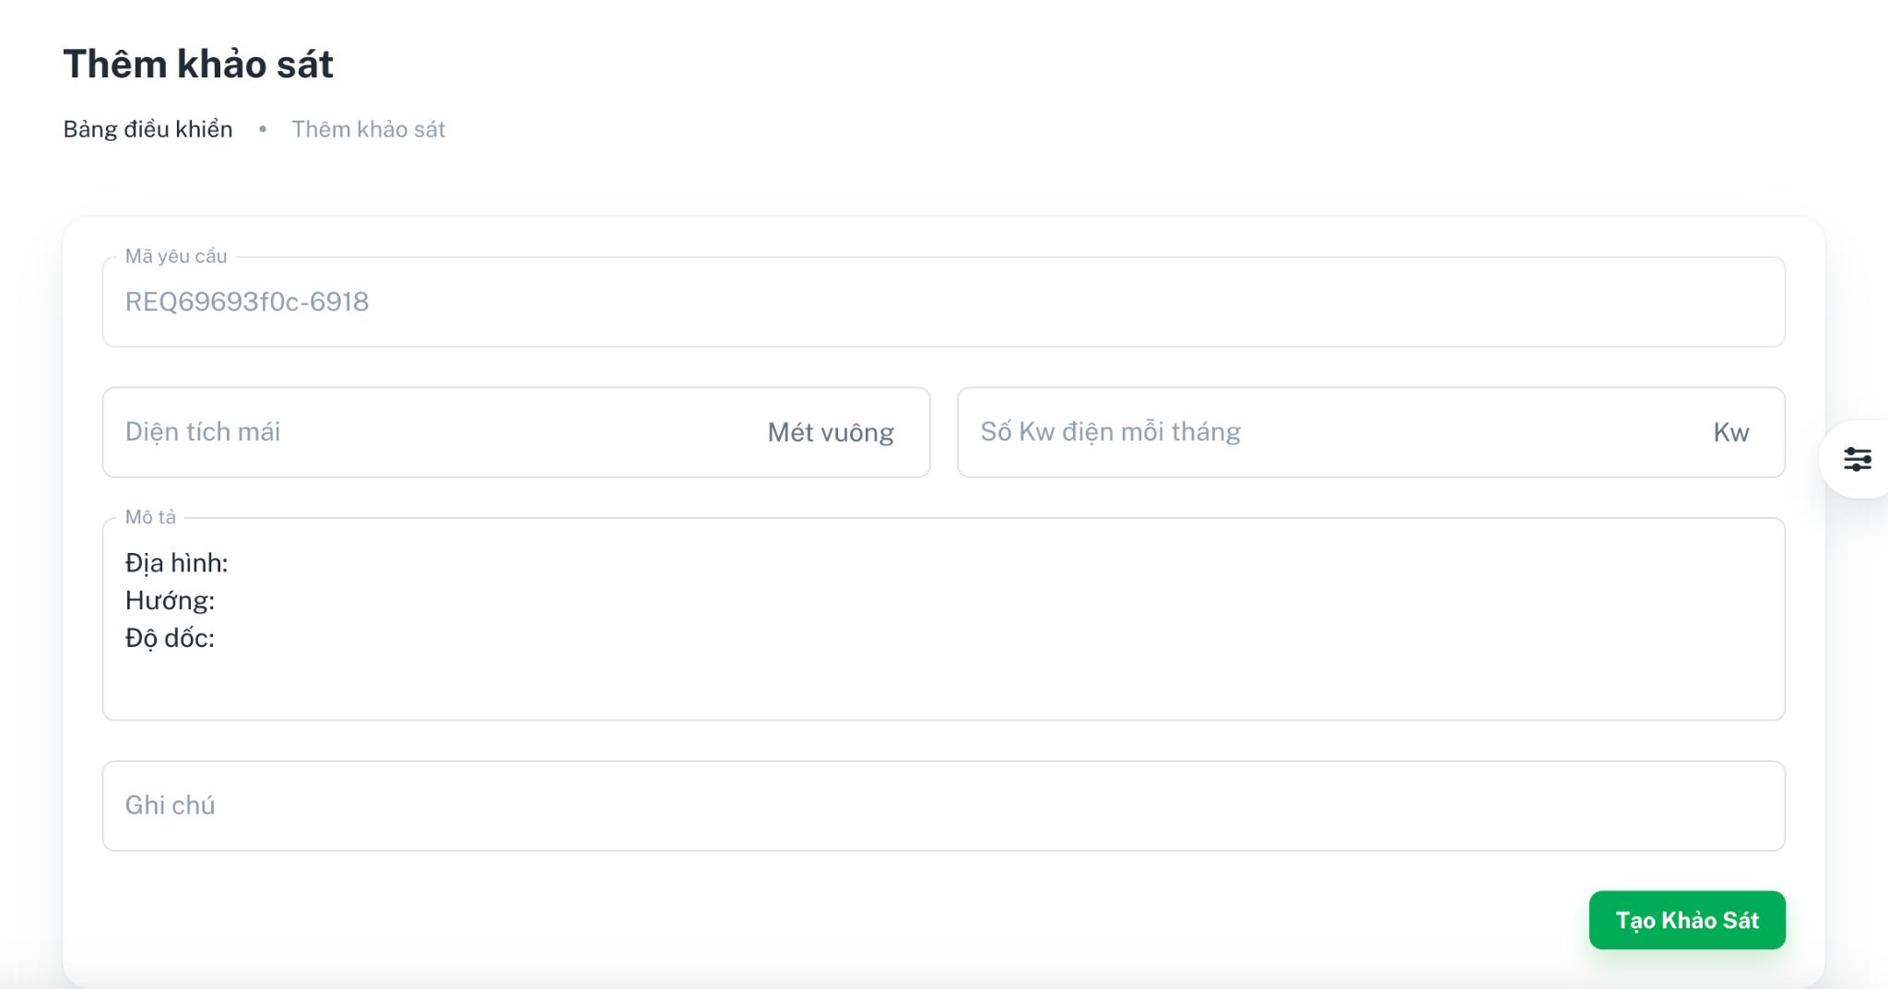

Function details:

* The staff clicks the “Yêu Cầu Khảo Sát” tab on the left menu.
* The staff clicks the “Tạo Khảo Sát” button on the “Yêu Cầu Khảo Sát” page.
* The staff fills in the required information fields such as Note and Description.
* Then, when the staff clicks on the “Tạo Khảo Sát” button, the system will notify on the screen:
  + **Success:** Returns a message “Tạo sản phẩm thành công”.
  + **Fail:** Returns an error message ”Có lỗi xảy ra, vui lòng thử lại!”.

**3.5 Mobile application for Customer**

#### 3.5.1 <Customer> Login

Function trigger: The user requests to log into the SMPA system

Function description: This function allows the customer to log into the system

Screen layout:

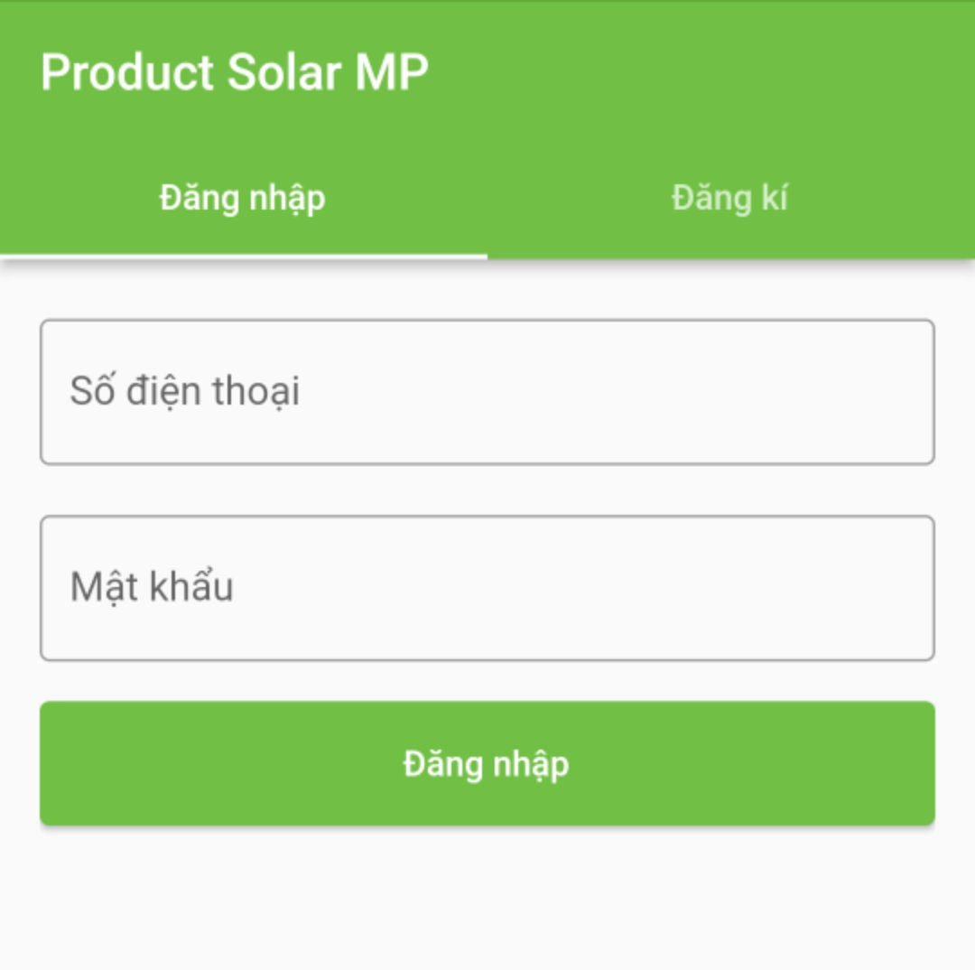

Function details:

* The user enters their registered phone number and password Then user click on “Đăng nhập” button.
* The system will redirect to the corresponding screen with the role customer:
  + **Success**: Redirects to the dashboard screen.
  + **Fail**: Returns an error message “Không tồn tại người dùng” or “Mật khẩu không đúng”.

#### 3.5.2 <Customer> Get combo list

Function trigger: The customer requests to view the combo list

Function description: This function allows the customer to view the combo list

Screen layout:

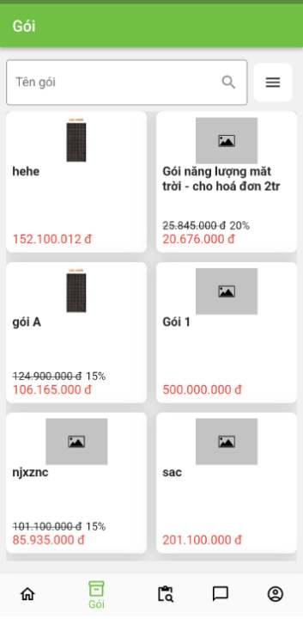

Function details:

* The customer taps on the “Gói” tab on the navigation bar
* The system shows a combo list.

#### 3.5.3 <Customer> Filter combo

Function trigger: The customer requests to filter for the specific combo with requirements.

Function description: This function allows the customer to filter for the specific combo with requirements

Screen layout:

 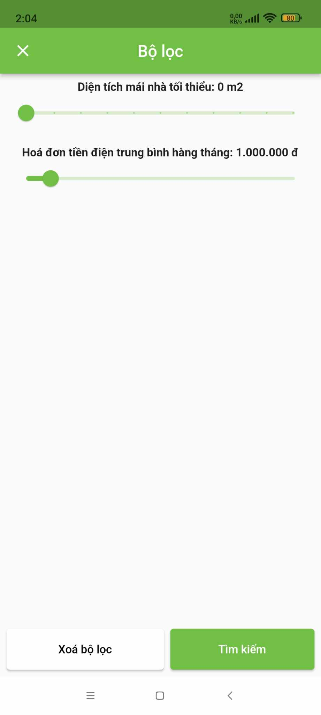

Function details:

* The customer taps on the “Gói” tab on the navigation bar
* The customer taps on the “☰” button on the upper right corner of the screen
* The customer uses sliders to filter results based on specific requirements
* The customer taps on “Tìm kiếm” button on the bottom right corner of the screen
* The system shows the result with the match requirements

#### 3.5.4 <Customer> Search combo

Function trigger: The customer requests to search for specific combo

Function description: This function allows the customer to search for the specific combo

Screen layout:

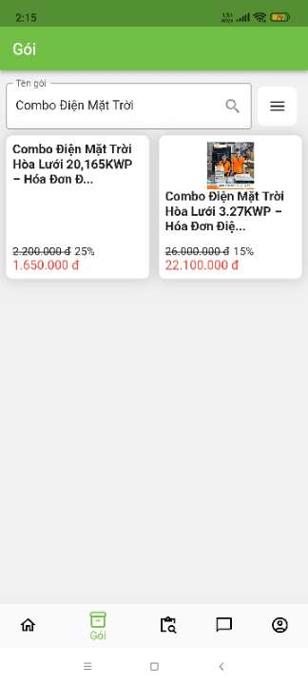

Function details:

* The customer taps on the “Gói” tab on the navigation bar
* The customer taps on the search bar on the upper left of the screen
* The customer enters combo’s name to search
* The customer taps on the  to search
* The system shows the result of the search

#### 3.5.5 <Customer> Get contract list

Function trigger: The customer requests to view their contract list

Function description: This function allows the customer to view their contract list

Screen layout:

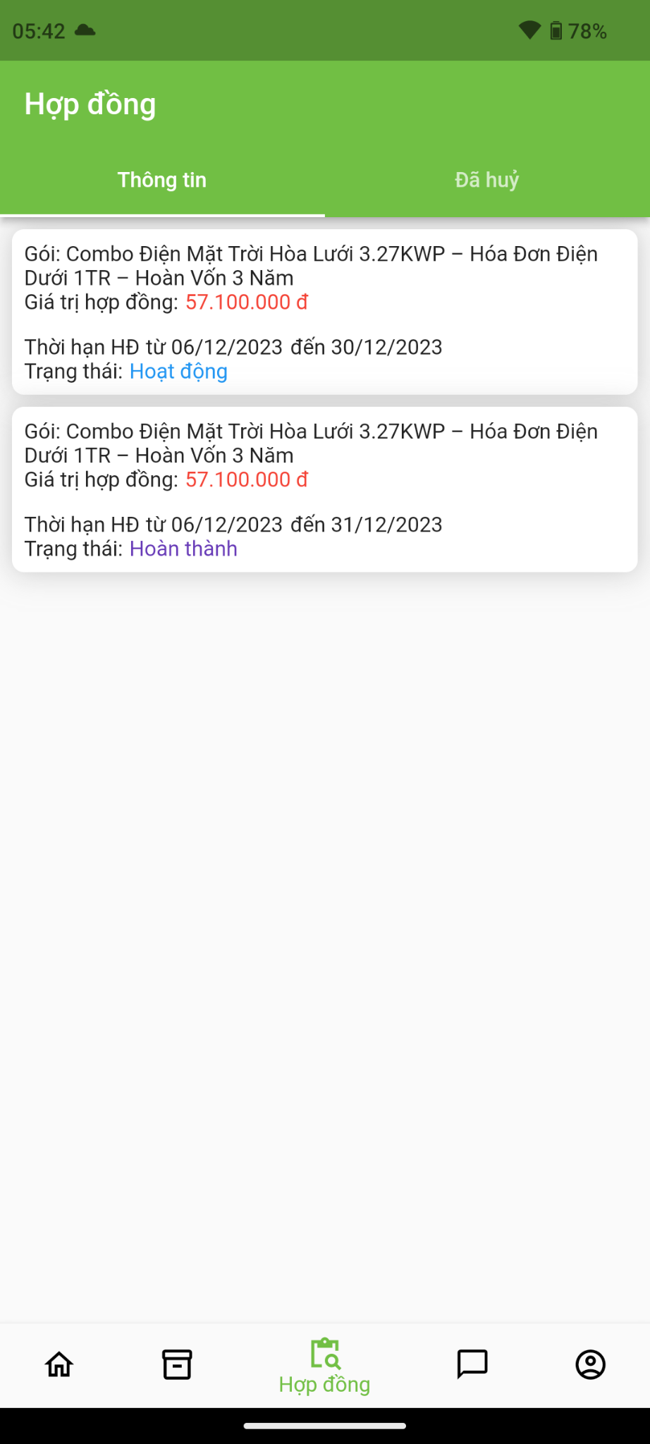

Function details:

* The customer taps on the “Hợp đồng” tab on the navigation bar
* The system shows customer’s contract list

#### 3.5.6 <Customer> Get cancelled contract list

Function trigger: The customer requests to view their cancelled contract list

Function description: This function allows the customer to view their cancelled contract list

Screen layout:

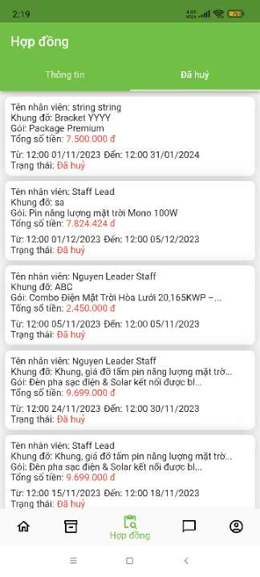

Function details:

* The customer taps on the “Hợp đồng” tab on the navigation bar
* The customer taps on the “Đã hủy” tab on the upper right of the screen
* The system shows customer’s cancelled contract list

#### 3.5.7 <Customer>Chat with Consultant

Function trigger: The customer requests to chat with the consultant

Function description: This function allows the customer to chat with the consultant

Screen layout:

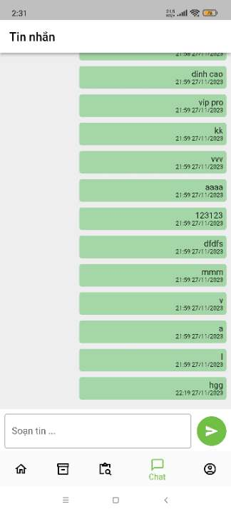

Function details:

* The customer taps on the “Chat” tab on the navigation bar
* The customer enters messages in the text box
* The customer taps on the “ “ to send the messages to the consultant

#### 3.5.8 <Customer> Get combo detail

Function trigger: The customer requests to view the combo detail

Function description: This function allows the customer to view the combo detail

Screen layout:

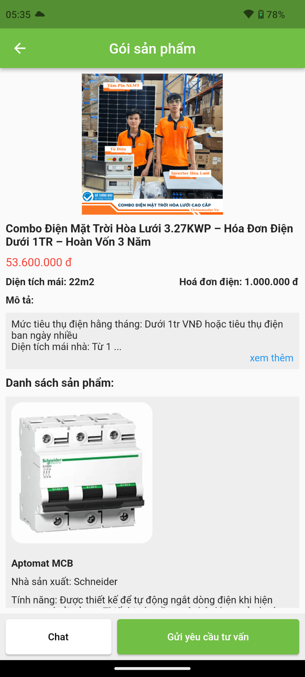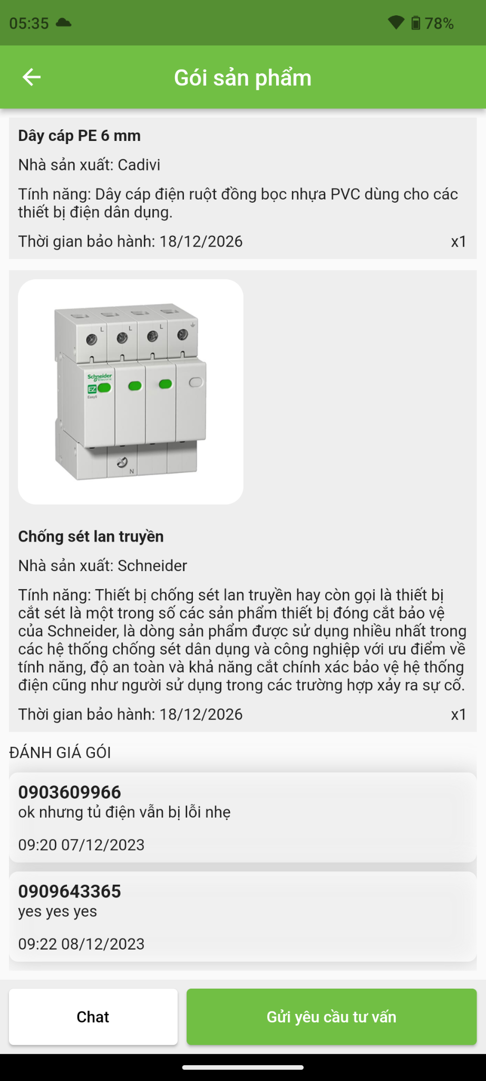

Function details:

* The customer taps on a combo listed in the list to view the detail
* The system shows that combo detail on the screen

#### 3.5.9 <Customer> Send request for a survey

Function trigger: The customer requests to send a request for a survey

Function description: This function allows the customer to send a request for a survey

Screen layout:

 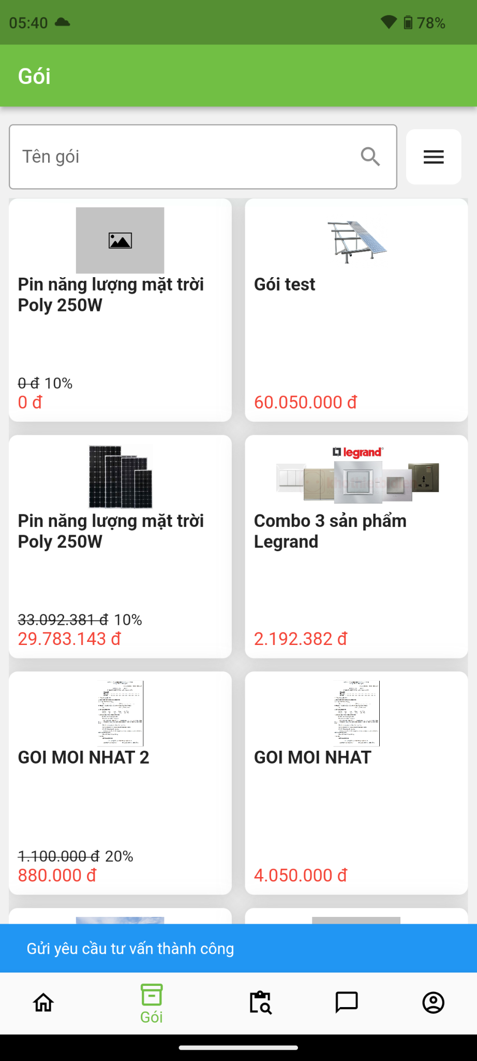

Function details:

* The customer taps on a combo listed in the list to view the detail
* The customer taps on the “Gửi yêu cầu tư vấn” button to send the request
* The system notify “Gửi yêu cầu tư vấn thành công” on the pop-up notification and return to combo list screen.

#### 3.5.10 <Customer> Edit profile

Function trigger: The customer requests to edit profile

Function description: This function allows the customer to edit profile

Screen layout:

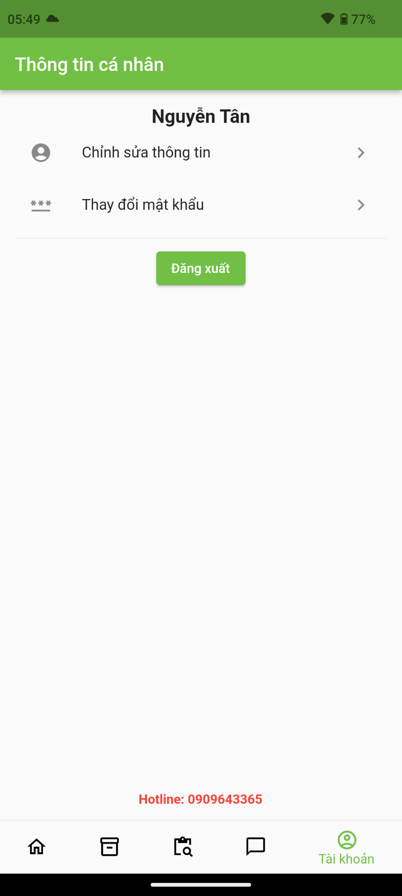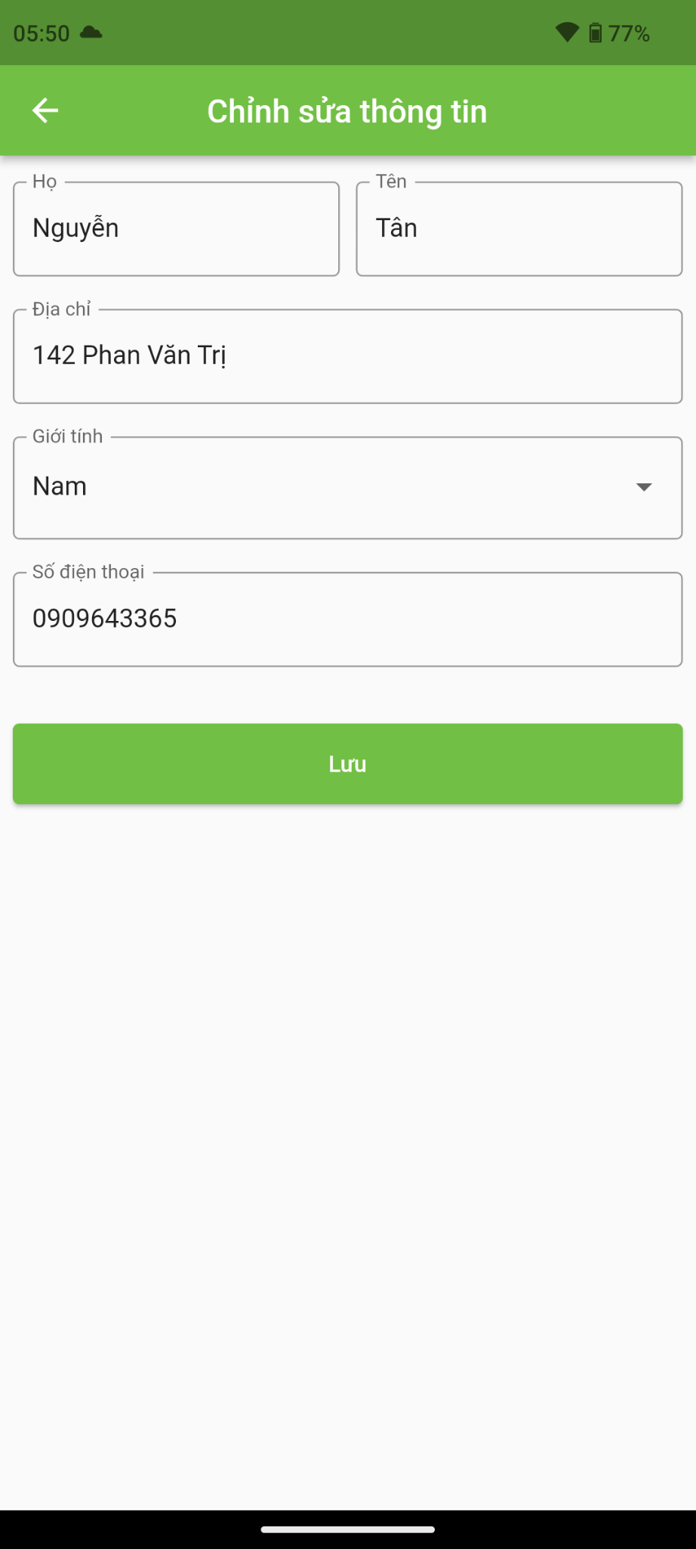

Function details:

* The customer taps on “Tài khoản” tab on the navigation bar
* The customer taps on “Chỉnh sửa thông tin” tab on the menu
* The customer edits the information fields
* The customer taps on the “Lưu” button to save
* The system notifies “Cập nhật thành công” on the pop-up notification and return to profile screen

#### 3.5.11 <Customer> Get contract details

Function trigger: The customer requests to view the contract details

Function description: This function allows the customer to view the contract details

Screen layout:

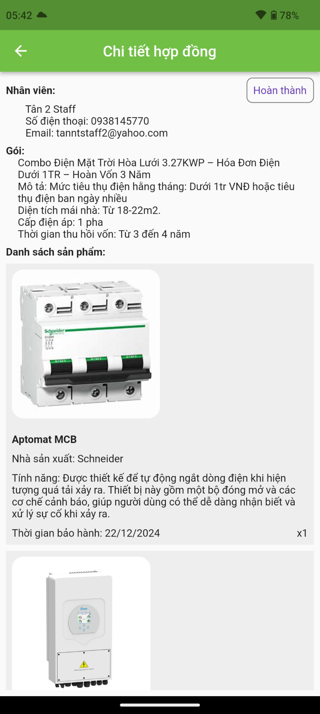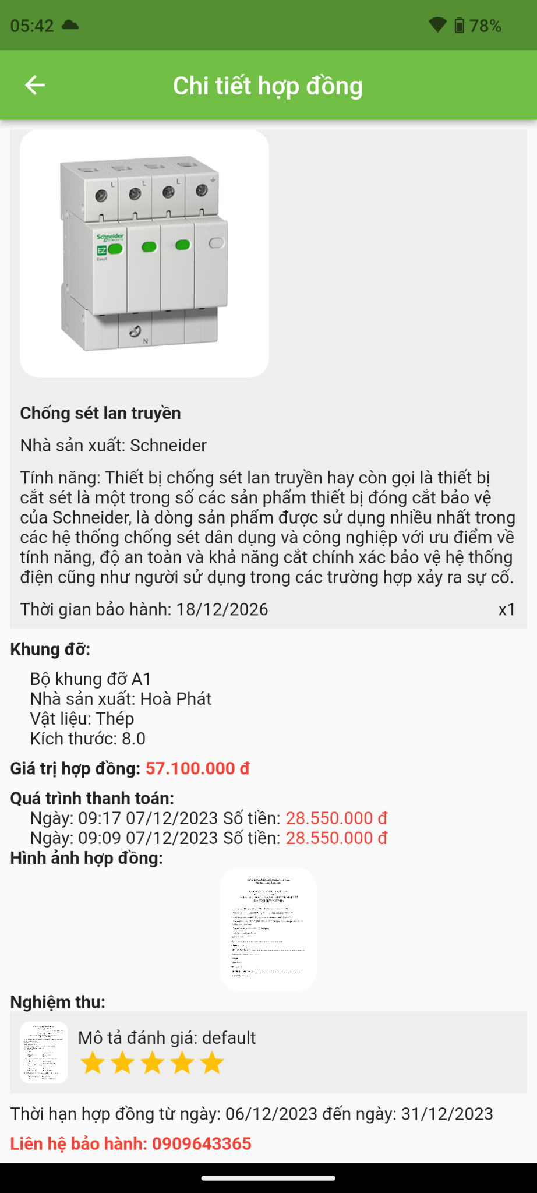

Function details:

* The customer taps on the “Hợp đồng” tab on the navigation bar
* The customer taps on the specific contract to view its details

#### 3.5.12 <Customer> Make payment

Function trigger: The customer requests to make a payment

Function description: This function allows the customer to make a payment

Screen layout:

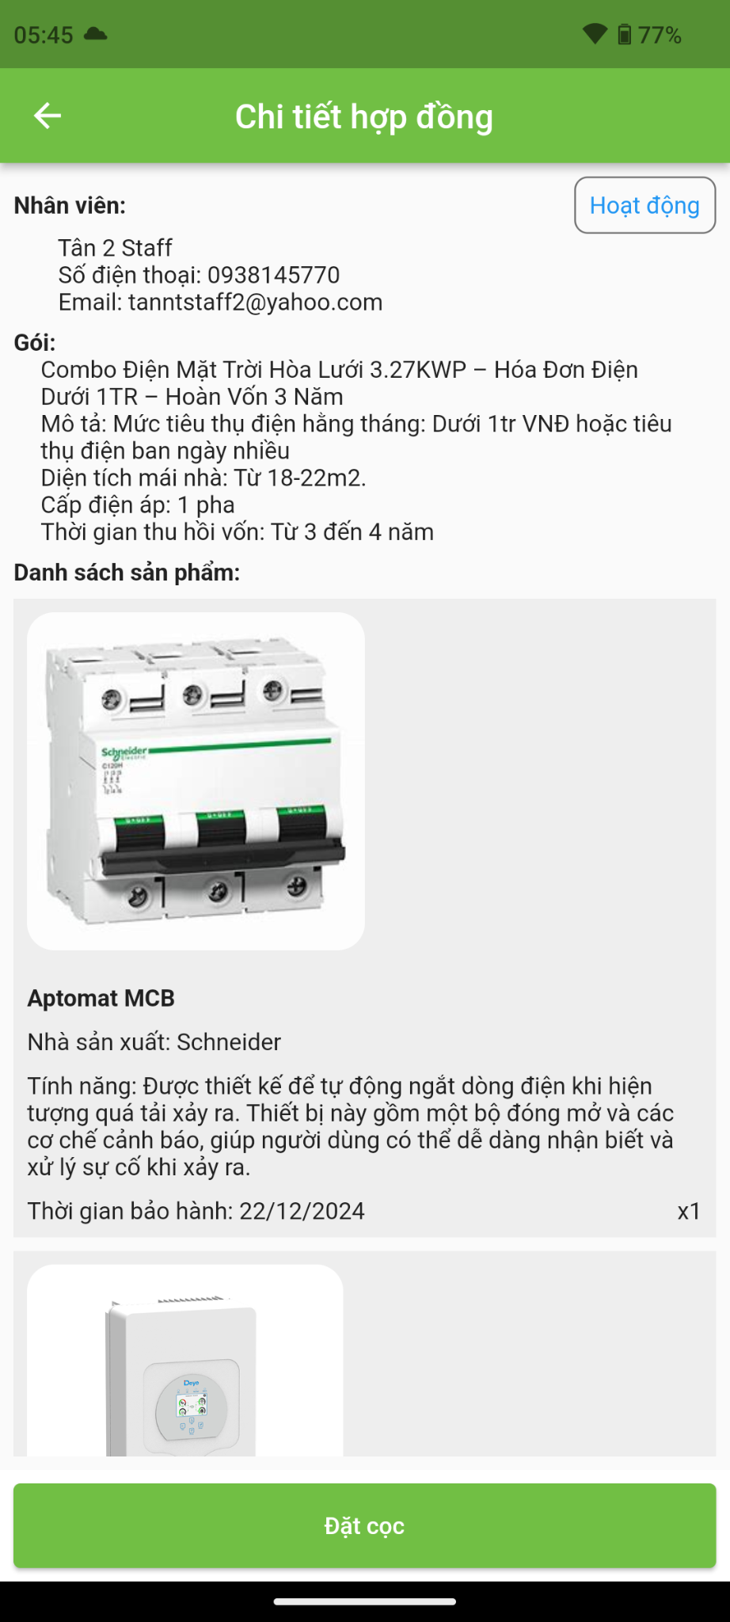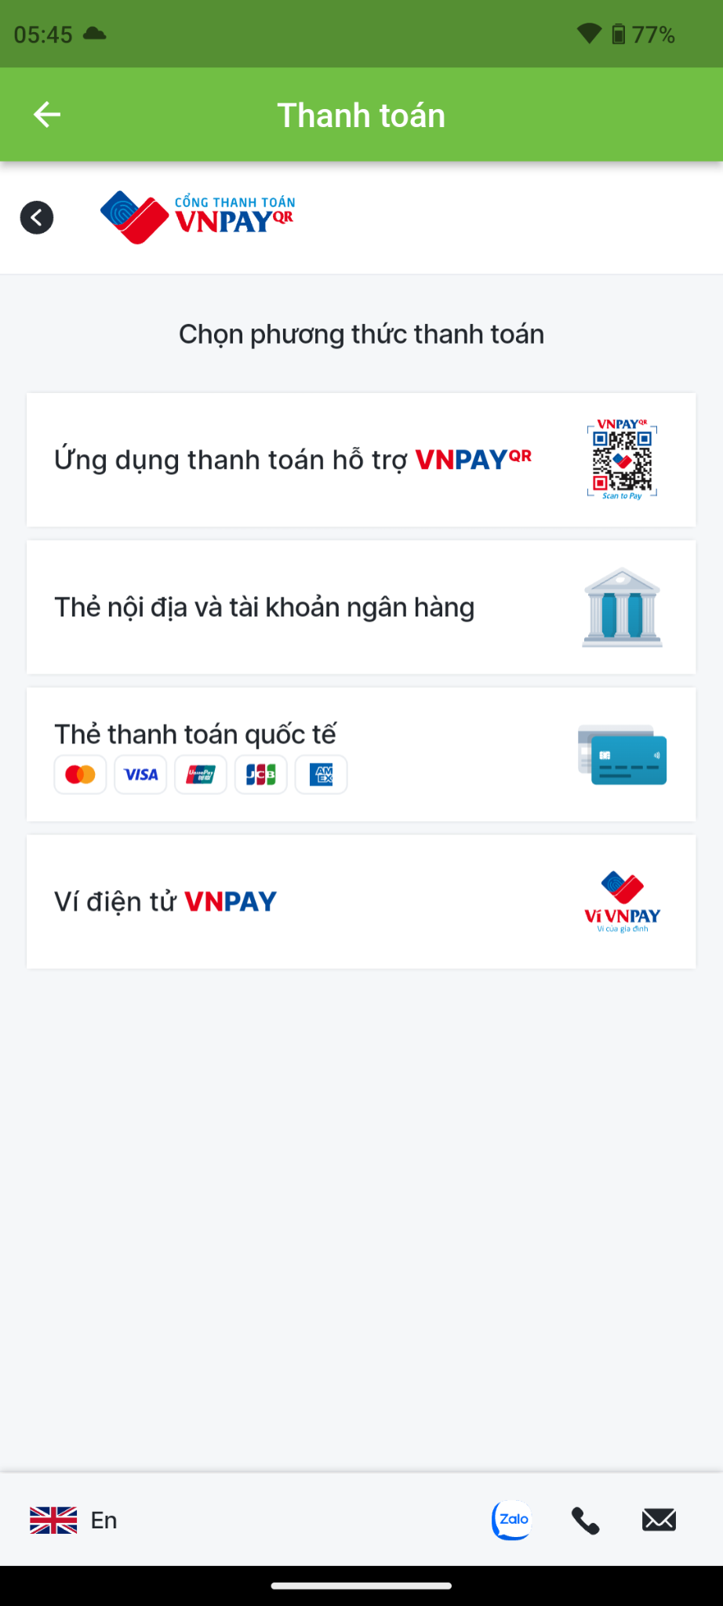

Function details:

* The customer taps on the “Hợp đồng” tab on the navigation bar
* The customer taps on the specific contract to view its details
* The customer taps on the “Thanh toán” button on the bottom of the screen to make a payment
* The customer makes payment

#### 3.5.13 <Customer> Change password

Function trigger: The customer requests to change password

Function description: This function allows the customer to change password

Screen layout:

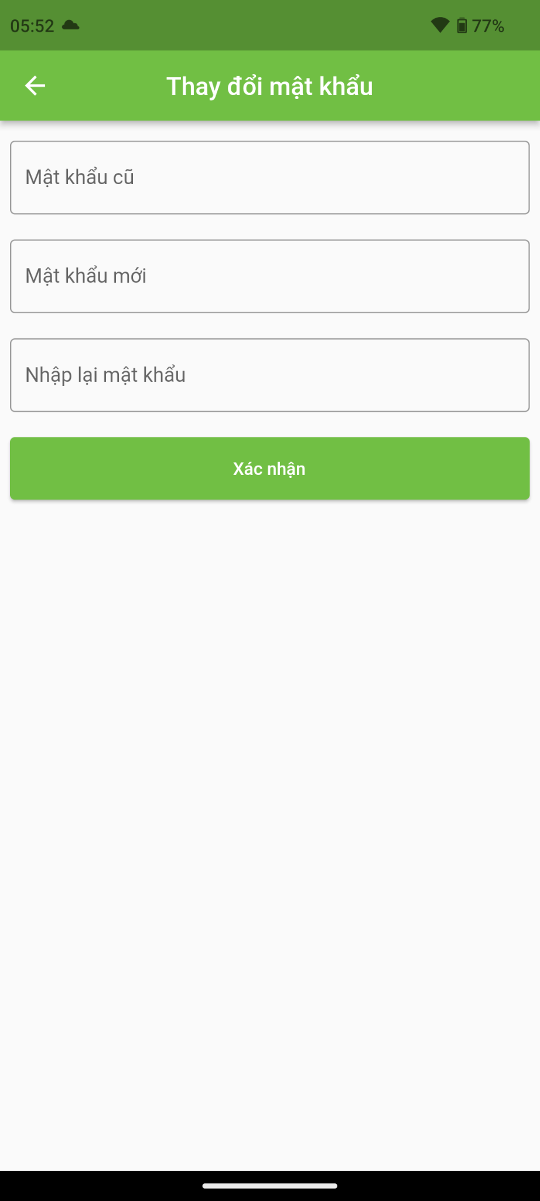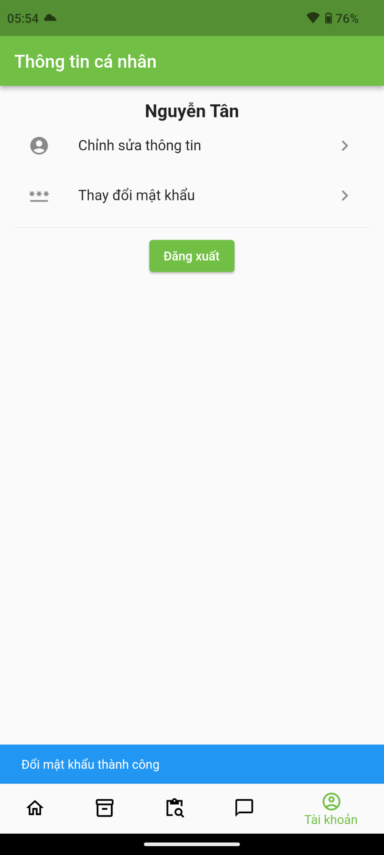

Function details:

* The customer taps on “Tài khoản” tab on the navigation bar
* The customer taps on “Thay đổi mật khẩu” tab on the menu
* The customer enters old password, then enter the new password
* The customer taps on the “Xác nhận” button to save
* The system notifies “Đổi mật khẩu thành công” on the pop-up notification and return to profile screen.

## 4. Non-Functional Requirements

### 4.1 External Interfaces

**a. User Interfaces**

UI-1: The language used in the application is Vietnamese.

UI-2: GUI must be simple and friendly.

UI-3: Icons used must be easy to recognize.

**b. Software Interfaces**

SI-1: Web application: Google Chrome browser and Firefox browser.

SI-2: Mobile application: Android version 8.0 or higher.

**c. Hardware Interfaces**

HI-1: Mobile use should support full-time internet connectivity

**d. Communications Interfaces**

CI-1: Mobile sends requests to the server through the HTTP protocol.

CI-2: Web application sends a request to the server through HTTP protocol.

### 4.2 Quality Attributes

#### 4.2.1 Usability

1. Mobile applications should be accessible for most users to understand and use quickly.
2. The web application should require more than 30 minutes of training time with the help of a support document to be used with ease.
3. Users are not required to have technical knowledge before using.
4. All text, label, and message should be uniformly written in Vietnamese.

#### 4.2.2 Reliability

1. The information stored in the database is permanent.
2. The likelihood of the system failure is less than 10%

#### 4.2.3 Performance

*1. Response time for HTTP requests should not be more than 10s.*

#### 4.2.4 Dependability

1. Input data is validated before saving to the database.

2. Each role can only access its own functions.

3. The internet connection must always be stable during the use of the system, especially in money–related features.

## 5. Requirement Appendix

### 5.1 Business Rules

| **ID** | **Rule Definition** |
| --- | --- |
| BR-01 | Customers should only work with the engineer of the store from the beginning till the end of the contract. |
| BR-02 | Customers have 24 hours to cancel the contract after they have signed. |
| BR-03 | Customers must deposit 50% after they have signed the contract and the 50% left when they have signed the acceptance. |
| BR-04 | After the receipt of the engineer's second notice of acceptance and handover, if customers fail to join in the acceptance and handover process within five days, the project is deemed completed by the engineer in adherence to the specified quantity, quality, and schedule outlined in the contract. |
| BR-05 | The warranty does not cover conditions such as products showing signs of human sabotage, damage resulting from natural disasters or force majeure events, and any harm caused by the arbitrary installation of additional solar panels or inverters by customers outside the scope of this contract without the supervision and consent of the store engineer. |
| BR-06 | The construction contract will terminate ahead of schedule once both parties have fulfilled their obligations and the contract has been successfully completed. |
| BR-07 | Both parties mutually commit to adhering to the terms stipulated in the contract, with any changes or additions requiring written agreement from both parties and such amendments and supplements shall be considered integral components of the contract. |
| BR-08 | Contract terms are not subject to change during the construction process. |

### 5.2 Common Requirements

### 5.3 Application Messages List

| **#** | **Message code** | **Message Type** | **Context** | **Content** |
| --- | --- | --- | --- | --- |
| 1 | MSG01 |  |  |  |
| 2 | MSG02 |  |  |  |
| 3 | MSG03 |  |  |  |
| 4 | MSG04 |  |  |  |
| 5 | MSG05 |  |  |  |
| 6 | MSG06 |  |  |  |
| 7 | MSG07 |  |  |  |
| 8 | MSG08 |  |  |  |
| 9 | MSG09 |  |  |  |

### 5.4 Other Requirements…

# IV. Software Design Description

## 1. System Design

### 1.1 System Architecture

### 1.2 Package Diagram

### 

## 2. Database Design

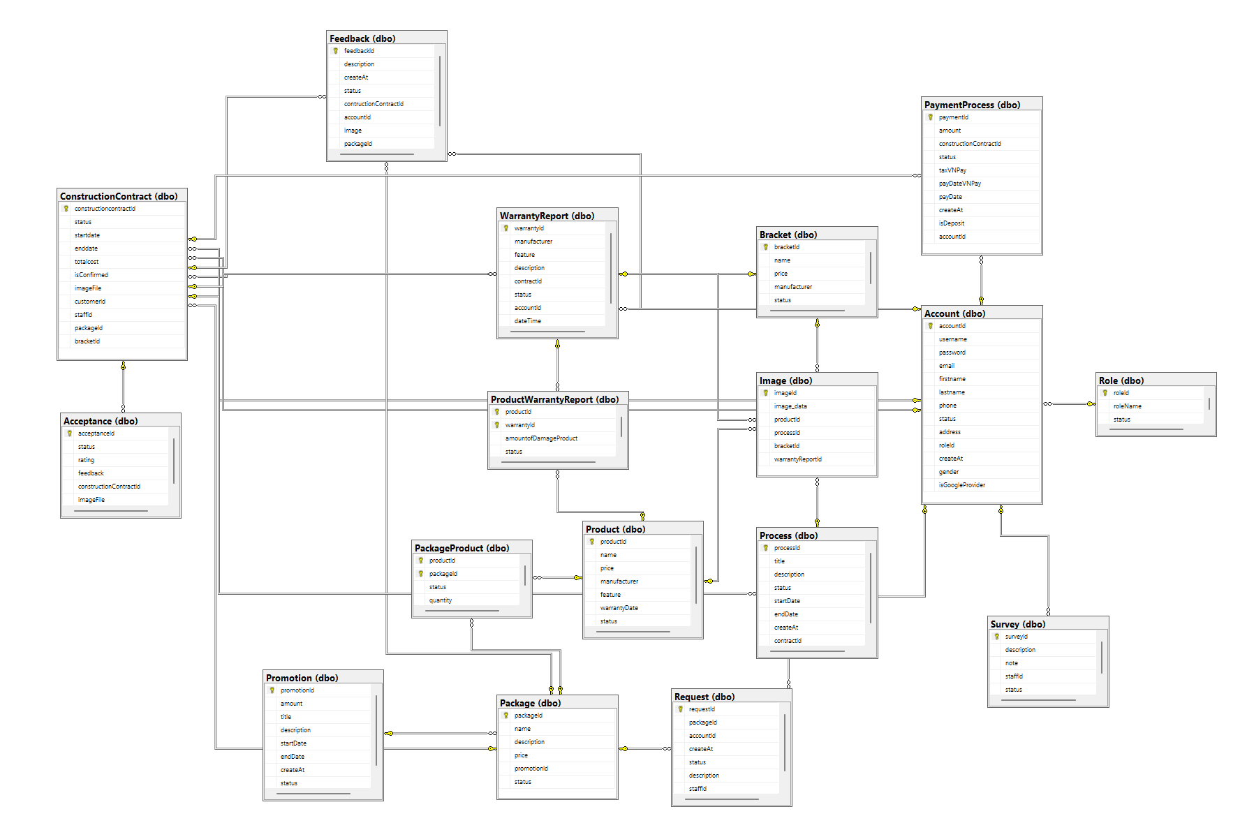

***Table Descriptions***

| **No** | **Table** | **Description** |
| --- | --- | --- |
| 01 | Account | Describe account in the system |
| 02 | Role | Describe role in the system |
| 03 | ConstructionContract | Describe construction contract in the system |
| 04 | PaymentProcess | Describe payment process in the system |
| 05 | Package | Describe package in the system |
| 06 | Acceptance | Describe acceptance in the system |
| 07 | Package Product | Describe package product in the system |
| 08 | Product | Describe product in the system |
| 09 | WarrantyReport | Describe warranty report in the system |
| 10 | ProductWarrantyReport | Describe product warranty report in the system |
| 11 | Bracket | Describe bracket in the system |
| 12 | Image | Describe image in the system |
| 13 | Process | Describe process in the system |
| 14 | Survey | Describe survey in the system |
| 15 | Feedback | Describe feedback in the system |
| 16 | Promotion | Describe promotion in the system |
| 17 | Request | Describe request in the system |

## 3. Detailed Design

### 3.1 Class Diagram

### 3.2 Class Specification

### 3.3 Sequence Diagram

**3.3.1 Login (Mobile)**

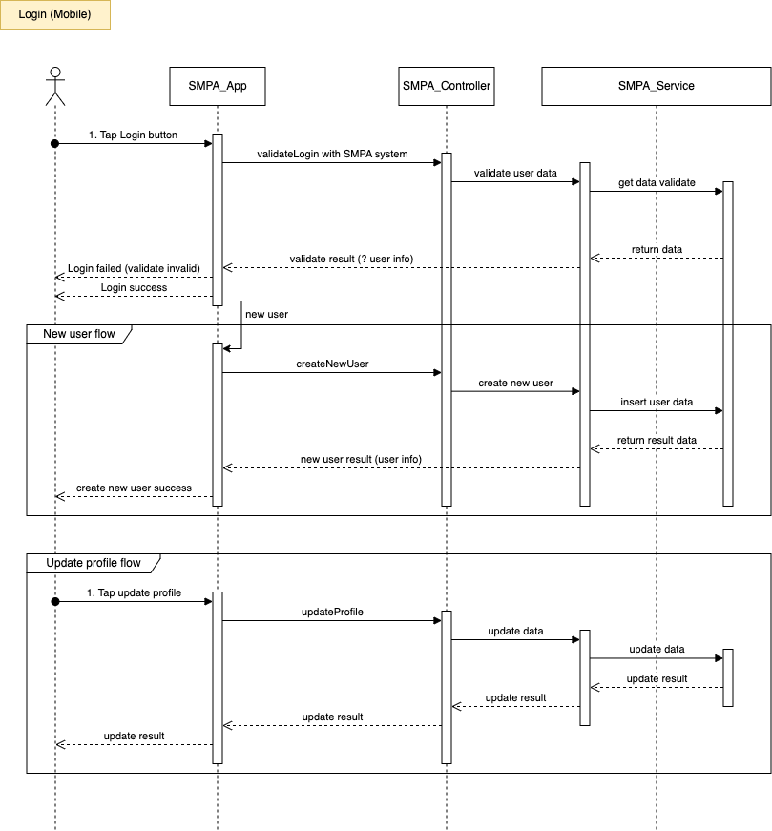

**3.3.2 Login (Web)**

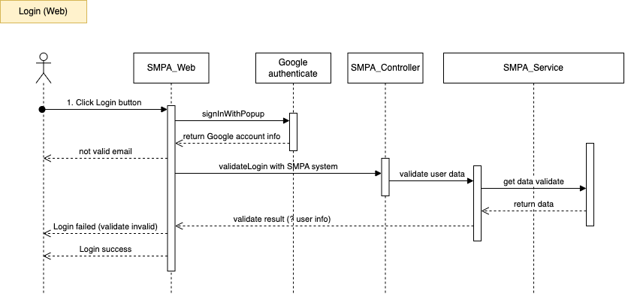

**3.3.3 View Package**

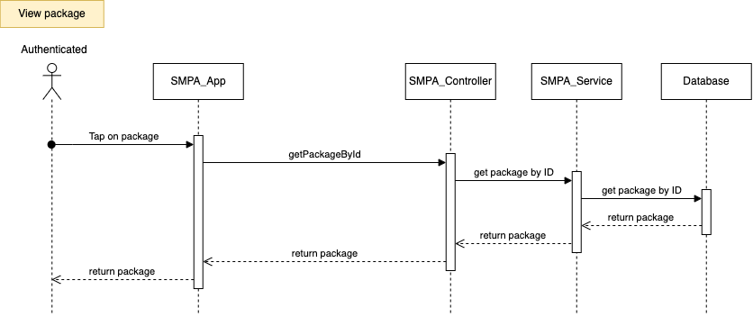

**3.3.4 Create Request**

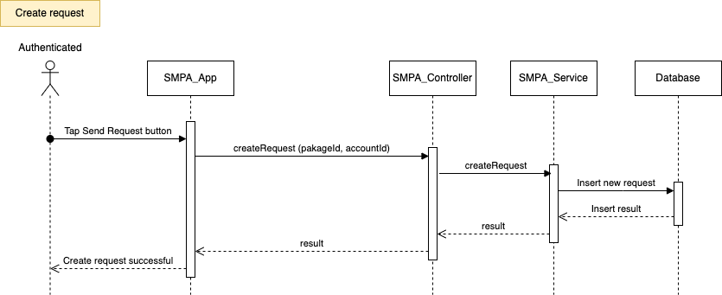

**3.3.5 Assign Request**

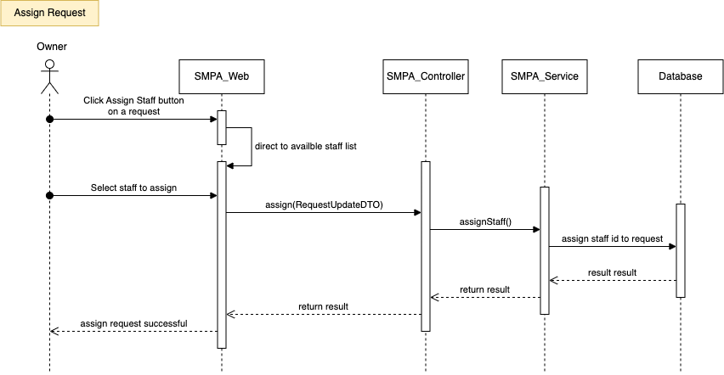

**3.3.6 Create Survey**

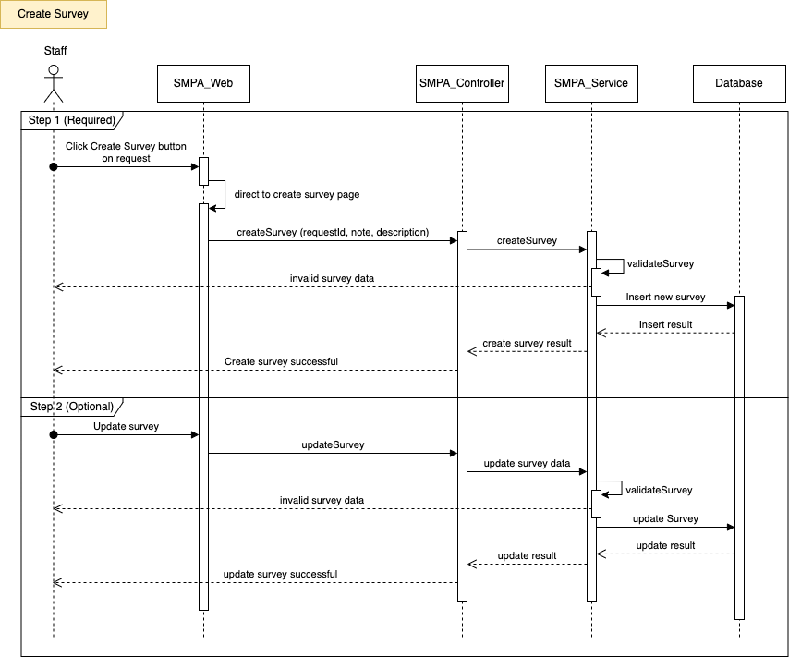

**3.3.7 Create Product**

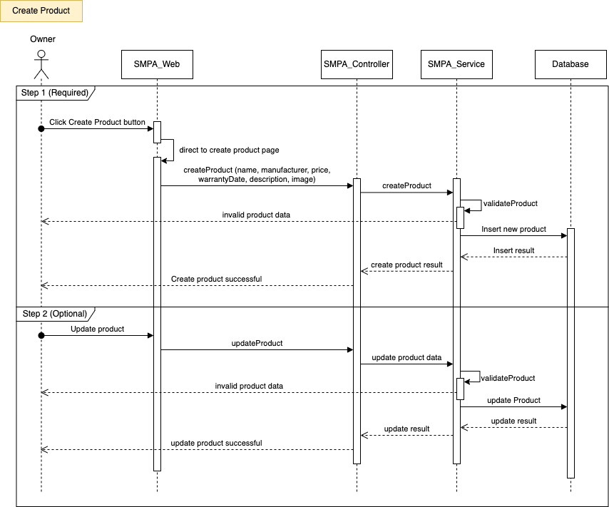

**3.3.8 Create Bracket**

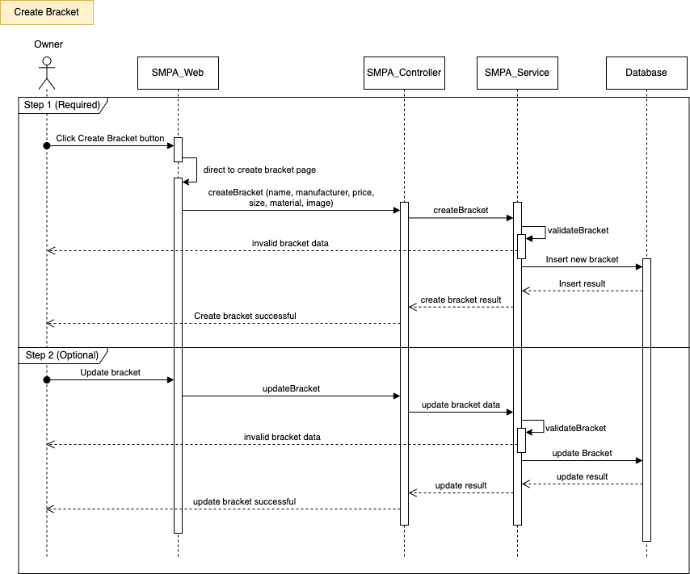

**3.3.9 Create Promotion**

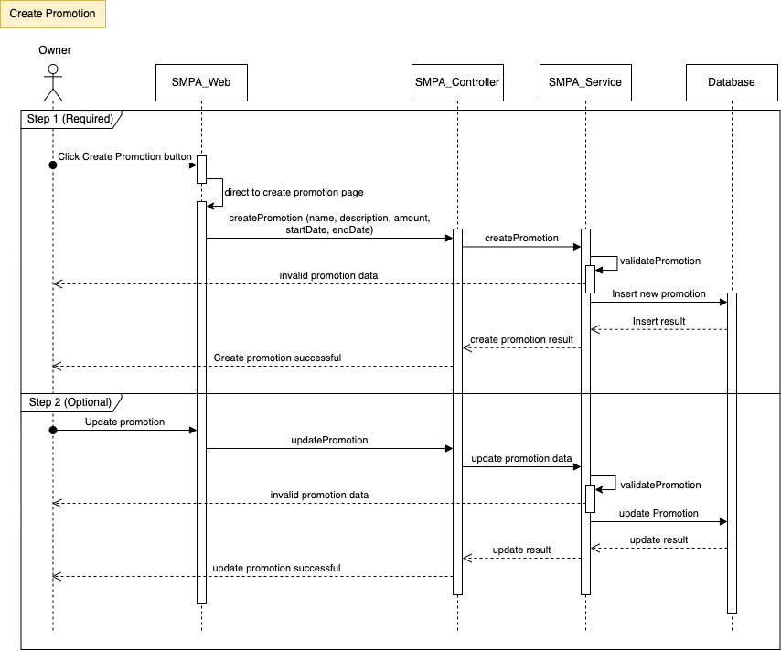

**3.3.10 Create Package**

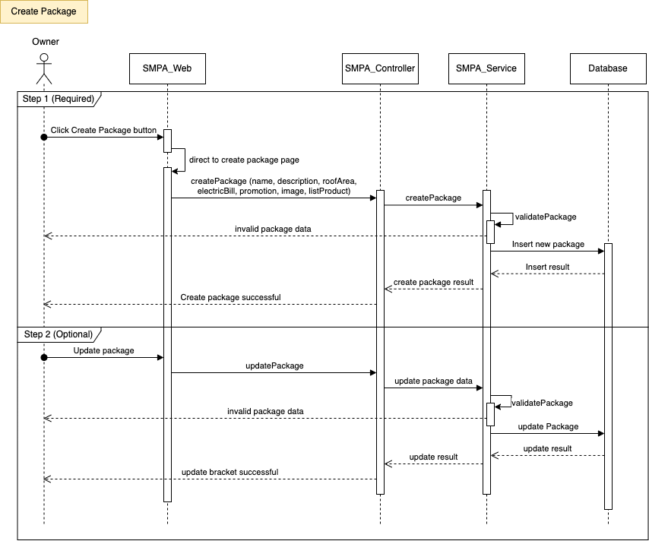

**3.3.11 Create Contract**

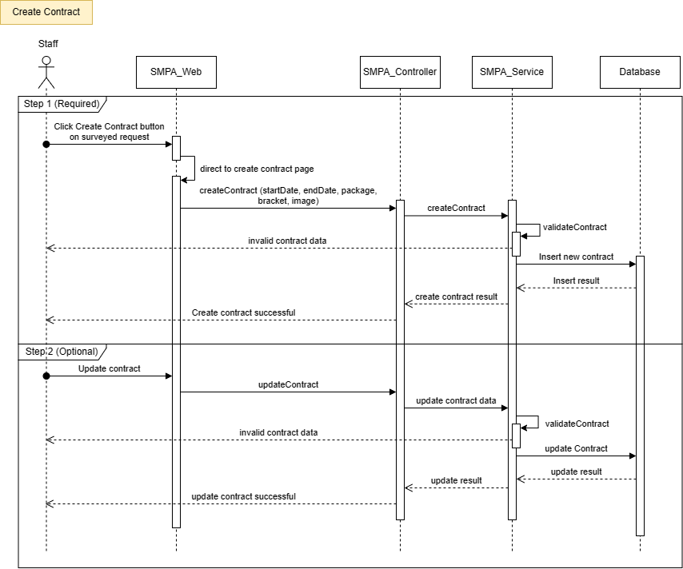

**3.3.12 Create Process**

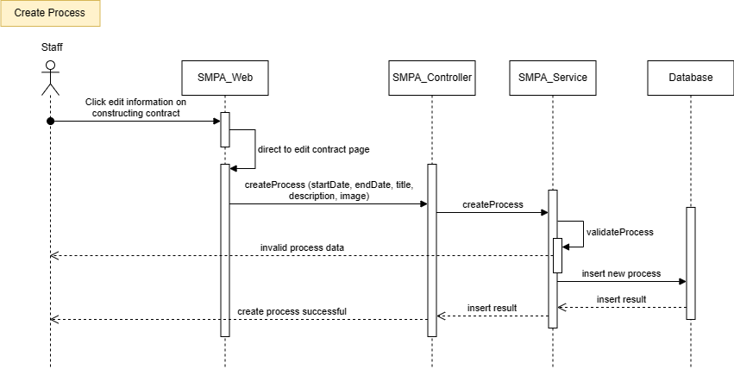

**3.3.13 Create Acceptance**

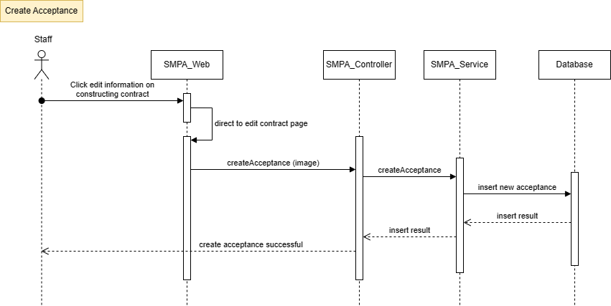

**3.3.14 View Contract**

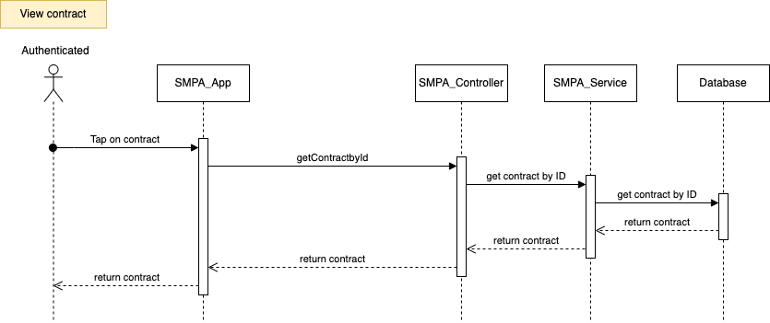

**3.3.15 Payment**

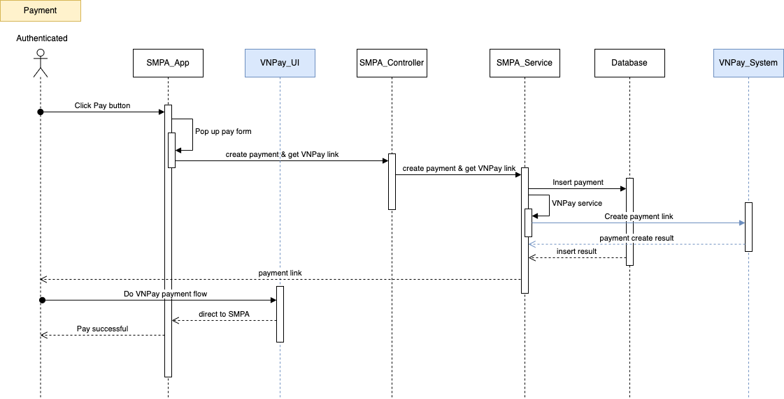

**3.3.16 Feedback**

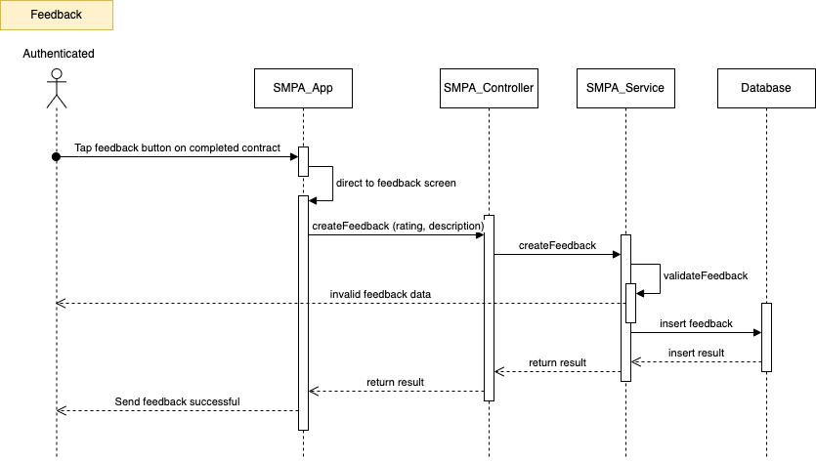

# V. Software Testing Documentation

## 1. Scope of Testing

Tests at different scopes complement each other’s strengths and weaknesses. A good mix of tests can

create an excellent testing plan that allows us to make changes confidently and catches actual bugs

quickly and efficiently.

* With the backend API, we applied Unit Testing and then Integration Testing.
* With the Front-End and Mobile, we applied System Testing with functional requirements.

## 2. Test Strategy

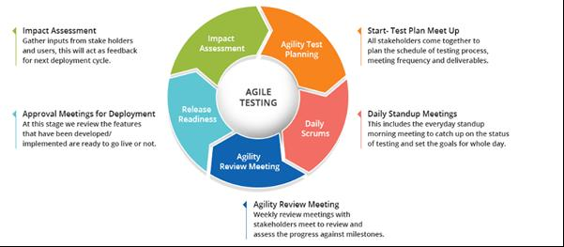

Since the CREL project team uses the Scrum workflow, the Agile testing approach is suitable for changing requirements with each cycle. It is an entirely new test phase, allows the testing team to spot bugs

quickly, and prevents the development team from repeating a bug type too many times. Additionally, the Agile

testing model has the following advantages:

* Suitable in small or medium projects.
* Provide a common ground for stakeholders to communicate incrementally.

### 2.1 Testing Types

* **Functional testing:** Ensure the system’s functionalities follow business functional requirements.
* **Non-functional testing:** To ensure the system’s user interface, performance, and user experience follow the business non-functional requirements with the provided hardware and internet transmission speed.

### 2.2 Test Levels

| **Type of test** | **Test Level** | | | |
| --- | --- | --- | --- | --- |
| **Unit** | **Integration** | **System** | **Acceptance** |
| Function Testing | **x** | **x** |  |  |
| User interface testing |  |  | **x** |  |

### 2.3 Supporting Tools

| **Purpose** | **Tool** | **Vendor/In-house** | **Version** |
| --- | --- | --- | --- |
| View logs of web application | Chrome DevTools | Chrome | 116.0.5845.97 |
| Backend IDE | Visual Studio | Microsoft | 1.81 |
| Web application | Visual Studio Code | Microsoft | 1.81 |
| Mobile application | Android Studio | Google | 2022.3.1 |
| Communication | Google Meet, Messenger | Microsoft, Facebook |  |

## 3. Test Plan

### 3.1 Human Resources

### 

| **Worker/Doer** | **Role** | **Specific Responsibilities/Comments** |
| --- | --- | --- |
| Nguyen Quang Minh | Leader | Planning. Verify test deliverables. |
| Bao Quoc | Member | Execute test and report as planned. |
| Nguyen Thanh Tan | Member | Execute test and report as planned. |
| Nguyen Phan Khoi Nguyen | Member | Execute test and report as planned. |

### 

### 3.2 Test Environment

| **Purpose** | **Tool** | **Provider** |
| --- | --- | --- |
| View logs of web application | Chrome DevTools | Chrome |
| Test case management | Microsoft Excel | Microsoft |
| UI for Unit test and Integration test | Postman | Postman |
| Backend IDE | Visual Studio | Microsoft |
| Web application IDE | Visual Studio Code | Microsoft |
| Mobile application IDE | Android Studio | Google |
| Execution hardware | Testing is implemented  on computers with the  following specifications:  · CPU: Intel i7  · RAM: 16GB  · Storage device: HDD or  SSD | Any providers |
| Communication | Online meeting,  Messenger | Google Meet,  Facebook |

### 3.3 Test Milestones

| **Milestone Task** | **Effort (md)** | **Start Date** | **End Date** |
| --- | --- | --- | --- |
| **Iteration 1: Test planning for web**  **application** | 7 | 29/11/2023 | 5/12/2023 |
| Create test plan | 1 | 29/11/2023 | 30/11/2023 |
| Review test plan | 1 | 30/11/2023 | 1/12/2023 |
| Create unit test | 3 | 1/12/2023 | 3/12/2023 |
| Create test case | 2 | 3/12/2023 | 5/12/2023 |
| **Iteration 2: Test planning for mobile application** | 6 | 29/11/2023 | 5/12/2023 |
| Create test plan | 1 | 1/12/2023 | 3/12/2023 |
| Review test plan | 1 | 3/12/2023 | 5/12/2023 |

## 4. Test Cases

| **Unit Test Cases** | **Test Report** |
| --- | --- |
| [Report5_Unit Test.xlsx](https://docs.google.com/spreadsheets/d/1bzFOia4PG3_GmNBzJ3Gw0O8BGmy0GxlU/edit#gid=644785519) | [Report5_Test Report.xlsx](https://docs.google.com/spreadsheets/d/1ssBN4PaxyIMCoInScHB-rQDdXfiiujQ7/edit#gid=141949066) |

## 5. Test Reports

# VI. Release Package & User Guides

## 1. Deliverable Package

| **No.** | **Deliverable Item** | **Description** |
| --- | --- | --- |
| 1 | Schedule/Task Tracking | [Report of Capstone |Drive](https://drive.google.com/drive/folders/1CSgnyWCCvJVJh1QqbbJ0ZZByDSfAg0Be?usp=sharing) |
| 2 | Project Backlog | Backlog|Trello |
| 3 | Source Codes | [solar-management|Github](https://github.com/orgs/solar-management-capstone/repositories) |
| 4 | Database Script(s) | [SMPA.sql](https://drive.google.com/file/d/1kE-Yo4dHj6maknDH1dwDBDr0TXCwP-Qs/view?usp=sharing) |
| 5 | Final Report Document | [Report7_Final_Project|Report.docx](https://docs.google.com/document/d/117tbms2ioG2_UbhkRd6gKSb3kj88GtPw/edit?usp=sharing&ouid=109512700903946657046&rtpof=true&sd=true) |
| 6 | Test Cases Document | [Report5_TestReport|Report.docx](https://docs.google.com/spreadsheets/d/1ssBN4PaxyIMCoInScHB-rQDdXfiiujQ7/edit?usp=drive_link&ouid=109512700903946657046&rtpof=true&sd=true) |
| 7 | Slide | [SMPA |GoogleSlide](https://docs.google.com/presentation/d/169ptBSLR93DW9cPiYZjLX4E40l2niMv9Sl4AU5p3Z-g/edit?usp=sharing) |

## 2. Installation Guides

### 2.1 System Requirements

**For Mobile Application**

| **Operating system** | Android 9.0 or higher |
| --- | --- |
| **Processor** | Exynos 9820 8 nhân |
| **Storage** | Minimum 850MB, 32GB is recommended |
| **RAM** | Minimum of 2GB, 8GB is recommended |
| **Hard Disk** | 2 GB of available hard-disk space for installation |

**For Web Application**

| **PC / Laptop** | **Minimum Requirements** | **Recommended** |
| --- | --- | --- |
| Internet Connection | Cable, Wi-Fi (4 Mbps) | Cable, Wi-Fi (8 Mbps) |
| Operating System | Windows 10 | Windows 11 |
| Computer Processor | Intel® Core i5 | Intel® Core i7 |
| Computer Memory | 4GB RAM | 8GB RAM or more |
| Web Browser | Chromes (v69 or higher) | Chrome latest stable version |

### 2.2 Installation Instruction

**2.2.1 Set up Environment for Web Application**

#### 2.2.1 Setup environment

* Download and install [Nodejs 18.16.0](https://nodejs.org/en/download).
* Download and install [Azure Data Studio](https://learn.microsoft.com/en-us/sql/azure-data-studio/download-azure-data-studio?view=sql-server-ver16&tabs=redhat-install%2Credhat-uninstall).
* Download and install [Visual Studio Code](https://code.visualstudio.com/).
* Download and install [Visual Studio 2022](https://visualstudio.microsoft.com/downloads/).
* Download and install [Git](https://git-scm.com/downloads).
* Connect local Git with GitHub account.
* Pull code from GitHub to local.

#### 2.2.2 Run backend server

* Clone the repository: *git clone* [*https://github.com/solar-management-capstone/solar-backend*](https://github.com/solar-management-capstone/solar-backend)
* Navigate to https://localhost:7083 to see the API home page.

#### 2.2.3 Run web application

* Clone the repository: *git clone* [*https://github.com/solar-management-capstone/solar-frontend*](https://github.com/solar-management-capstone/solar-frontend)
* Install node packages: *npm install --global*
* Build project: *npm build*
* Run project: *npm start*
* Navigate to http://localhost:3000 to see the website.

**2.2.4 Set up Environment for Mobile Application**

* Install Flutter SDK

<https://topdev.vn/blog/huong-dan-cai-dat-flutter/>

#### 2.2.5 Deployment Guide

#### 2.2.5.1 Deployment frontend to Vercel

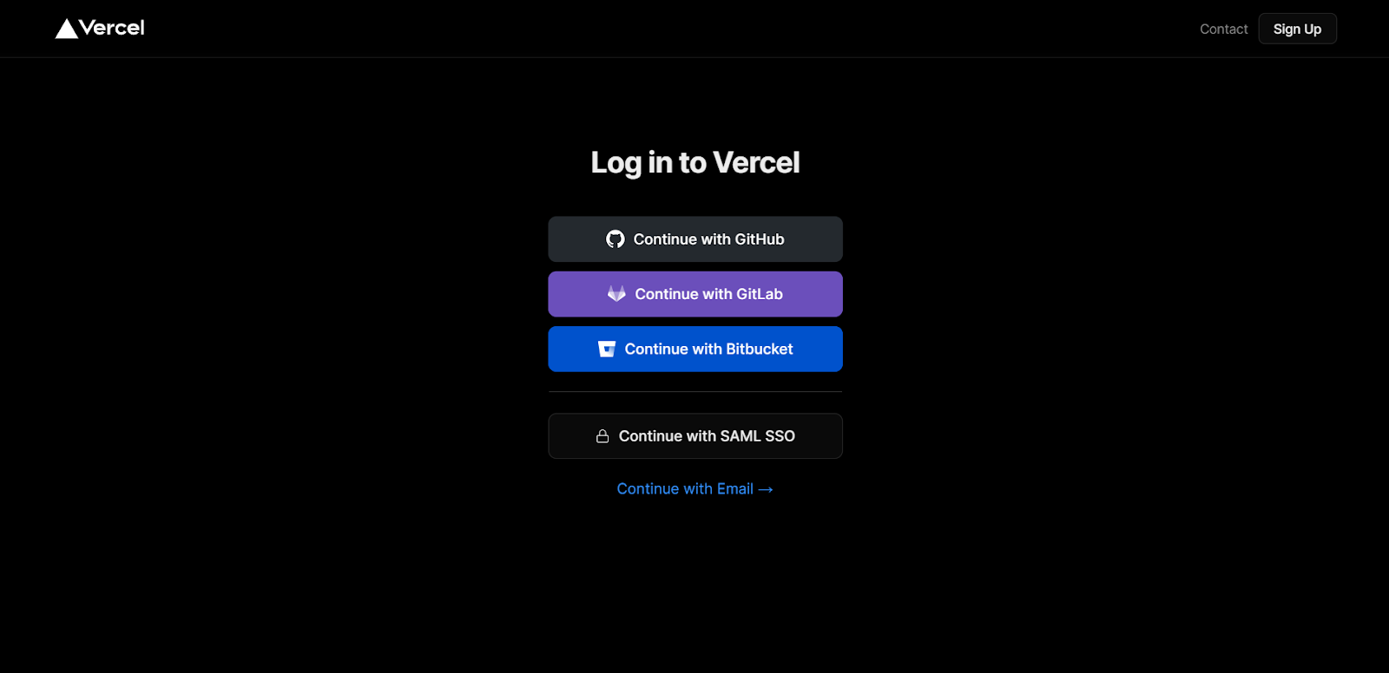

Step 1: Go toVercel and login with your GitHub account.

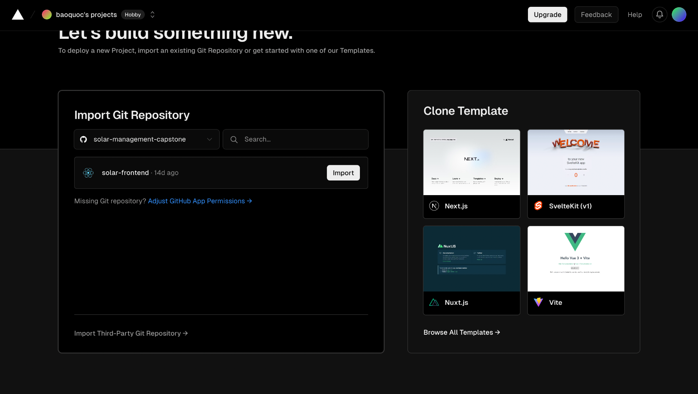  
Step 2: Import project from Github to deploy.

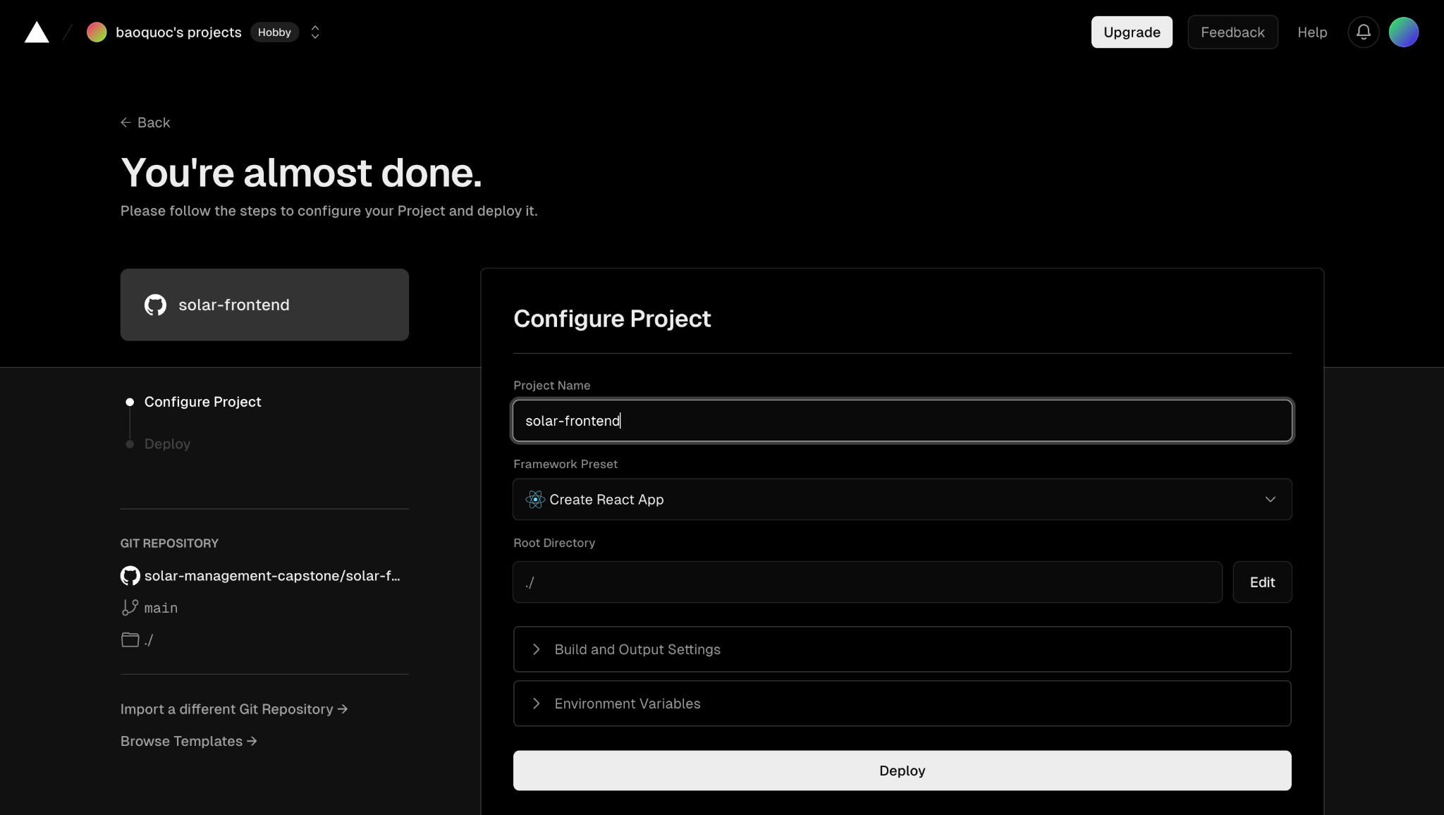  
Step 3: Enter a project name to display and click deploy to deploy the project.

#### 2.2.5.2 Azure App Services Deployment

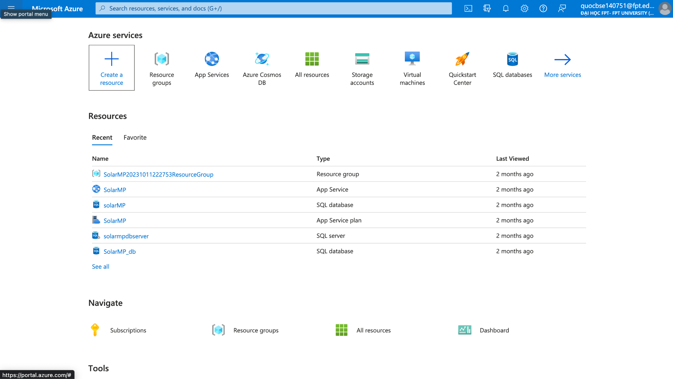

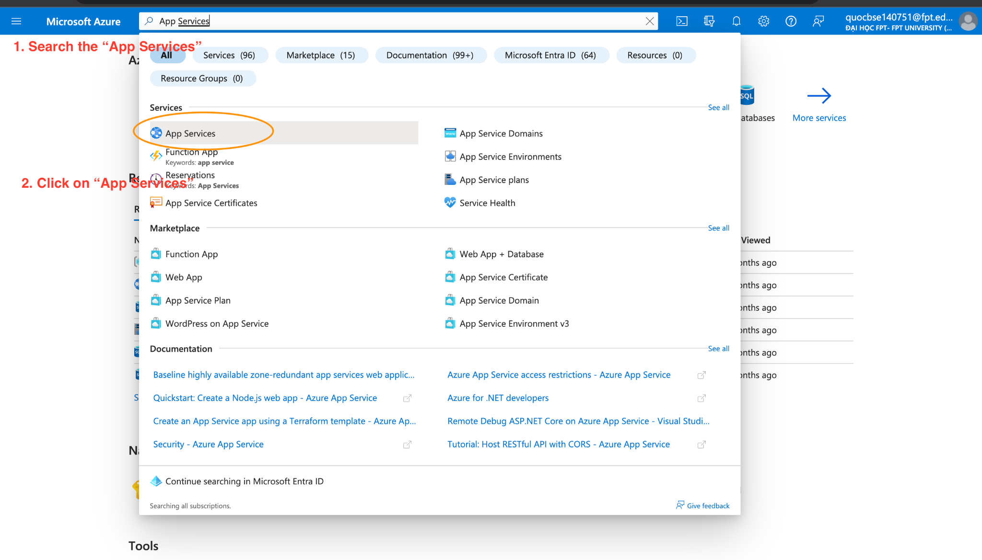

### 

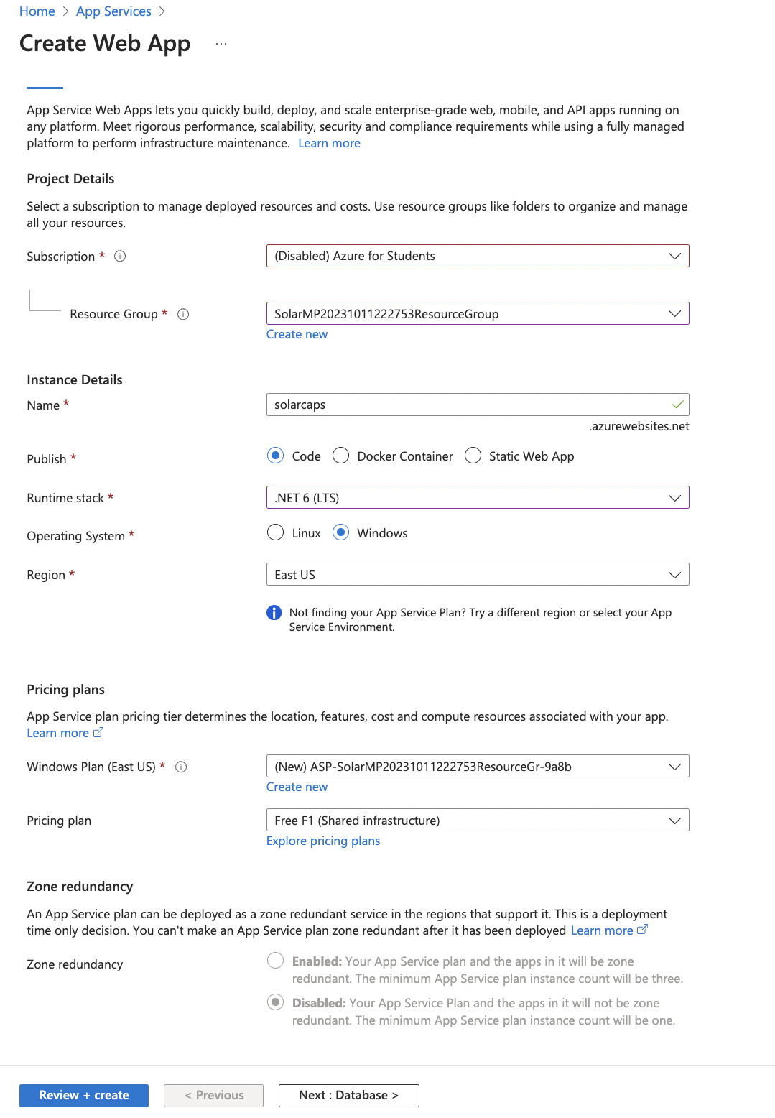

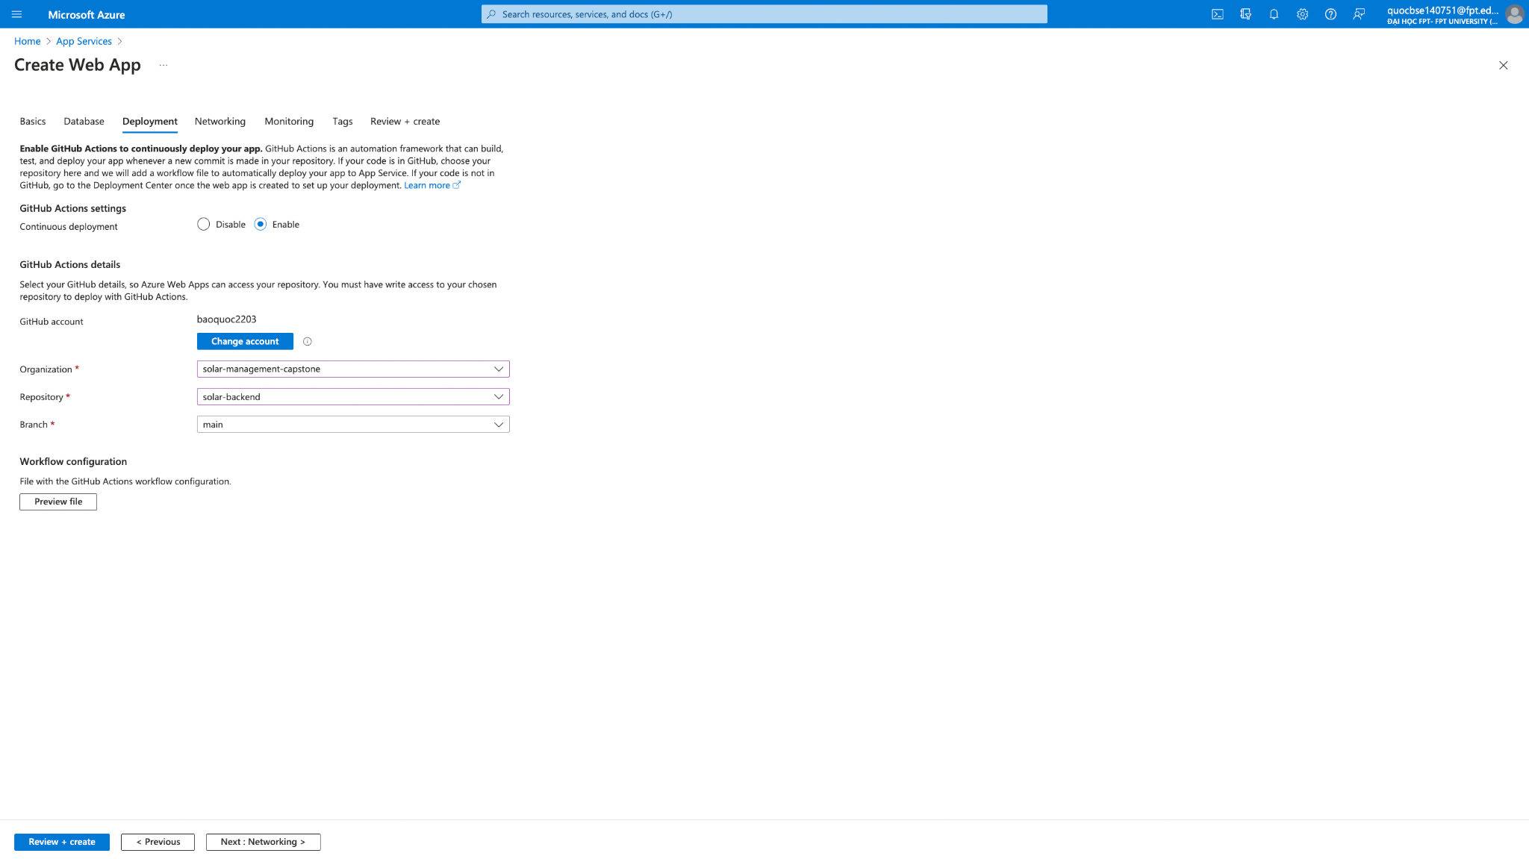

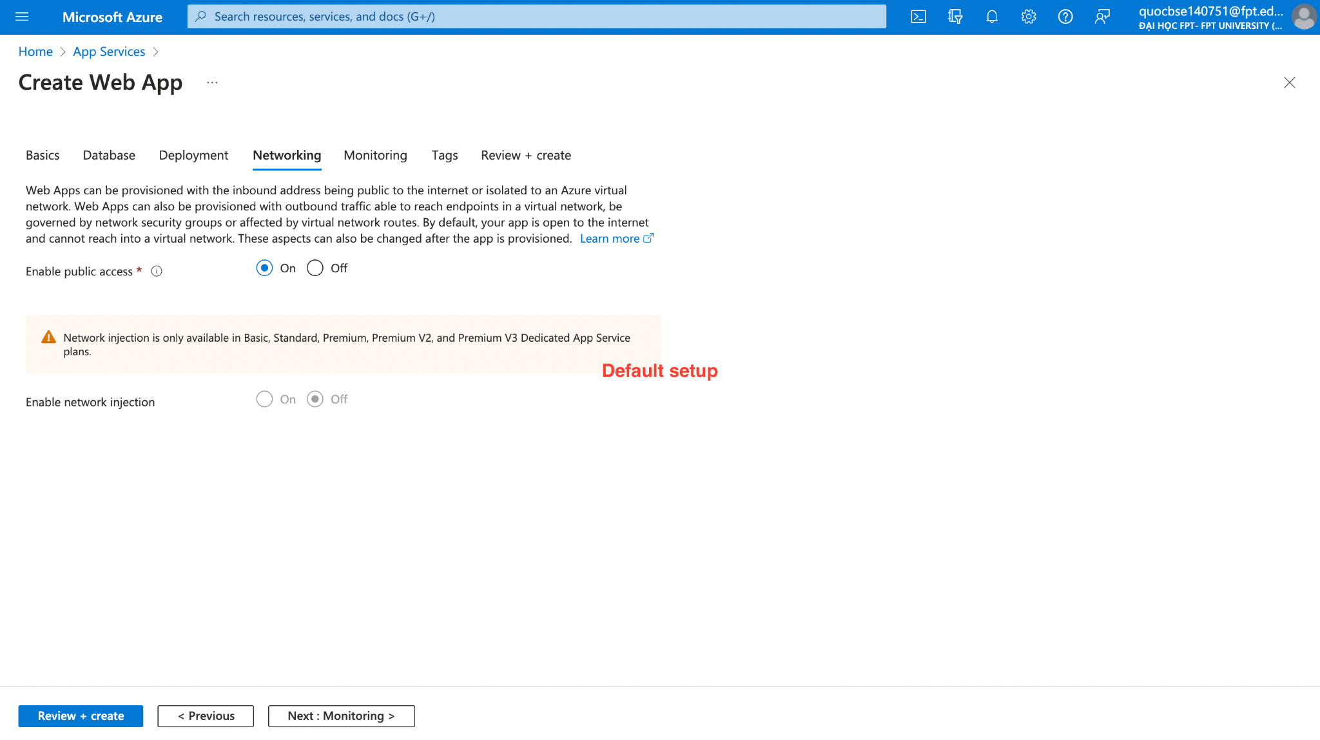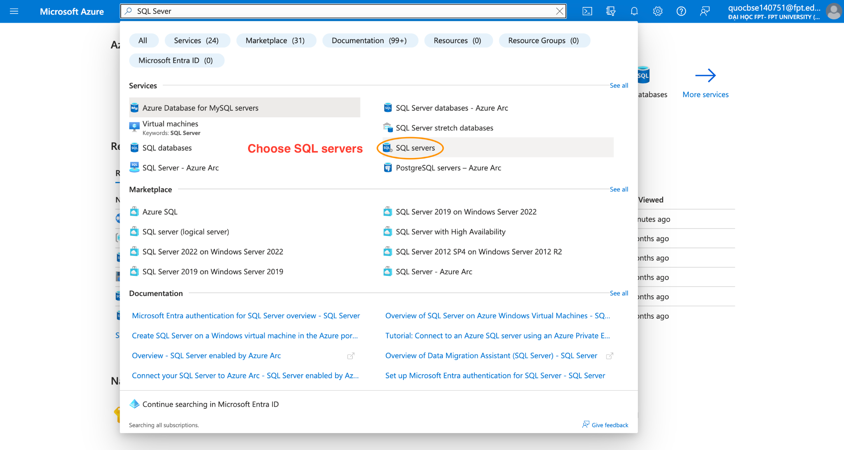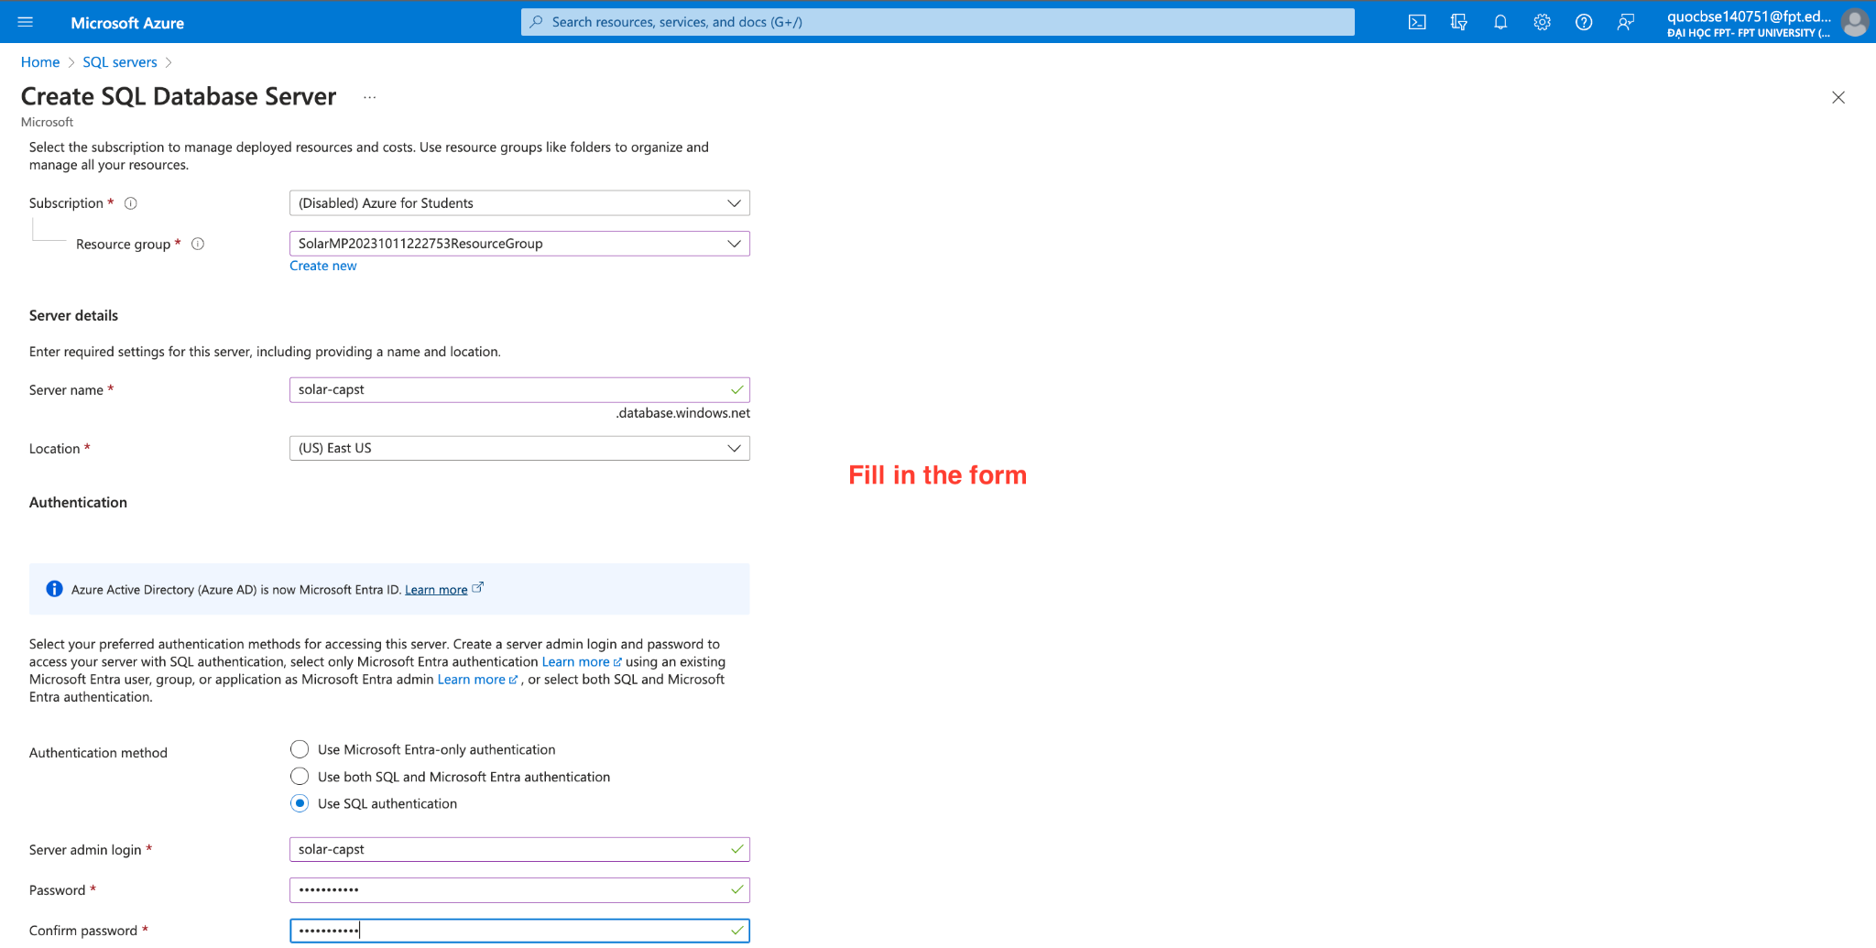

## 3. User Manual

### 3.1 Overview

This user manual provides an overview of the Solar Minh Phat Power Construction Contract Management System, a software application that allows you to manage your contracts and packages. The user manual will guide you through the installation, configuration, operation, and maintenance of the system. It will also provide troubleshooting tips and contact information for technical support.

### 3.2 Mobile Application for Customer

**3.2.1 Send request**

*Step 1: Log into the mobile application by customer account*



*Step 2: In the Homepage, taps on the tab “Gói” on the navigation bar*



*Step 3: In page “Gói” taps on any package to the package details*



*Step 4: In page “Gói sản phẩm”, taps on “Gửi yêu cầu tư vấn” button to send request*

### 3.3 Web Application for Owner

**3.3.1 Assign request to Staff leader**

*Step 1: Log in the web application by owner account*

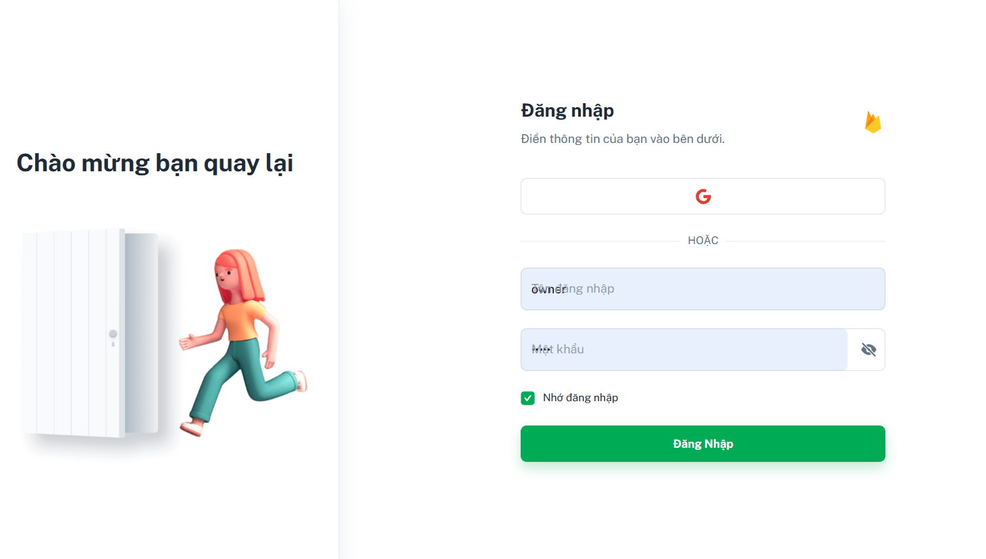

*Step 2: In the Homepage, clicks on “Quản lý yêu cầu”*

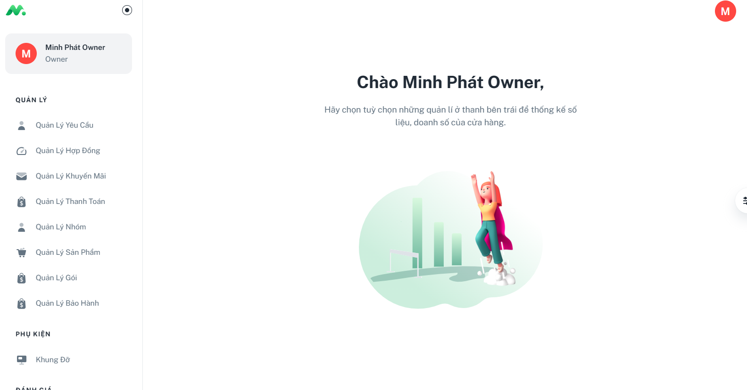

*Step 3: In the “Quản lý yêu cầu” page, clicks the “Gán nhân viên” button to assign staff*

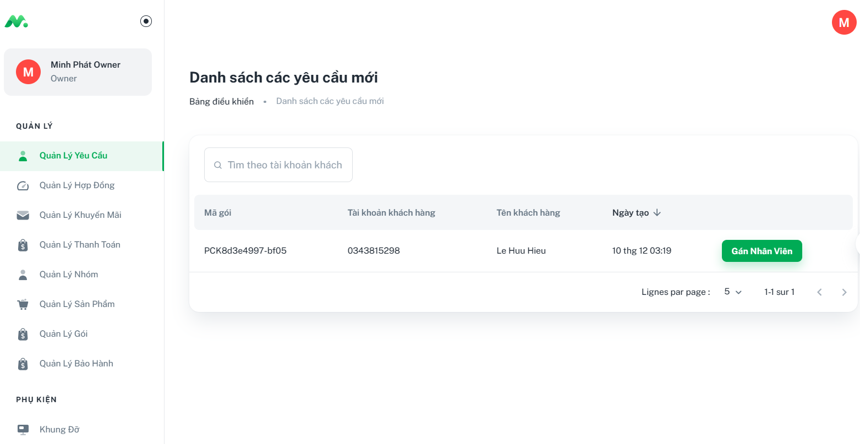

*Step 4: Choose a staff leader by clicking the radio button and clicks “Xác nhận” button*

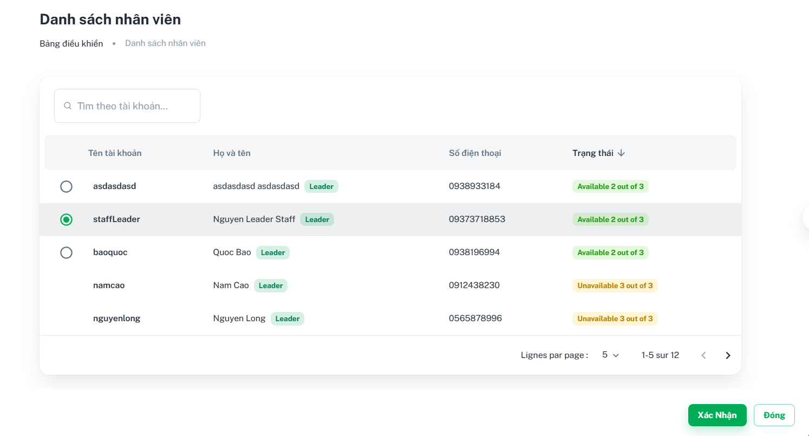

**3.3.2 Create product**

*Step 1: In the Homepage, clicks on the tab “Quản lý sản phẩm”*



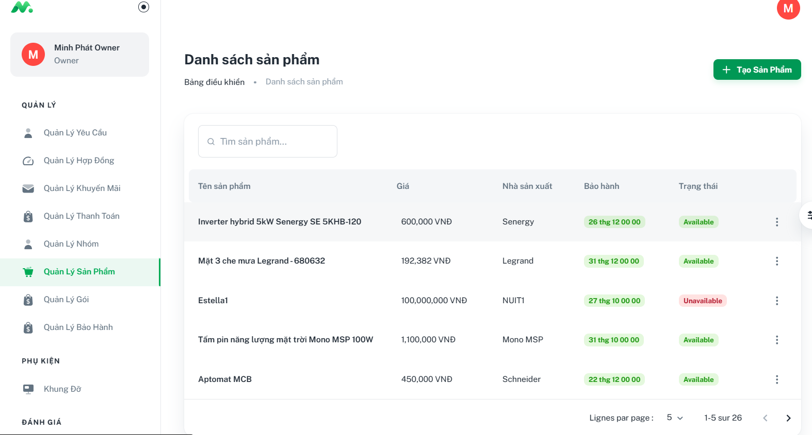

*Step 2: In the “Quản lý sản phẩm” page, clicks on the “Tạo sản phẩm” button and then fills all the required fields*

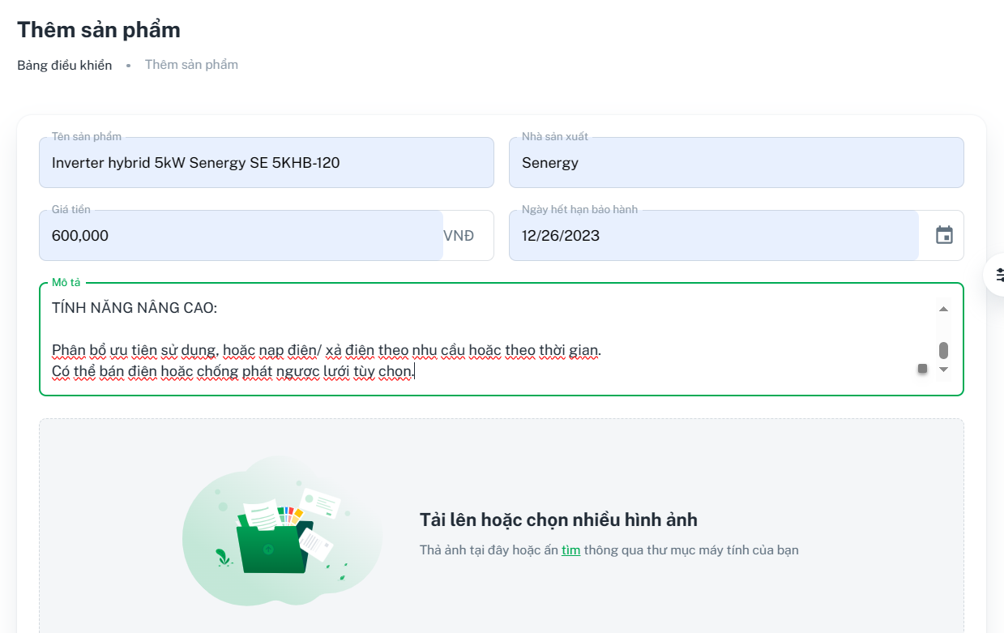

Step 3: Clicks the button “Thêm sản phẩm”

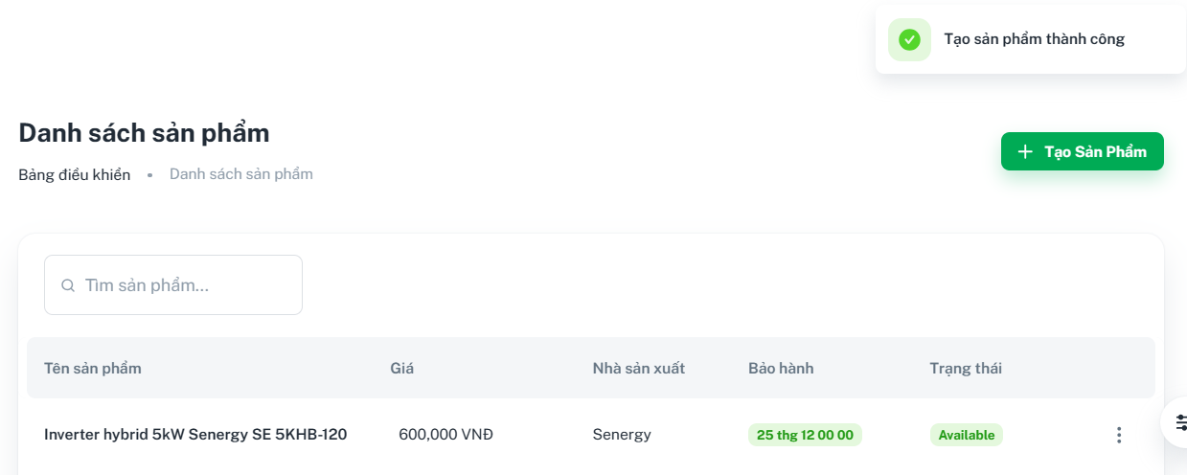

**3.3.3 Create bracket**

*Step 1: In the Homepage, clicks on the tab “Khung đỡ”*



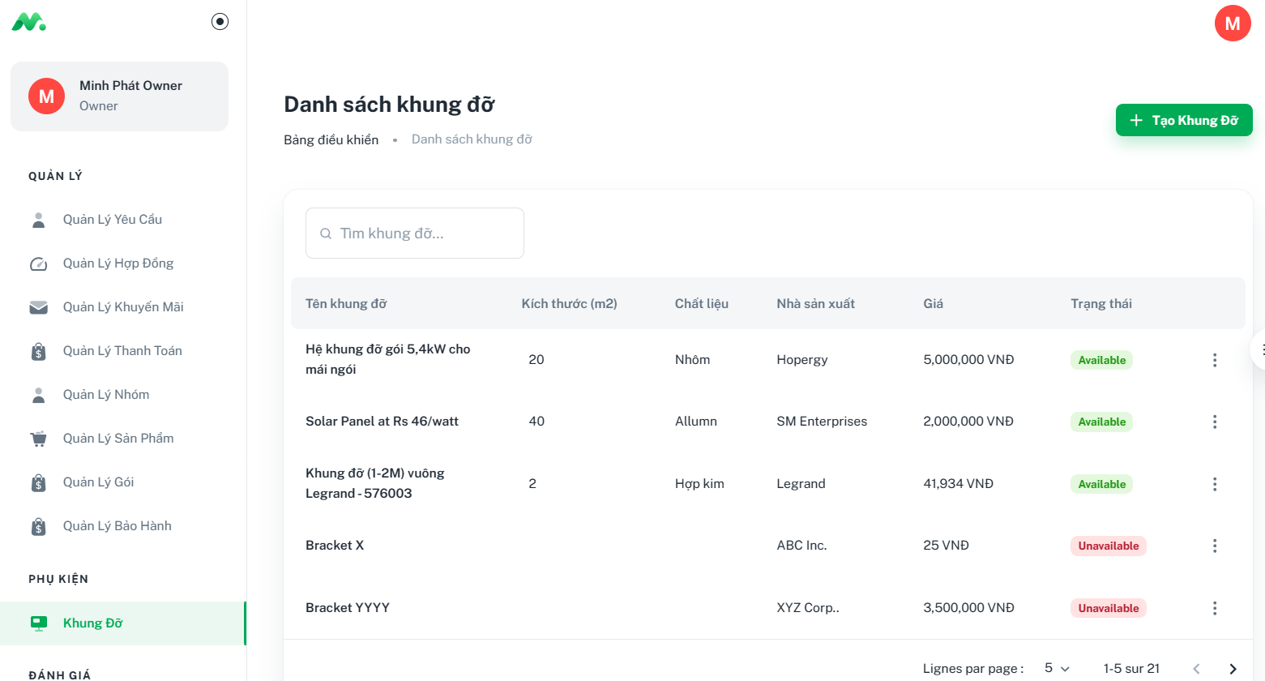

*Step 2: In the “Khung đỡ” page, clicks on the “Tạo khung đỡ” button and then fills all the required fields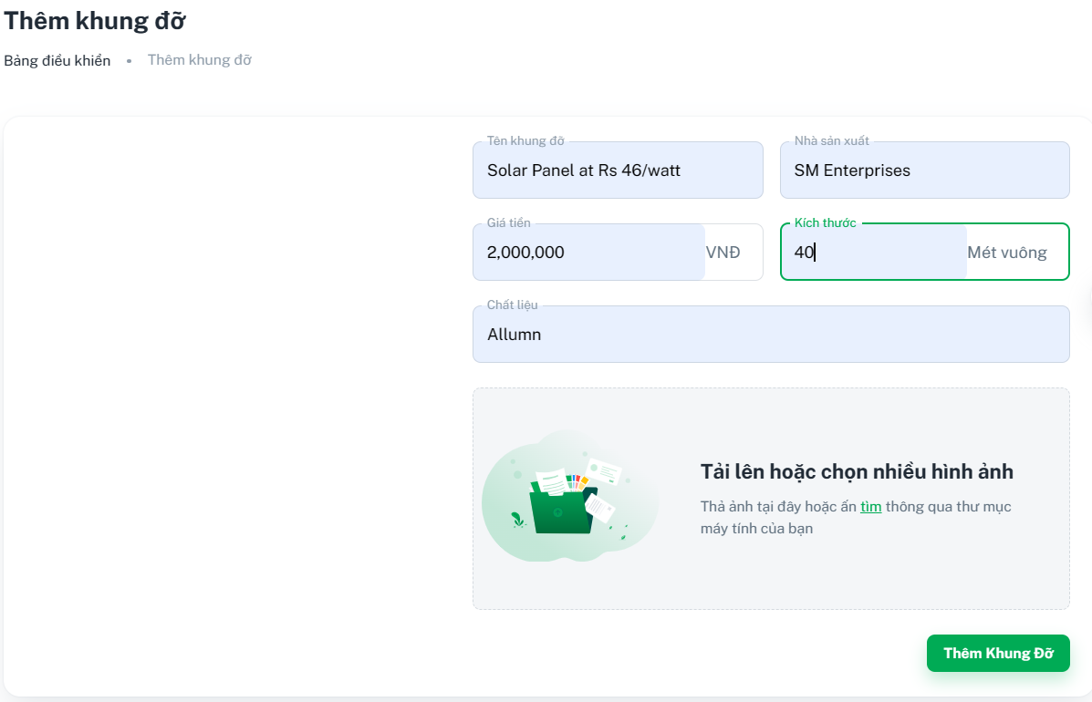*

*Step 3: In the “Thêm khung đỡ” page, click on “Thêm khung đỡ” button*

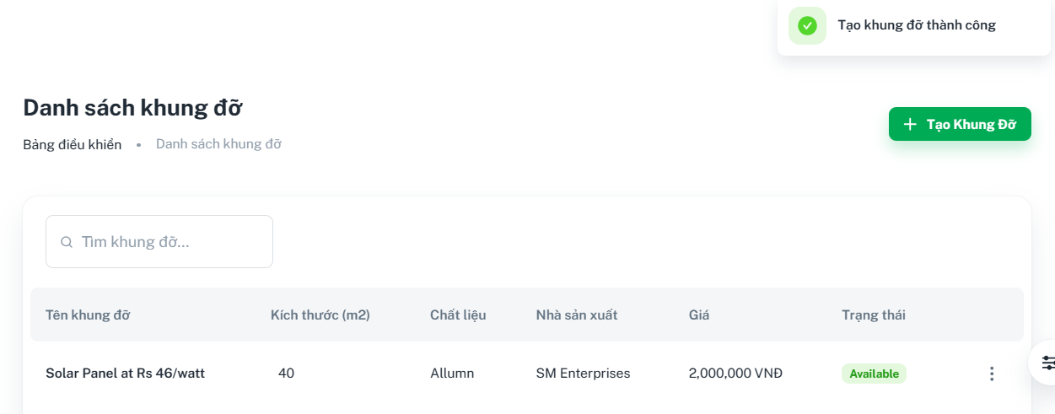

**3.3.4 Create combo**

*Step 1: In the Homepage, clicks on the tab “Quản lý sản phẩm”*



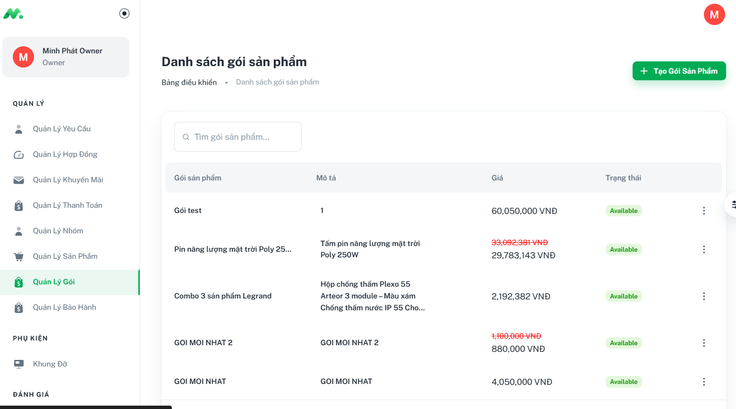

*Step 2: In the “Quản lý gói” page, clicks on the “Tạo gói sản phẩm” button and then fills all the required fields and choose the product included*

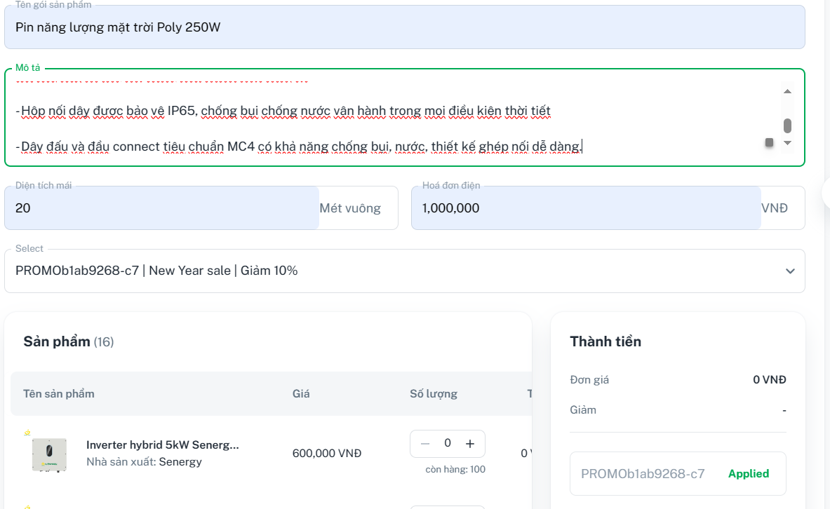

*Step 3: Step 3: In the “Tạo gói sản phẩm” page, click on “Tạo gói sản phẩm” button*

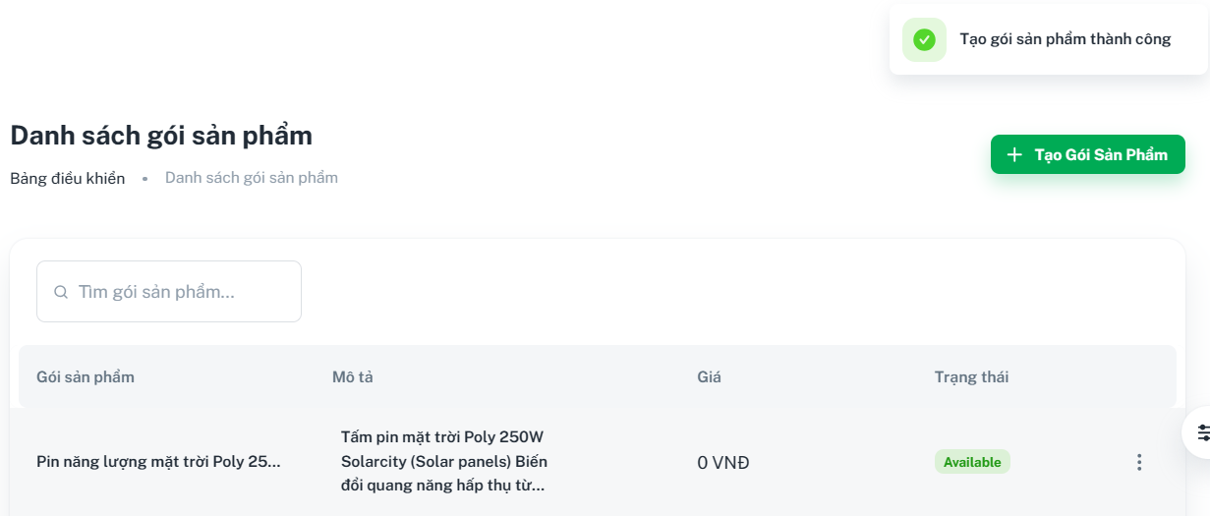

### 3.4 Web Application for Staff

**3.4.1 Create survey**

*Step 1: Log in the web application by staff account*



*Step 2: In the Homepage, clicks on “Yêu cầu khảo sát”*

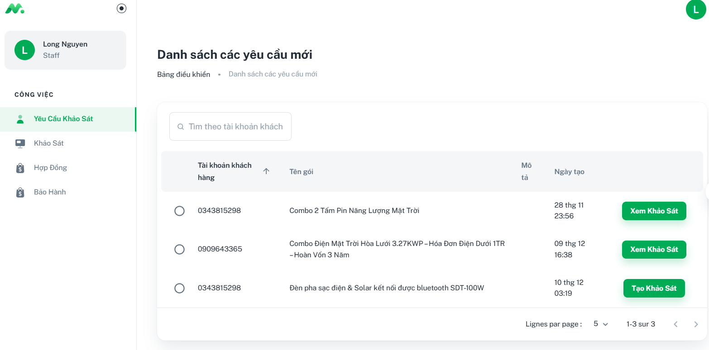

*Step 3: In the “Yêu cầu khảo sát” page, clicks on the “Tạo khảo sát” button and then fills all the fields*

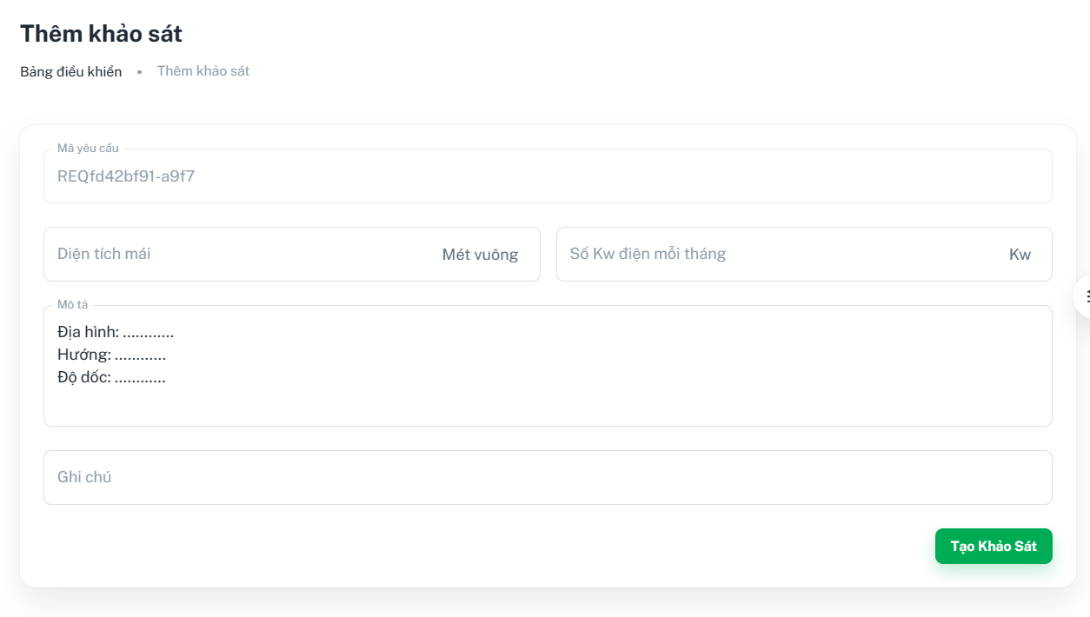

*Step 4: In the “Thêm khảo sát” page, clicks on the “Tạo khảo sát” button*

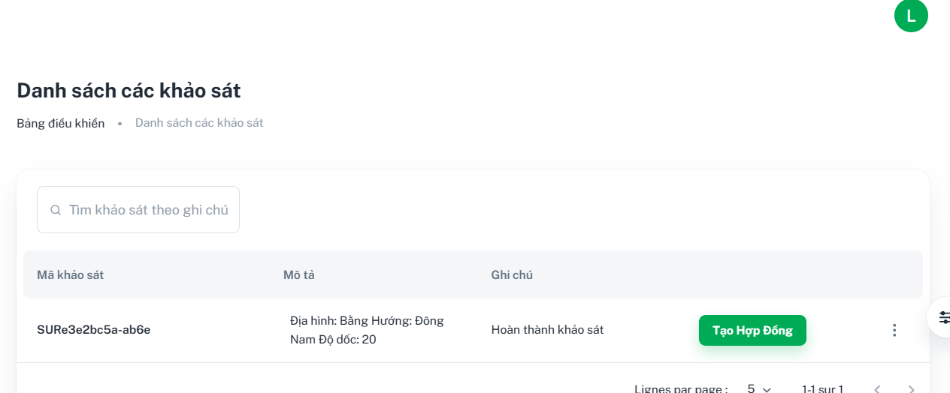

**3.4.2 Create contract**

*Step 2: In the Homepage, clicks on “Khảo sát”*

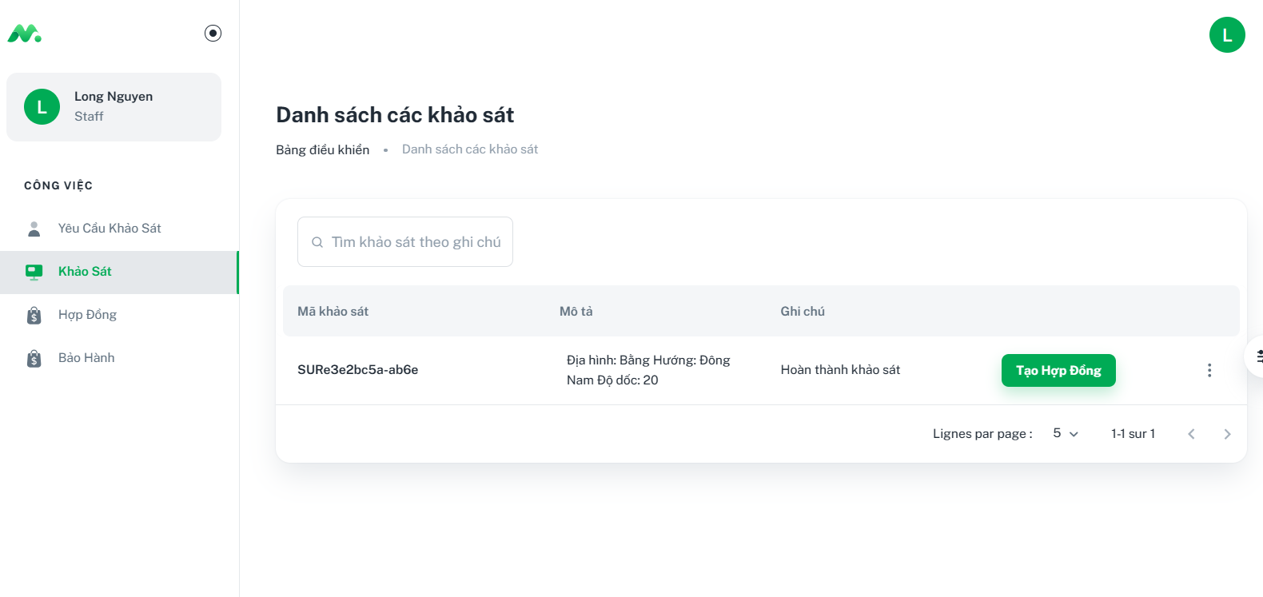

*Step 3: In the “Khảo sát” page, clicks on the “Tạo hợp đồng” button and then fills all the fields*

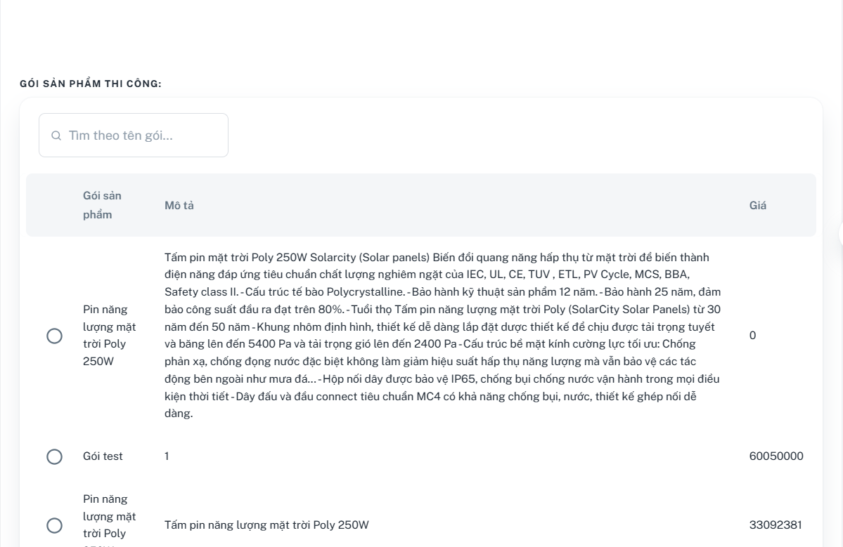

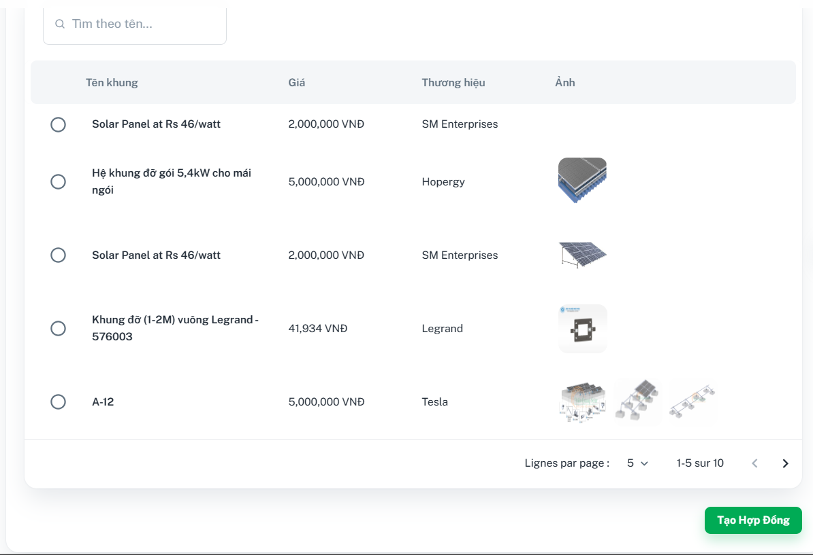

*Step 4: In the “Tạo hợp đồng” page, clicks on the “Tạo hợp đồng” button*

